HPE-Odessa DevOps



Release Deployment Guidelines

September 22, 2023

This document contains unpublished confidential and proprietary information of Odessa Technologies, Inc. No disclosure or use of any of these materials may be made without the express written consent of Odessa. ©1998-2020 Odessa Technologies, Inc. All Rights Reserved.

## Document revision history.

|  |  |  |  |
| --- | --- | --- | --- |
| Date | Description | Version | Author |
| 10 Jan 2023 | Draft | 1.0 | Avinesh Kumar Gupta |
| 20 Apr 2023 | Updated sections for Odessa Core | 1.1 | Avinesh Kumar Gupta |
| 26 Apr 2023 | Internal Odessa review | 1.2 | Paranthaman, Ajay Sethi, and Jayanth S |
| 3 May 2023 | HPE review | 1.3 | Vayman, William Guruswamy, Felix, and Microsoft (Chris Romp), Avinesh Gupta, Paranthaman, Ajay Sethi and Jayanth S |
| 3 May 2023 | Review comment to implement self-hosted agent | 1.4 | Vayman, William Guruswamy, Felix, and Microsoft (Chris Romp), Avinesh Gupta, Paranthaman, Ajay Sethi and Jayanth S |
| 8 May 2023 | Final review | 1.5 | Vayman, William Guruswamy, Felix, and Microsoft (Chris Romp), Avinesh Gupta, Paranthaman, Ajay Sethi and Jayanth S |
| 8 May 2023 | Agreed solutions-  Phase -1: Remote Script execution for VM deployment (refer section 3.1.4)  Phase – 2: Use self-hosted agent for VM deployment (refer section 3.1.5) | 1.6 | Vayman, William Guruswamy, Felix, and Microsoft (Chris Romp), Avinesh Gupta, Paranthaman, Ajay Sethi and Jayanth S |

Index

Document revision history. 2

1. Introduction 9

1.1 Overview 9

1.2 Intended Audiences 9

1.3 In Scope 9

1.4 Assumptions 9

1.5 Out of Scope 10

2. Odessa Applications 10

2.1 DevOps Permissions 10

2.1.1 Access on Odessa Azure Services/Resources 10

2.1.2 Access on Azure DevOps Project 12

2.2 Odessa Azure Resource List 12

2.3 Azure DevOps Project Link 12

2.3.1 Organization Name 12

2.3.2 Azure DevOps Project Name 12

2.3.3 Azure DevOps Project Link 12

2.3.4 Azure DevOps Organization View 12

2.3.5 Azure DevOps Project View 13

3. DevOps Solution Design 13

3.1 Odessa Release Content 13

3.1.1 Release Content Template **Sample** 14

3.1.2 Type of deployable contents 21

3.1.3 Pre-requisites Configurations 22

3.1.4 Release Content Artifacts 22

3.1.4 The Consolidated view of Azure Service Types Used by DevOps Pipeline 22

3.1.5 Azure DevOps - All Pipeline Structure 23

4. Artifact Details 24

4.1 Artifact Feed Names for All Applications 24

4.2 Package Naming Conventions 24

4.2.1 Core 25

4.2.2 ReportBuilder 26

4.2.3 DataWarehouse 26

4.2.4 PartnerPortal 27

4.2.5 DataHub 27

4.3 Artifact Details 28

4.3.1 **Core** 28

4.3.2 ReportBuilder 28

4.3.3 DataWarehouse 29

4.3.4 PartnerPortal 29

4.3.5 Datahub 29

5. Odessa Core Pipeline Setup 30

5.1 Pipeline Setup – DEV 30

5.1.1 Prerequisite Configuration/Permissions for DEV 30

**5.1.2 Enable Remote Execution from DevOps Pipeline within Report Server VM** 32

5.1.3 Automated Pipeline Deployment Workflow 35

5.1.4 Release Pipeline Setup 36

5.2 Pipeline Setup – ITG (HPE owned) 38

5.2.1 Prerequisite Configuration/Permissions for ITG 38

**5.2.2 Enable Remote Execution from DevOps Pipeline within Report Server VM** 40

5.2.3 Automated Pipeline Deployment workflow 43

5.2.4 Release Pipeline Setup 45

5.3 Pipeline Setup – STG (HPE Owned) 46

5.3.1 Prerequisite Configuration/Permissions for STG 46

**5.3.2 Enable Remote Execution from DevOps Pipeline within Report Server VM** 48

5.3.3 Automated Pipeline Deployment workflow 51

5.3.4 Release Pipeline Setup 52

6. Gold Config - Core Pipeline Setup 53

6.1 Prerequisite Configuration/Permissions 53

6.2 Automated Pipeline Deployment Workflow 55

6.3 Pipeline Setup 56

**6.3.1 Pipeline -** Odessa Core Config w Artifacts 56

6.3.2 Pipeline **-** Restart Core Config App Services 56

7. Report Builder Pipeline Setup 56

7.1 Pipeline Setup – DEV 56

7.1.1 Prerequisite Configuration/Permissions for DEV 56

7.1.2 Automated Pipeline Deployment Workflow 58

7.1.3 Release Pipeline Setup 59

7.2 Pipeline Setup – ITG (HPE owned) 60

7.2.1 Prerequisite Configuration/Permissions for ITG 60

7.2.2 Automated Pipeline Deployment Workflow 62

7.2.3 Release Pipeline Setup 62

7.3 Pipeline Setup – STG (HPE owned) 62

7.3.1 Prerequisite Configuration/Permissions for STG 62

**7.3.2 Enable Remote Execution from DevOps Pipeline within RDL Service VM** 64

7.3.3 Automated Pipeline Deployment Workflow 68

7.3.4 Release Pipeline Setup 69

8. Data warehouse/Insights Pipeline Setup 70

8.1 Pipeline Setup – DEV 70

8.1.1 Prerequisite Configuration/Permissions for DEV 70

**8.1.2 Enable Remote Execution from DevOps Pipeline within DWH VM** 71

8.1.3 Automated Pipeline Deployment Workflow 75

8.1.4 Release Pipeline Setup 76

8.2 Pipeline Setup – ITG (HPE owned) 77

8.2.1 Prerequisite Configuration/Permissions for ITG 77

**8.2.1 Enable Remote Execution from DevOps Pipeline within DWH VM** 78

8.2.3 Automated Pipeline Deployment Workflow 82

8.2.4 Release Pipeline Setup 83

8.3 Pipeline Setup – STG (HPE owned) 83

8.3.1 Prerequisite Configuration/Permissions for STG 83

**8.3.2 Enable Remote Execution from DevOps Pipeline within DWH VM** 85

8.3.3 Automated Pipeline Deployment Workflow 88

8.3.4 Release Pipeline Setup 89

9. Partner Portal Pipeline Setup 89

9.1 Pipeline Setup – DEV 89

9.1.1 Prerequisite Configuration/Permissions 89

**9.1.2 Enable Remote Execution from DevOps Pipeline within Report Server VM** 92

9.1.3 Automated Pipeline Deployment Workflow 95

9.1.4 Release Pipeline Setup 96

9.2 Pipeline Setup – ITG (HPE owned) 98

9.2.1 Prerequisite Configuration/Permissions 98

**9.2.2 Enable Remote Execution from DevOps Pipeline within Report Server VM** 100

9.2.3 Automated Pipeline Deployment Workflow 104

9.2.4 Release Pipeline Setup 105

9.3 Pipeline Setup – STG (HPE owned) 106

9.3.1 Prerequisite Configuration/Permissions 106

**9.3.2 Enable Remote Execution from DevOps Pipeline within Report Server VM** 108

9.3.3 Automated Pipeline Deployment Workflow 111

9.3.4 Release Pipeline Setup 112

10. Data Hub Pipeline Setup 113

10.1 Pipeline Setup – DEV 113

10.1.1 Prerequisite Configuration/Permissions for DEV 113

**10.1.2 Enable Remote Execution from DevOps Pipeline within Data Hub VM** 114

10.1.3 Automated Pipeline Deployment Workflow 118

10.1.4 Release Pipeline Setup 119

10.2 Pipeline Setup – ITG (HPE owned) 120

10.2.1 Prerequisite Configuration/Permissions for ITG 120

**10.2.2 Enable Remote Execution from DevOps Pipeline within Data Hub VM** 122

10.2.3 Automated Pipeline Deployment Workflow 125

10.2.4 Release Pipeline Setup 126

10.3 Pipeline Setup – STG (HPE owned) 126

10.3.1 Prerequisite Configuration/Permissions for STG 126

**10.3.2 Enable Remote Execution from DevOps Pipeline within Data Hub VM** 128

10.3.3 Automated Pipeline Deployment Workflow 131

10.3.4 Release Pipeline Setup 132

11. Steps for Creating/Updating Azure Key Vault **Secrets** 132

11.1 Sample for Creating new Secret – 132

11.2 Sample for Updating an existing Secret – 134

12. Steps for Creating/Updating Azure App Configuration Keys 137

12.1 Sample for Creating new Key – 138

12.1.1 Key-value 139

12.1.2 Key Vault reference 139

12.2 Sample for Updating an existing key – 140

12.1.1 Update Key-value 140

12.1.2 Update Key Vault reference 141

13. Odessa Core Deployment 141

13.1 Automated and Manual Release Tasks 141

13.2 Steps for – Validate Audit Jobs Completion 142

13.3 Steps for - Create Release 142

13.4 Steps for – Deploy Core Components 143

13.5 Steps for – Update Config Changes 144

13.6 Steps for – Restart Core Services 145

13.7 Steps for - Uploading Business Configuration 145

13.8 Steps for - Uploading RBS. 146

13.9 Steps for - Executing Workflow Setup 147

13.10 Steps for - Execute Extract SP in Main and Replica DB 148

13.10.1 Main DB 148

13.10.2 Replica DB 149

14. Golden Config – Core Deployment 151

14.1 Automated and Manual Release Tasks 151

14.2 Steps for - Create Release 152

14.3 Steps for – Deploy GoldConfig-Core Components 153

14.4 Steps for – Update Config Changes 154

14.5 Steps for – Restart Core Config Services 154

14.6 Steps for - Uploading Business Configuration 155

14.7 Steps for - Uploading RBS 156

14.8 Steps for - Executing Workflow Setup 157

14.9 Steps for - Execute Extract SP in Main and Replica DB 158

14.9.1 Main DB 158

14.9.2 Replica DB 159

15. Report Builder Deployment 161

15.1 Automated and Manual Release Tasks 161

15.2 Steps for - Create Release 161

15.3 Steps for – Deploy ReportBuilder Components 162

15.4 Steps for – Update Config Changes 163

15.5 Steps for – Restart ReportBuilder Services 164

16. Data Warehouse Deployment 164

16.1 Automated and Manual Release Tasks 165

16.2 Steps for – Run Measure Jobs from odessacore 165

16.3 Steps for - Create Release 167

16.4 Steps for – Deploy DWH Components 168

16.5 Steps for – Update Config Changes 169

16.6 Steps for – Run ETL 170

16.7 Non-Production (Data Repopulation) Workflow Diagram 171

16.8 Steps for – Upload Documents 172

17. Partner Portal Deployment 172

17.1 Automated and Manual Release Tasks 173

17.2 Steps for – Validate Jobs Completion 173

17.3 Steps for - Create Release 173

17.4 Steps for – Deploy Partner Portal Components 174

17.5 Steps for – Update Config Changes 175

17.6 Steps for – Restart Partner Portal Services 176

18. Gold Config – Partner Portal Pipeline Setup 177

18.1 Prerequisite Configuration/Permissions 177

18.2 Automated Pipeline Deployment Workflow 178

18.3 Pipeline Setup 178

**18.3.1 Pipeline -** Odessa Partner Portal Config w Artifacts 178

19. Golden Config – Partner Portal Deployment 179

19.1 Gold configuration deployment steps 179

19.1.1 Deploy Gold Config – Partner Portal component. 180

19.1.2 Release version verification 181

20. Data Hub Deployment 182

20.1 Data hub deployment steps 182

21. Annexure 182

21.1 Notations 182

21.6 Datahub– Resource Mapping 183

22. References 183

# 1. Introduction

## 1.1 Overview

This document explains the step-by-step information about deploying Odessa applications in HPE DEV Azure environment.

The following contents have been covered as part of this document –

* List of Odessa applications
* DevOps Solution Design
* Best practices used for each Azure resource used for deployment.
* Automated and Manual components for each application (Hybrid deployment model)
* Deployment checklist for each Odessa applications
* New environment setup for DevOps pipelines

## 1.2 Intended Audiences

The intended audiences for this document are the Odessa release management team and the HPE release management team.

## 1.3 In Scope

* Odessa provides and uploads the deployable release artifacts over HPE Azure storage container in DEV environment.
* Odessa to setup DevOps pipeline in HPE DEV environment.

## 1.4 Assumptions

* HPE provides necessary access to the following Azure storage containers.

|  |  |
| --- | --- |
| **Storage Container** | **Purpose** |
| stodessacoreblobdev/release-content | Odessa team uploads release content artifacts |
| stodessacoreblobdev/dumps | HPE DevOps team uploads dumps like logs/db backups within this container. The Odessa team should be able to access data from this container. |

* VM scale-set is configured by HPE azure team.

## 1.5 Out of Scope

* HPE Azure infrastructure setup
* Azure DevOps organization creation
* Azure DevOps project creation
* Granting permission on Azure resources
* Setting up DevOps pipeline for Odessa Applications in higher environments (ITG, STG, Production and DR)

# 2. Odessa Applications

This document covers the following Odessa applications to deploy in Azure HPE environment.

1. Odessa Core
   * + Gold Config – Core
2. Partner Portal
   * Gold Config – Partner Portal
3. Report Builder
4. Data warehouse (insights)
5. Data Hub

## 2.1 DevOps Permissions

DevOps team member should have access in following two areas –

1. Access on Odessa Azure Services/Resources
2. Access on Azure DevOps Project

### Access on Odessa Azure Services/Resources

DevOps users should have azure group access as listed below -

|  |  |  |
| --- | --- | --- |
| **Group Name** | **Environment** | **Description** |
| hpefs-bastion-users | Dev, ITG and STG | Bastion access for Jump box Login |
| hpefs-odessa-az-vm-user-dev | Dev & ITG | Jump box VM access |
| hpefs-az-vm-user-stg | STG | Jump box VM access |
| hpefs-odessa-az-vm-admin-dev | Dev | * Report Server VM access   + Report Service Engine (SSRS)   + TValue Service (hosted in IIS) * Data warehouse VM access |
| hpefs-odessa-apps-az-vm-admin-itg | ITG |
| hpefs-odessa-az-vm-admin-stg | STG | * Report Server VM access   + Report Service Engine (SSRS)   + TValue Service (hosted in IIS)   + Report Builder App Service     - Report Builder Generation RDL Service (hosted in IIS) * Data warehouse VM access |
| hpefs-odessa-az-db-admin-dev | DEV | HPE Domain:   * SQL Mi access for following app databases -   + Core DB   + Report Builder DB   + Report Server (SSRS) DB * Partner Portal DB |
| hpefs-odessa-az-db-admin-itg | ITG |
| hpefs-odessa-az-db-admin-stg | STG |
| HPEFS-ODESSA\hpefs-odessa-az-db-admin-dev | DEV | * Data warehouse DB access within Data Mart/DWH VM |
| HPEFS-ODESSA\hpefs-odessa-apps-az-db-admin-itg | ITG | * Data warehouse DB access within Data Mart/DWH VM |
| hpefs-odessa-az-db-admin-stg | STG | * Data warehouse DB access within Data Mart/DWH VM |
| hpefs-az-portal-dev-devops | Dev | * Portal Access for following –   + Core App Services     - App Server     - Batch Jobs     - Api Server     - Doc Portal   + Report Builder App Services     - App Server     - Batch Jobs     - Report Generation App Service (Dev & ITG)   + Report Builder App Services     - App Server     - Batch Jobs     - Api Service     - Doc Portal (NA for ITG and STG)   + Storage Accounts   + Key Vaults   + App Configurations |
| hpefs-az-portal-itg-devops | ITG |
| hpefs-az-portal-stg-devops | STG |
| Note: For Non-Prod Jump Box access – A Temp Domain Account to be created  (Sample email - <….>@hpefs-odessa.com | | |

### Access on Azure DevOps Project

DevOps users should have minimum “**Project Administrator**” access in Azure DevOps portal to manage DevOps pipeline.

## 2.2 Odessa Azure Resource List

Refer Odessa Azure Resource list excel > [Odessa Azure Resource List.xlsx](https://hpe.sharepoint.com/:x:/r/sites/msteams_a09baa/Shared%20Documents/MOC%20-%20Management%20Of%20Change/Support/IT%20Support/DevOps/Odessa%20Azure%20Resource%20List.xlsx?d=we457407f7e834889861b2be29b0bdb2c&csf=1&web=1&e=nJSaMk)

## Azure DevOps Project Link

### 2.3.1 Organization Name

* hpefsam

### 2.3.2 Azure DevOps Project Name

* HPEFS_Odessa_Core

### 2.3.3 Azure DevOps Project Link

* [Summary - Overview (visualstudio.com)](https://hpefsam.visualstudio.com/HPEFS_Odessa_Core)

### 2.3.4 Azure DevOps Organization View

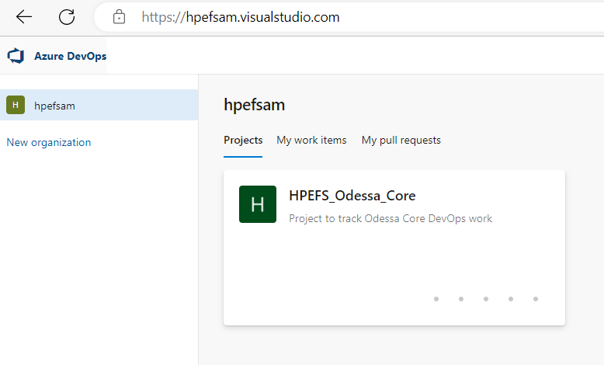

### 2.3.5 Azure DevOps Project View

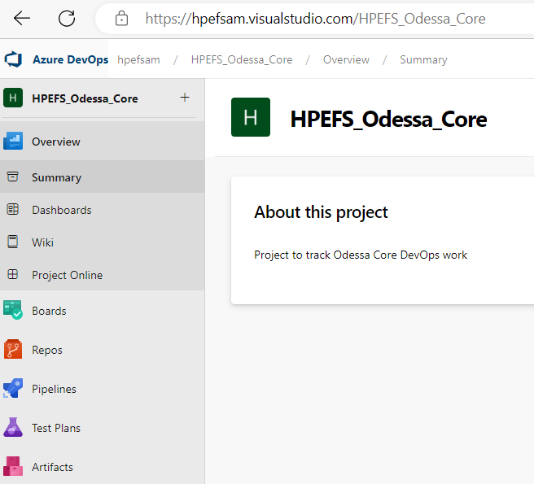

# 3. DevOps Solution Design

As part of building the DevOps pipeline, the possible and supported best practices have been implemented. Each Odessa application consists of many modules which are deployed in different types of Azure resource types.

## 3.1 Odessa Release Content

The Odessa team provides the release contents for all Odessa applications along with Release Content/Deployment Request Form. Release content artifacts are maintained inside storage account – “**stodessacoreblobdev**/**release-content**” while Release Content Deployment Form is shared over email to DevOps team prior the release downtime.

### 3.1.1 Release Content Template **Sample**

#### 3.1.1.1 Odessa Core – Sample Deployment Request Form

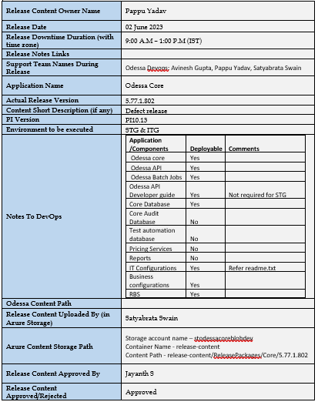

#### 3.1.1.2 Report Builder – Sample Deployment Request Form

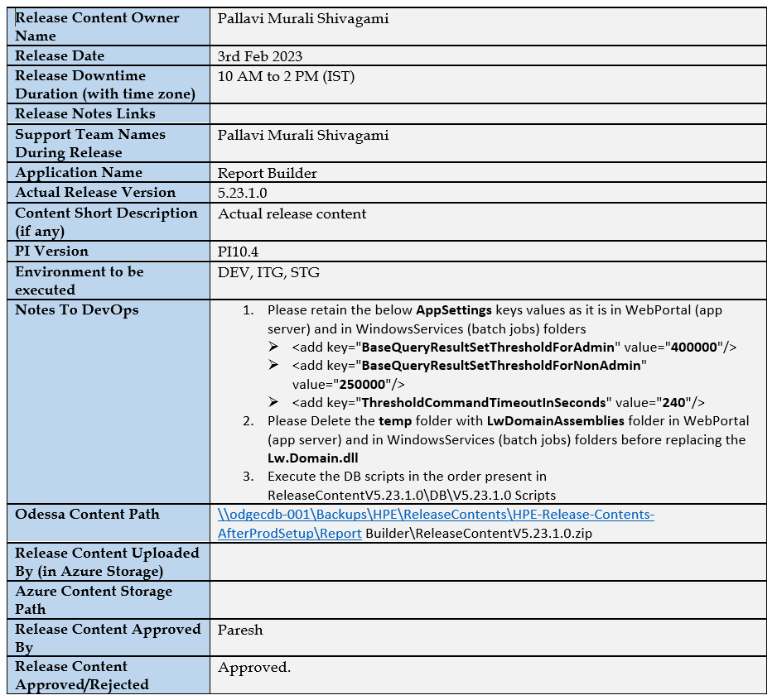

#### 3.1.1.3 Data warehouse – Sample Deployment Request Form

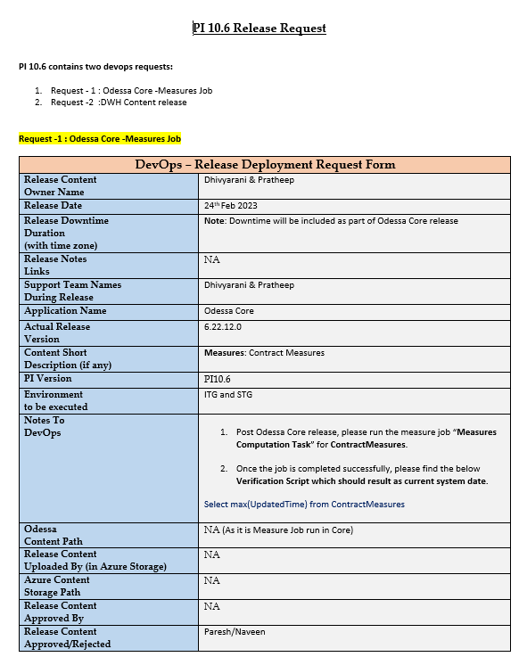

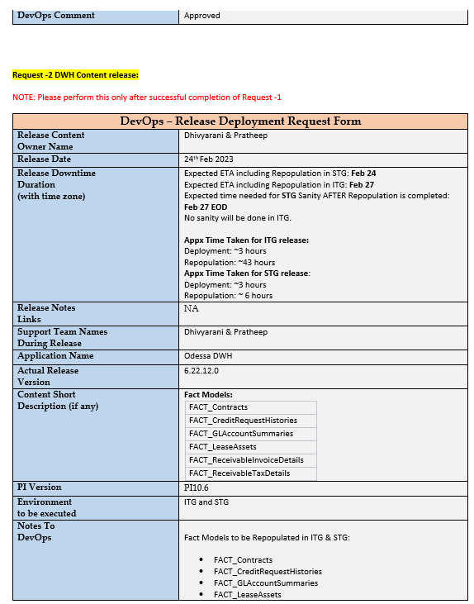

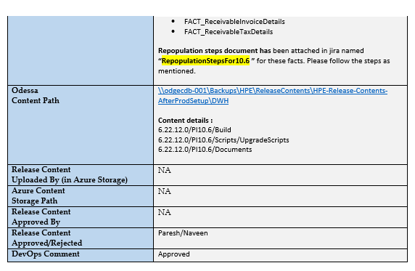

**Sample of Data Repopulation Document**

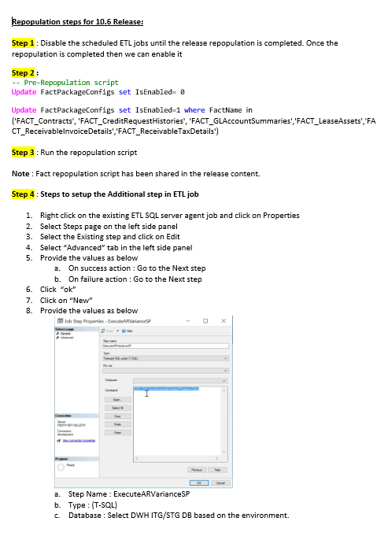

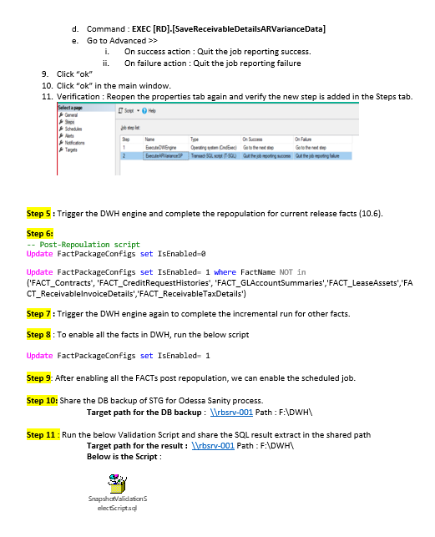

#### 3.1.1.4 Partner Portal – Sample Deployment Request Form

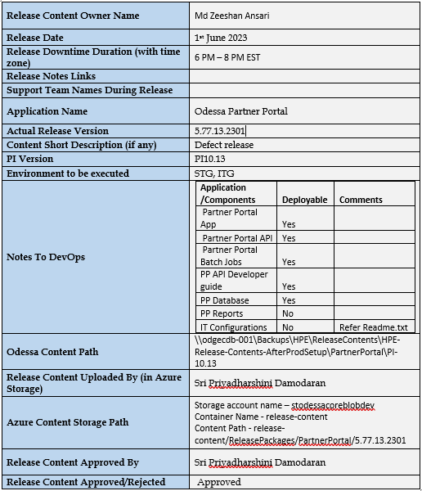

#### 3.1.1.5 Data Hub – Sample Deployment Request Form

<to be filled>

### 3.1.2 Type of releases

* Regular release
* Hot fixes
* Data patch in specific environments
* Any others.

### 3.1.3 Pre-requisites Configurations

Some release contents require pre-requisites configuration in Azure which require higher permissions therefore these tasks are excluded from DevOps pipeline and are configured manually by DevOps team before starting the release deployments.

**Some examples of these configurations are as below –**

* Creating/Updating Key Vault secrets
* Creating/Updating App Configuration Keys
* Granting permissions over Storage containers
* Creating new containers
* Any others.

**Odessa provides all these pre-configuration details within “Release Deployment Request Form -** *refer section 3.1.1***” which is shared before the actual release or hot fix.**

### 3.1.4 Release Content Artifacts

Once release contents are available within the above storage container, a DevOps pipeline fetches these contains from Storage container and pushes those within DevOps Artifacts. To understand the workflow please refer to the diagram below.

Below table describes some standards recommended for maintaining the artifacts within Azure DevOps Artifacts.

### 3.1.4 Solution Design – Phase 1

Below table describes the consolidated list of different types of Azure resources which have been used for deployment using DevOps pipeline.

All the below DevOps pipeline use the Virtual Machine Scale Set (VMSS) solution.

|  |  |  |
| --- | --- | --- |
| **Azure Resource Type** | **High Level Deployment Tasks** | **Method/Solution Implemented** |
| **App Services** | * Stopping services * Release content deployment * Starting services | Agents –   * VM scale-set * Azure App Service Deploy |
| **SQL Mi Database** | * Database script execution | Agent -   * PowerShell |
| **Virtual Machine** | * Report Sever Engine - RDL files deployment | Agent –   * Azure Key Vault * Extract Files * Windows machine file copy * PowerShell on target machines |
| **SQL on Virtual Machine** | * Data warehouse/Insights release content deployment inside windows physical path | Agent –   * Azure Key Vault * Extract Files * Windows machine file copy * PowerShell on target machines |
| **SQL on Virtual Machine** | * Data warehouse/Insights SQL Server database script deployment | Agent –   * Azure Key Vault * Extract Files * Windows machine file copy * PowerShell on target machines |

* **Reference link –** [Configuring WinRM over HTTPS to enable PowerShell remoting](https://www.microsoft.com/en-gb/industry/blog/technetuk/2016/02/11/configuring-winrm-over-https-to-enable-powershell-remoting/).
* Enable inbound port 5986 with VM for remote PowerShell remote execution.
* A self-signed Certificate used in DEV environment to enable Remote PowerShell script execution.
* Solution Review: Currently using self-signed certificate and proposal is to use DevOps agent.

|  |  |  |
| --- | --- | --- |
| **Environment** | **Certificate Type & Details** | **Note** |
| DEV | Self-signed | CA certificate? (TBD) |
| ITG | ? | Use CA certificate |
| STG | ? | Use CA certificate |
| PROD | ? | Use CA certificate |

### 3.1.5 Solution Design – Phase 2

With Phase 1 solutioning, VM deployment is done using Remote Script Execution which requires a certificate. To avoid additional overhead for maintaining certificate by HPE. There is another solution called using Self-Hosted Agent which doesn’t require certificate. DevOps team can plan to use Self-hosted agent for VM deployment. Below are the steps for configuring the Self-hosted agent.

Once a Self-hosted agent is setup in VM then each pipeline requires a slight correction for using new Agent Pool configured for this agent. Apart from this, there are no changes in the pipeline.

#### 3.1.5.1 Creating an Agent Pool (Project Settings -> Agent Pools -> Add Pool)

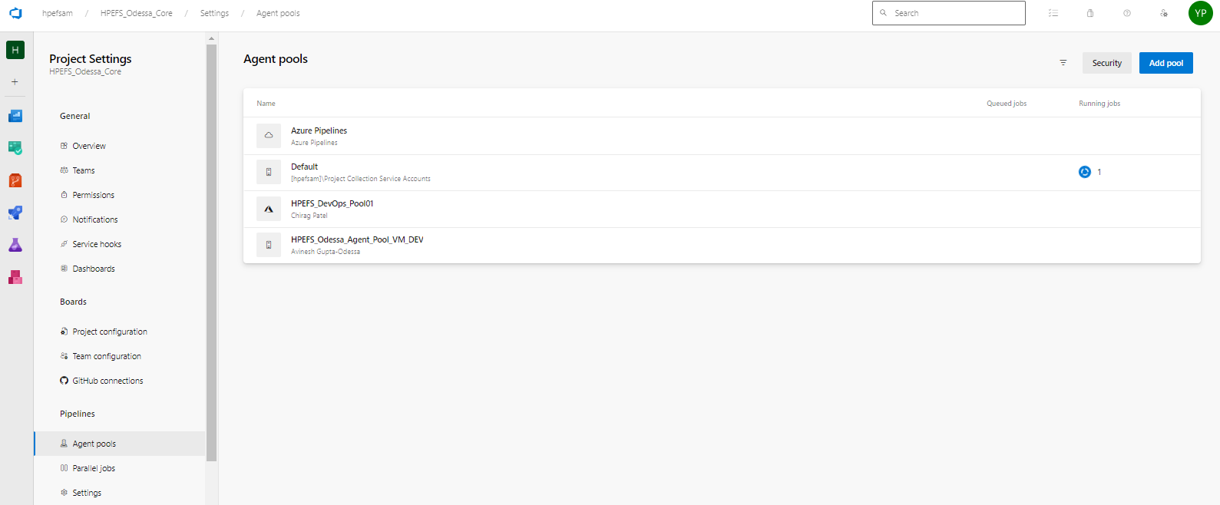

Add agent pool as below.

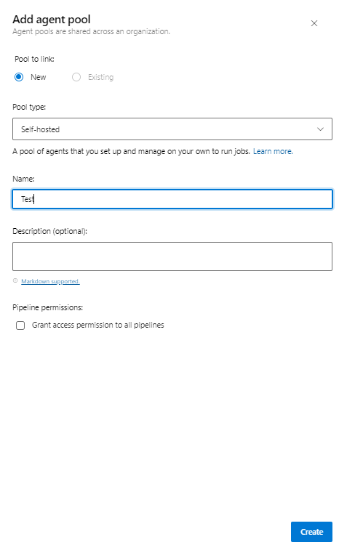

#### 3.1.5.2 Downloading an Agent tool (New agent pool -> Analytics -> New Agent).

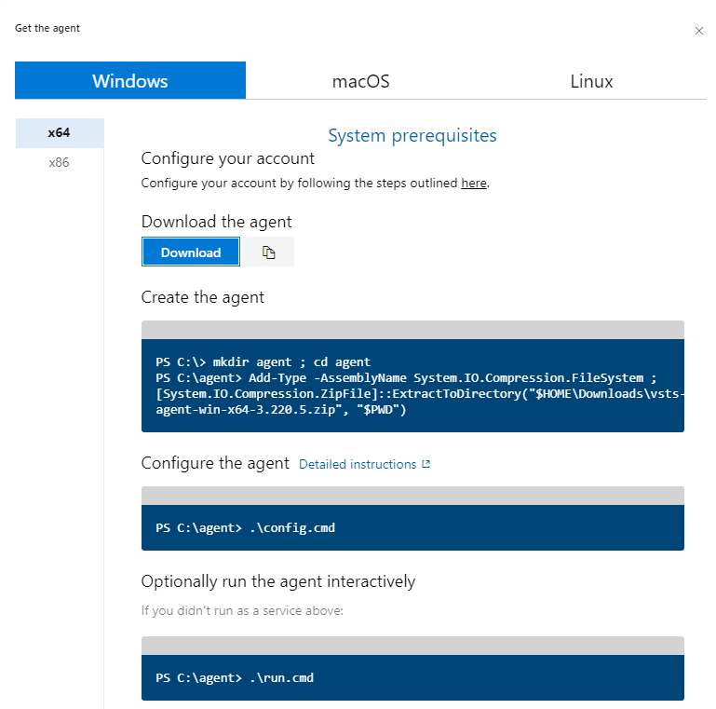

#### 3.1.5.3 Installing and configurating this Agent within VM

##### 3.1.5.3.1 Installing this Agent within VM

CMD – hostname (check the hostname is correct or not)

Downloaded agent.

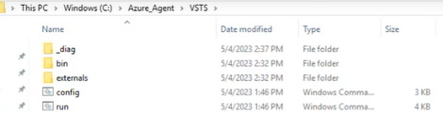

##### 3.1.5.3.2 Open text file and add all the necessary details below.

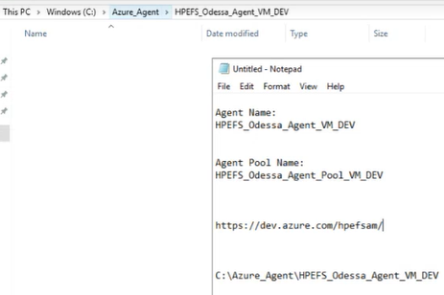

##### 3.1.5.3.3 Create access token as below snapshot.

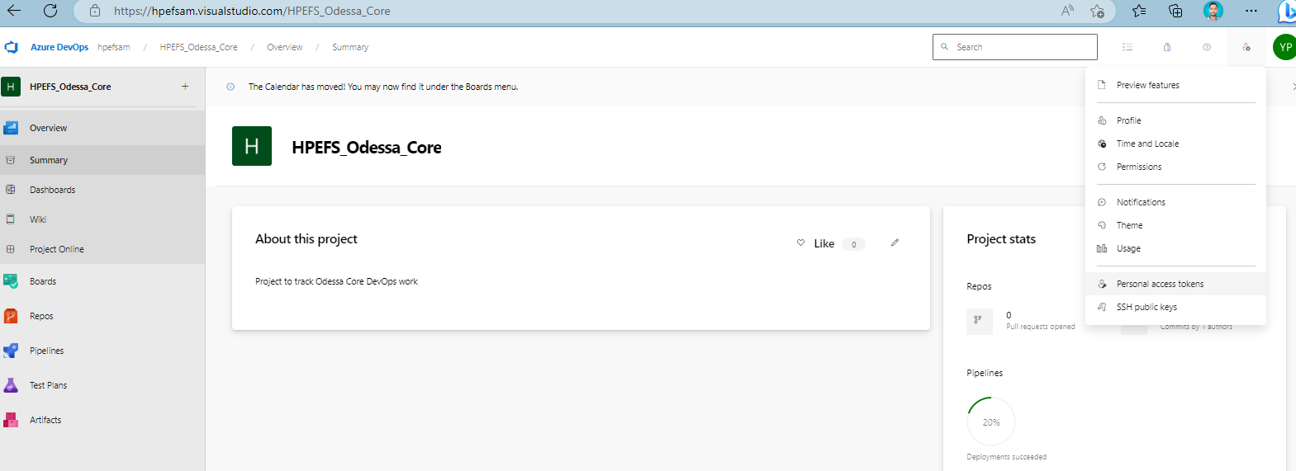

##### 3.1.5.3.4 Create access token and copy it.

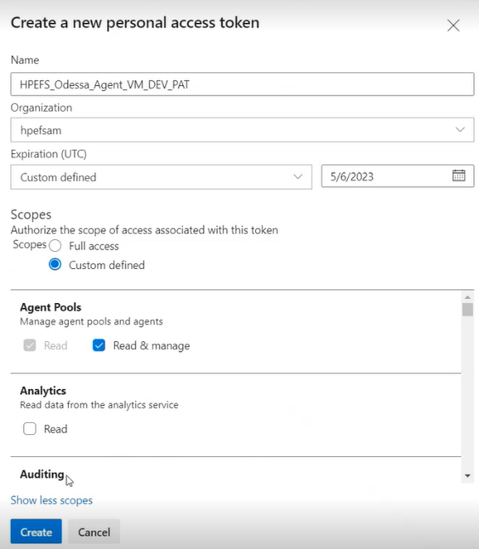

Then create it.

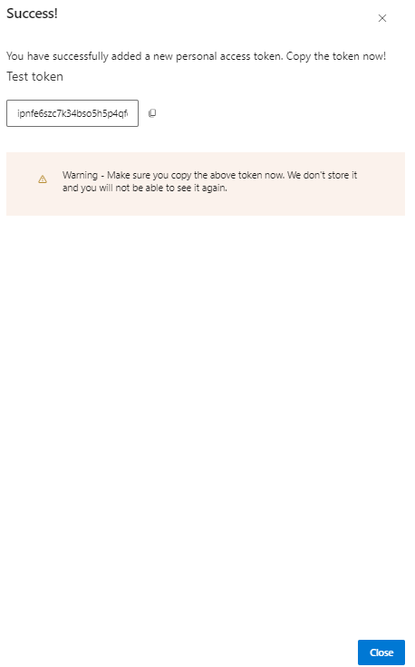

And copy it to text file.

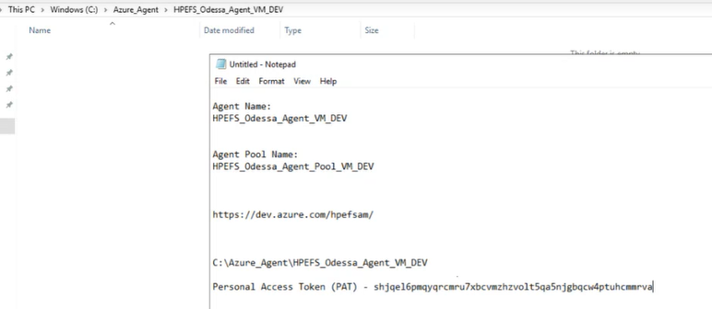

##### 3.1.5.3.5 Open command prompt in administrative mode.

##### 3.1.5.3.6 Copy VSTS path and paste it to CMD prompt and then press enter.

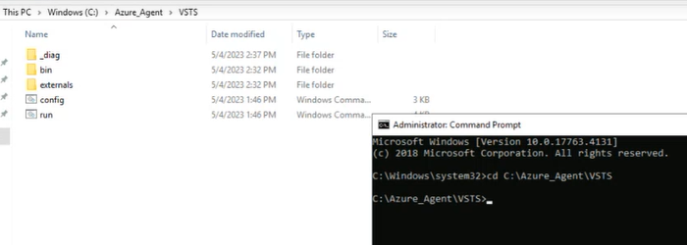

##### 3.1.5.3.7 Text config.cmd and then press enter as below.

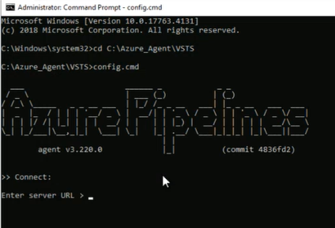

##### 3.1.5.3.8 Enter URL and then paste Personal Access Token after 2 times enter press (This may take some time) as below.

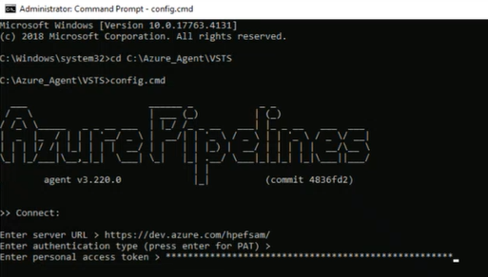

##### 3.1.5.3.9 Paste the agent pool name and then press the enter key.

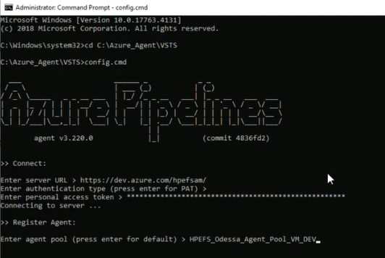

##### 3.1.5.3.10 Paste the agent’s name and then press the enter key.

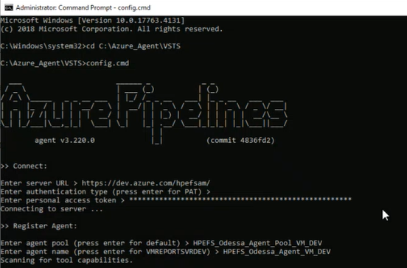

##### 3.1.5.3.11 Paste the agent path and press the enter key.

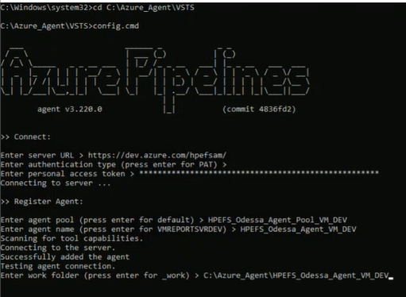

##### 3.1.5.3.12 Give answer for the security questions and press the enter key as below.

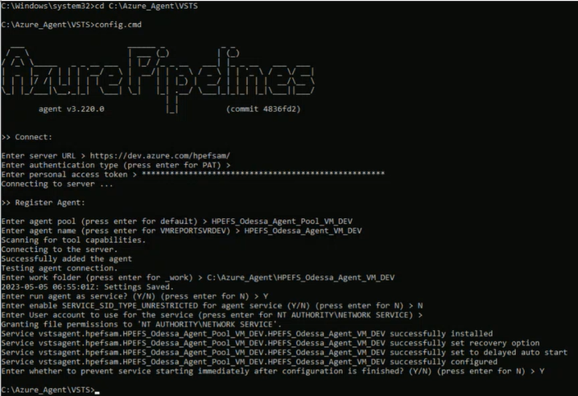

##### 3.1.5.3.13 Agent has been configured successfully so need to check the status below.

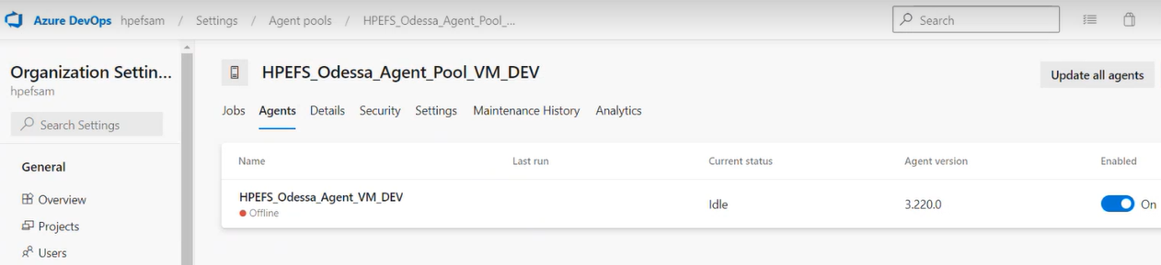

##### 3.1.5.3.14 Search the newly created agent pool in services.

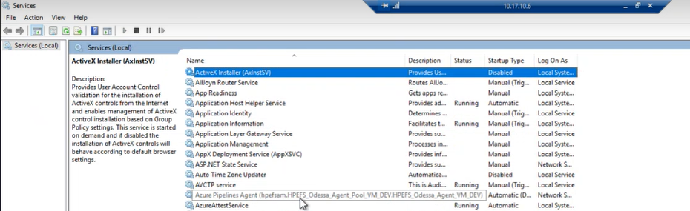

##### 3.1.5.3.15 Press right click and check the properties of the newly created agent pool.

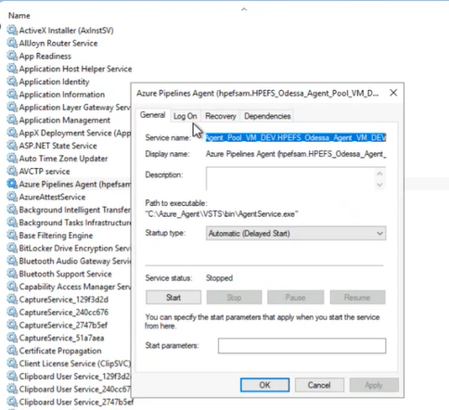

##### 3.1.5.3.16 Click on logon and then browse it.

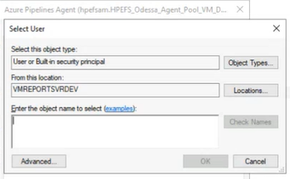

##### 3.1.5.3.17 Check the domain name below.

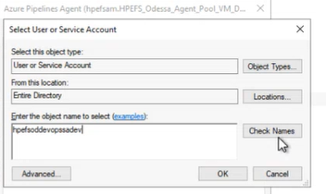

##### 3.1.5.3.18 Click on Ok and then add the password and apply it.

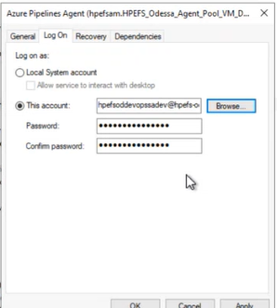

##### 3.1.5.3.19 After the above configuration we need to start the newly created agent pool service.

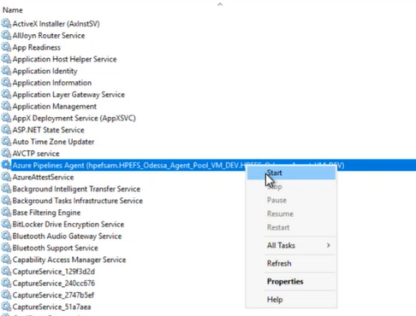

##### 3.1.5.3.20 Configure the newly created agent pool in release pipeline as below snapshot and test it.

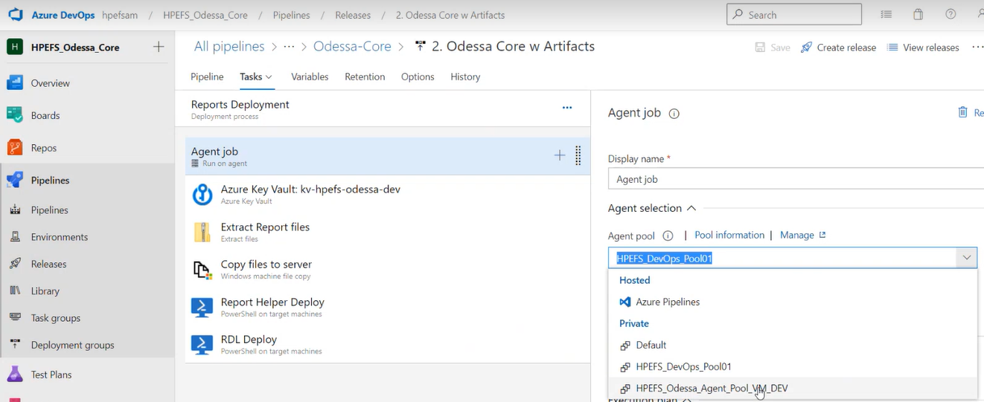

##### 3.1.5.3.21 Self hosted agent pool has been configured successfully.

### 3.1.6 Azure DevOps - All Pipeline Structure

Attached snapshots for all available release pipeline folder structure.

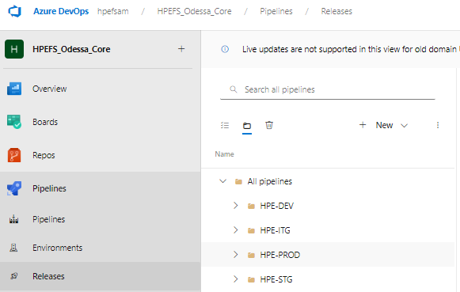

## 3.2 DevOps Authorization Configuration

### 3.2.1 Approval Matrix

HPE to provide approval matrix for release execution. This must be configured within Production DevOps pipeline.

### 3.2.2 Type of Approval Methods

1. Any one user (Any one configured user approval needed)
2. In sequence (All configured users approval needed in sequence)
3. Any order (All configured users approval needed in any order)

### 3.2.3 Steps for configuring Authorization Workflow

#### 3.2.3.1 Click on Pre-Deployment Condition as shown below.

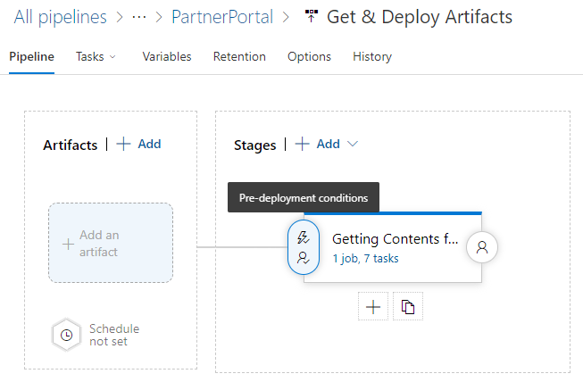

#### 3.2.3.2 Enable Pre-Deployment Approval

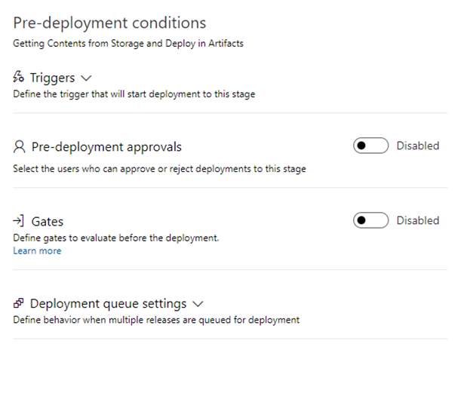

#### 3.2.3.3 Add approvers with approver order.

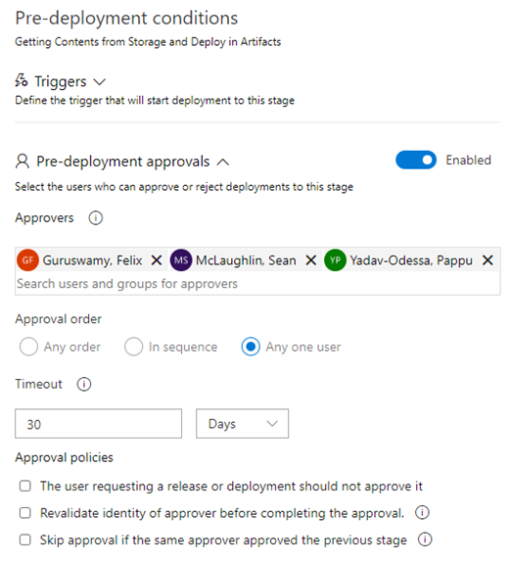

#### 3.2.3.4 Save the edited pipeline.

#### 3.2.3.5 Create release.

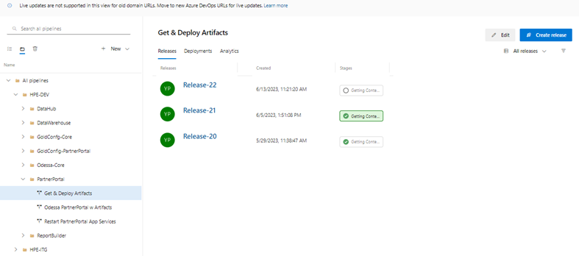

#### 3.2.3.6 Add release version and create.

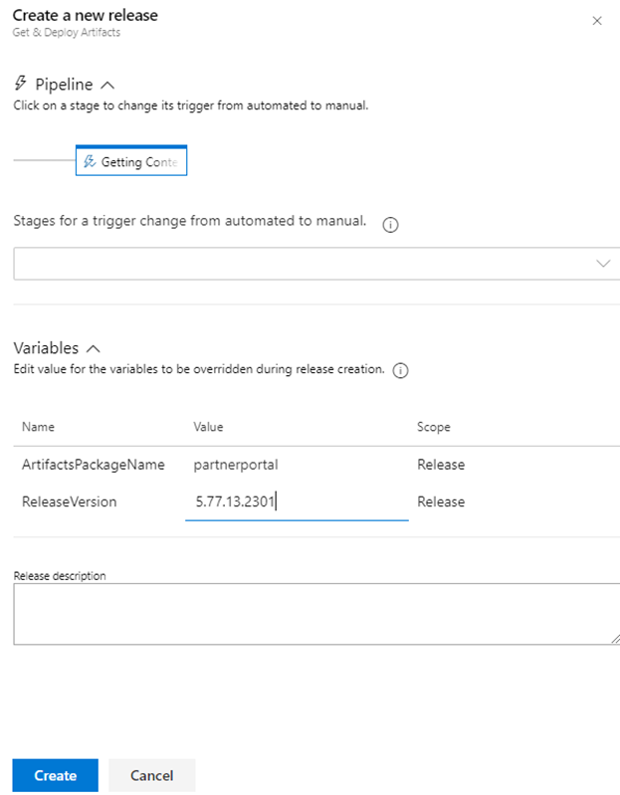

#### 3.2.3.7 Pipeline is pending for the approval (sent notification to all approvers)

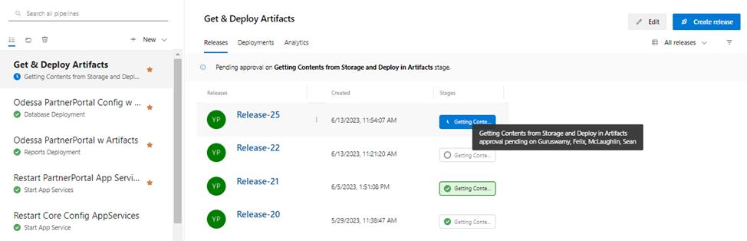

#### 3.2.3.8 Anyone (section 3.2.3.3) approver can approve/reject the release.

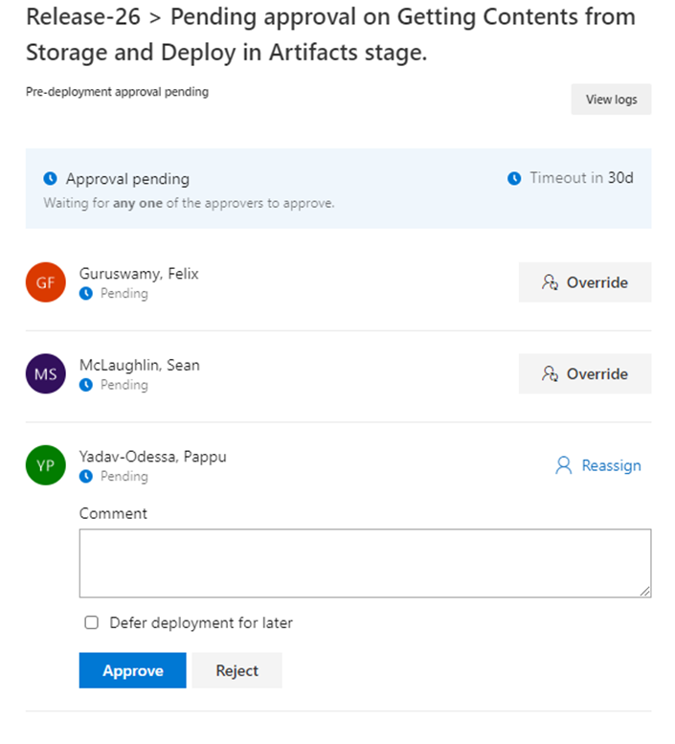

#### 3.2.3.9 If release approved then deployment will start or if release rejected then deployment will be cancelled.

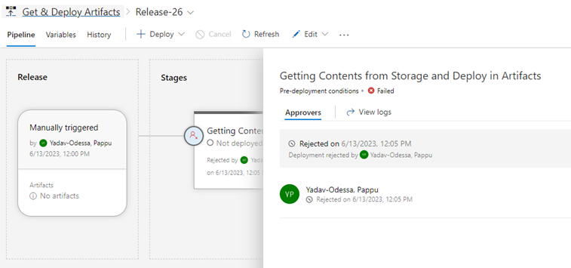

# 4. Artifact Details

## 4.1 Artifact Feed Names for All Applications

* HPEFS-Odessa-Apps

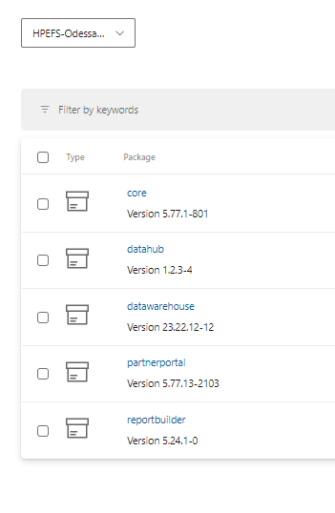

## 4.2 Package Naming Conventions

DevOps release activities uses the following storage container where application wise content folders are available, and each application folder contains the release artifacts which are uploaded by Odessa team prior to release and finally those are deployed within environments.

Note: DevOps pipeline follows the strict naming convention for folder names. Folder name must not use any special characters and even no spaces in words.

**Azure Release Content Storage Location –**

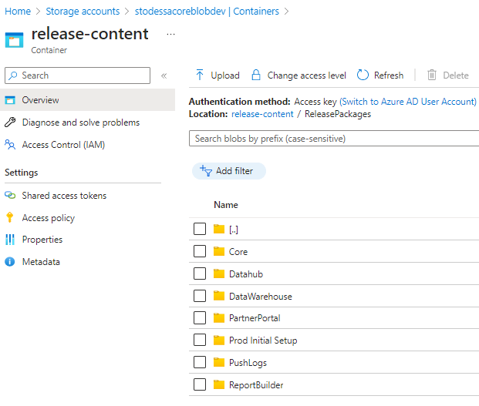

### 4.2.1 Core

It contains application release number ex 5.77.1.504

**Note:** *Version number is the bi-weekly release number. Application release number are same to Odessa release content folder names uploaded within above storage container.*

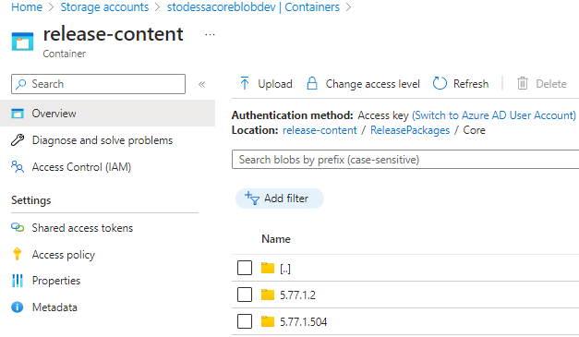

### 4.2.2 ReportBuilder

It contains application release number ex 5.23.2.0

**Note:** *Version number is the bi-weekly release number. Application release number are same to Odessa release content folder names uploaded within above storage container.*

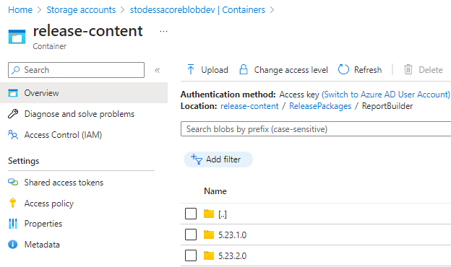

### 4.2.3 DataWarehouse

It contains application release number ex 6.22.12.0

**Note:** *Version number is the bi-weekly release number. Application release number are same to Odessa release content folder names uploaded within above storage container.*

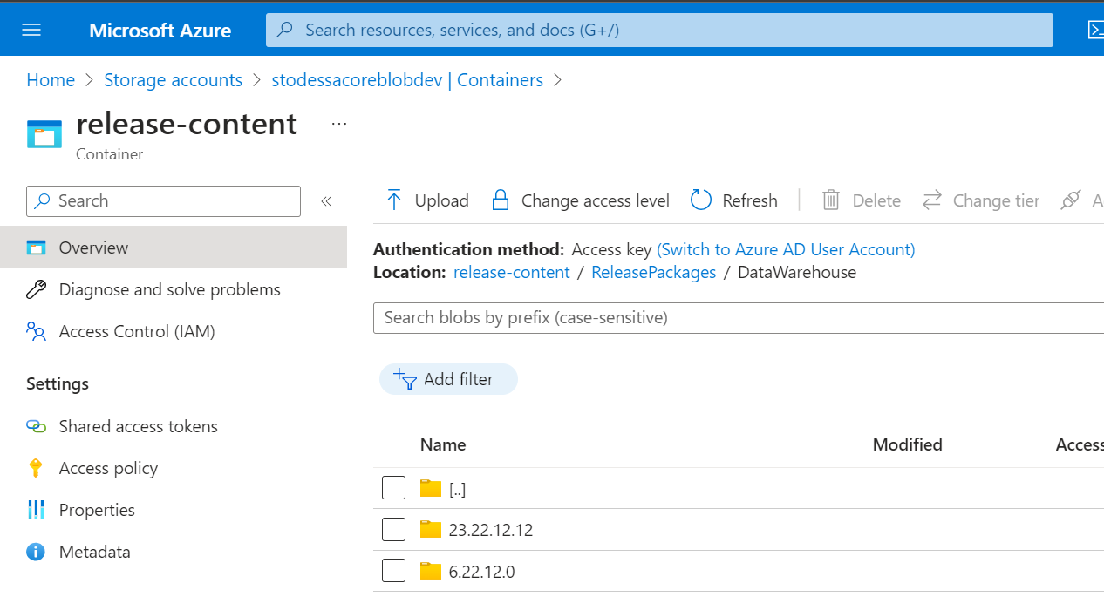

### 4.2.4 PartnerPortal

It contains application release number ex 5.77.13.2002

**Note:** *Version number is the bi-weekly release number. Application release number are same to Odessa release content folder names uploaded within above storage container.*

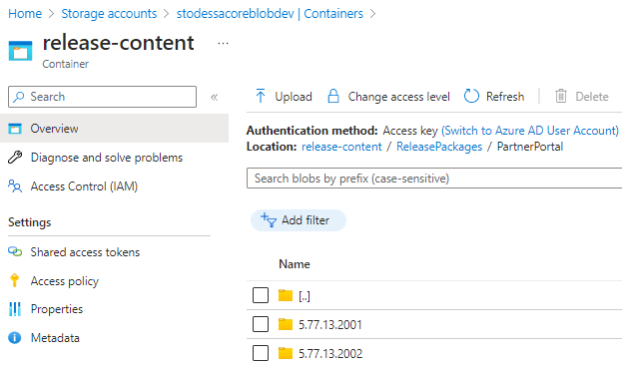

### 4.2.5 DataHub

It contains application release number ex 5.3.1.2

**Note:** *Version number is the bi-weekly release number. Application release number are same to Odessa release content folder names uploaded within above storage container.*

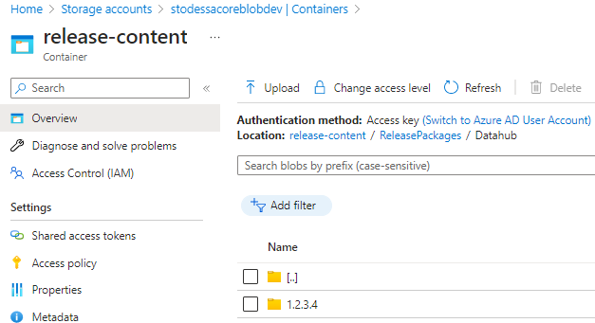

## 4.3 Artifact Details

### 4.3.1 **Core**

|  |  |
| --- | --- |
| **Storage Location for Core Artifacts** | **Description** |
|  | ReleasePackages/Core/{ReleaseVersion}/   * LessorPortal.zip -> {App service contents} * WebAPI.zip -> {Api service contents} * DocPortal.zip -> {Doc portal service contents} * WindowsService.zip -> App_Data/jobs/continuous/WindowsService/{Batch job service contents} * PricingService.zip -> {contents} * Database.zip -> DBScripts/DDL/{contents}, DBScripts/DML/{contents}, TestAutomation/{contents}, AuditDB/{SQL MI contents} * Reports.zip -> RDLs/{contents}, ReportHelper/{Report server contents} * BusinessConfiguration -> Application configuration |

### 4.3.2 ReportBuilder

|  |  |
| --- | --- |
| **Storage Location for Core Artifacts** | **Description** |
|  | ReleasePackages/ReportBuilder/{ReleaseVersion}   * WebPortal.zip -> {App service contents} * RDLService.zip -> {Report generation service contents} * DB.zip -> Scripts/{contents} * WindowsService.zip -> App_Data/jobs/continuous/WindowsService/{Batch job service contents} |

### 4.3.3 DataWarehouse

|  |  |
| --- | --- |
| **Storage Location for Core Artifacts** | **Description** |
|  | ReleasePackages/DataWarehouse/{ReleaseVersion}   * Engine.zip -> {Engine contents} * Build.zip -> {Build contents} * Documents.zip -> {Documents} * Scripts.zip -> UpgradeScripts /{contents}   Note: Either content will have Build or Engine but both will not be there. |

### 4.3.4 PartnerPortal

|  |  |
| --- | --- |
| **Storage Location for Core Artifacts** | **Description** |
|  | ReleasePackages/PartnerPortal/{ReleaseVersion}/   * WebApp.zip -> {App service contents} * WebAPI.zip -> {Api service contents} * DocPortal.zip -> {Doc portal service contents} * WindowsService.zip -> App_Data/jobs/continuous/WindowsService/{Batch job service contents} * Database.zip -> DBScripts/DDL/{contents}, DBScripts/DML/{contents}, * Reports.zip -> RDLs/{contents}, ReportHelper/{Report server contents} |

### 4.3.5 Datahub

|  |  |
| --- | --- |
| **Storage Location for Core Artifacts** | **Description** |
|  | ReleasePackages/Datahub/{ReleaseVersion}   * Engine.zip -> {Engine contents} * Database.zip -> DBScripts/Core/{contents}, DBScripts/Datahub/{contents}, |

# 5. Odessa Core Pipeline Setup

## 5.1 Pipeline Setup – DEV

### 5.1.1 Prerequisite Configuration/Permissions for DEV

Below table contains the permissions granted for DEV environment and are the pre-requisite configuration for DevOps Pipeline setup.

**Note: Similar permissions are required to be granted for higher environments to set up DevOps Pipeline.**

|  |  |  |  |
| --- | --- | --- | --- |
| **Type/**  **Category** | **Pre-configuration Permission Tasks** | **Object/**  **Resource Name** | **Notes** |
| Azure Service Principal | Create DevOps Service Principal (SP) | **Service Connection –**  odessa-hpefs-devops-sp-dev | This is the first step where SP to be created in Azure |
| DevOps  Service Connection | Create DevOps Service Connection (SC) by pointing to above SP | **Service Principal-**  odessa-hpefs-devops-sp-dev | Once we have above SC then create SP in DevOps by pointing to this SP |
| DevOps  Artifacts | Add Contributor Access to Project Collection Build Service | **Path -** Azure Devops->Artifacts->Settings->Permission->  Permission - Contributor | By default, permission is set to – Collaborative which needs to be updated with Contributor access.  This has been already given so no further access is needed for higher environments. |
| Azure VMSS | Granting access to VM Scale-set on Storage Account’s container | **VMSS Name –**vmssdevopsnonp  Storage Container Name – stodessacoreblobdev  **IAM Role -** Storage Blob Data Reader | This access has been given already so no further access is needed for higher environments. |
| Azure App Services | Grant access to SP on Core app services | **App services -**  app-hpefs-odessa-appserver-dev  app-hpefs-odessa-apiserver-dev  app-hpefs-odessa-batchjobs-dev  app-hpefs-odessa-docportal-dev  **IAM Role –** Contributor  **SP -** odessa-hpefs-devops-sp-dev | SP requires IAM permission on App services for deployment |
| Azure Key Vault | Grant access policy to SP on Key Vault Secrets | **Key Vault –**  kv-hpefs-odessa-dev  **SP -** odessa-hpefs-devops-sp-dev  **IAM Role –** Contributor  Access Policy – Get and List | This permission is required to download credentials from Key Vault.  **Keys:**  odessa-hpefs-devops-db-username  odessa-hpefs-devops-db-password  odessa-hpefs-devops-rs-password  odessa-hpefs-devops-rs-username |
| Azure Report Server VM | Grant VM Admin permission to domain account within Report Server VM | **Domain Account** – hpefsoddevopssadev  **Report Server VM** – vmreportsvrdev / 10.17.10.6  **Permission** – Administrator Group | This permission is required on VM to deploy bulk RDL, helper files and to start and stop SSRS service. |
| Azure Report Server VM | Grant IAM roles to SP for Report Server VM | **Report Server VM** – vmreportsvrdev / 10.17.10.6  **IAM Roles** - Contributor, Virtual Machine Administrator Login | These permissions are needed to have access on Report Server VM. |
| Azure Report Server VM | Create Inbound port within Report Server VM for Remote Powershell script execution | **Port No** – 5986  **Report Server VM** – vmreportsvrdev / 10.17.10.6 | Need to create Inbound Port  **Reference link –** [Configuring WinRM over HTTPS to enable PowerShell remoting](https://www.microsoft.com/en-gb/industry/blog/technetuk/2016/02/11/configuring-winrm-over-https-to-enable-powershell-remoting/). |
| Azure Report Server VM | Create certificate within Report Server VM for Remote Powershell script execution | **Self Signed Certificate –** vmreportsvrdev (Friendly Name)  **Report Server VM –**  vmreportsvrdev / 10.17.10.6 | For DEV environment, Self-signed certificate is used. TBD if CA certificate can be used.  For Higher environment this is recommended to have CA certificate.  **Reference link –** [Configuring WinRM over HTTPS to enable PowerShell remoting](https://www.microsoft.com/en-gb/industry/blog/technetuk/2016/02/11/configuring-winrm-over-https-to-enable-powershell-remoting/). |
| Azure SQL Mi | Grant IAM role to SQL MI for SP | **SQL Mi** –sqlmi-odessa-dev  **SP** –odessa-hpefs-devops-sp-dev  **IAM Role** - Contributor | Permission to SP for accessing SQL Mi |
| Azure SQL Mi | Create new SQL user for DevOps within SQL Mi and grant sys_admin roles | **Local SQL User –** OdessaDevOpsUser  **SQL Mi –** sqlmi-odessa-dev  **Roles –** sys_admin | Permission needed for deploying DDL, DML and Job creation related scripts |
| Azure App Configuration | Grant IAM role to SP for App Configuration | **App Configuration Name –** appcs-hpefs-odessa-dev  **SP –** odessa-hpefs-devops-sp-dev  **IAM Role -** App Configuration Data Reader Role, Owner/Custom Read/Write/Delete (still pending) | Permission to read/update/delete App configuration keys.  Requested for MS support ticket |

### **5.1.2 Enable Remote Execution from DevOps Pipeline within Report Server VM**

To enable remove power shell execution, refer the following steps –

Reference Link - [Configuring WinRM over HTTPS to enable PowerShell remoting](https://www.microsoft.com/en-gb/industry/blog/technetuk/2016/02/11/configuring-winrm-over-https-to-enable-powershell-remoting/).

1. **Enable Port 5986**

Login to VM->Open Windows FireWall with Advanced Security->

Verify Port 5986 is allowed or not in Inbound Rule, If not allowed and Rule exist then enable it.

If Rule is not existed create a new inbound Rule

* Open “Windows Defender Firewall” and click on “Advance settings” and click on “Inbound Rules” and create new inbound rule.

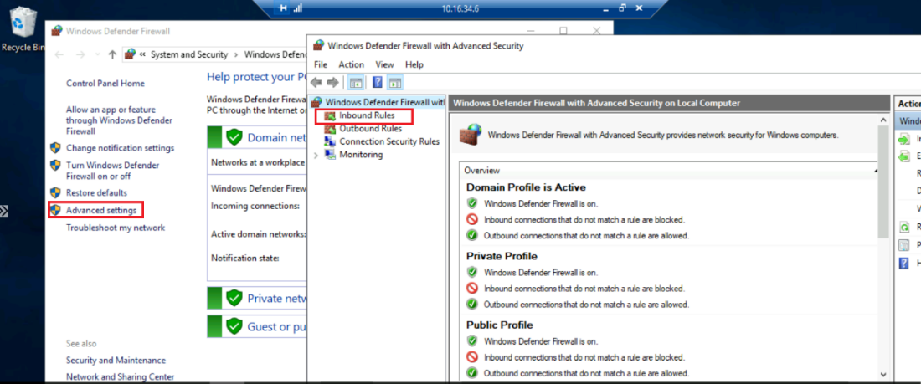

* Enable Inbound 5986 port as below -

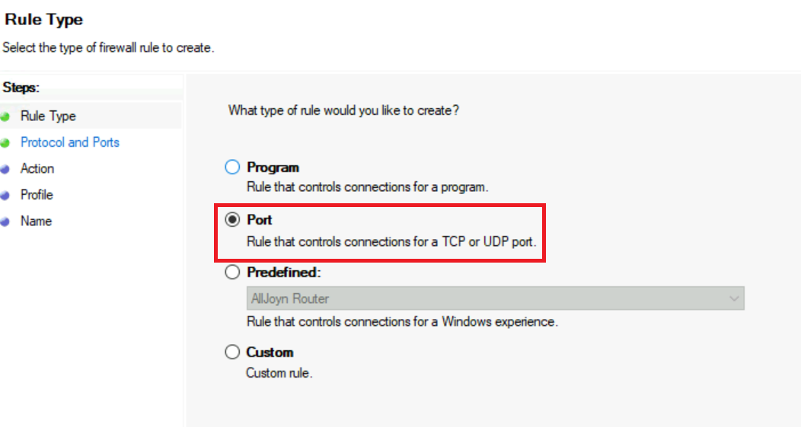

Step 3:

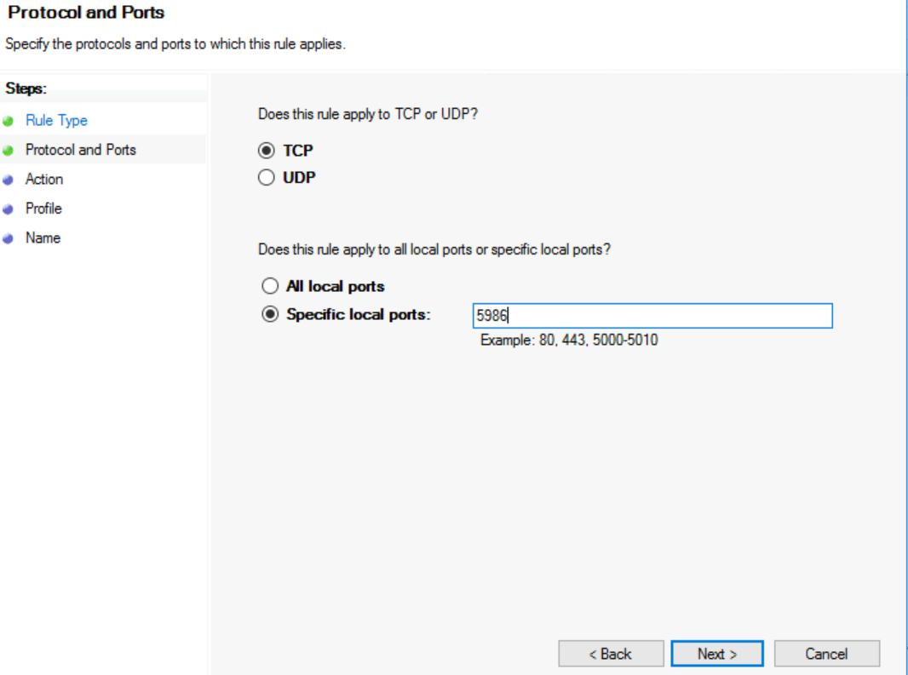

Step 4:

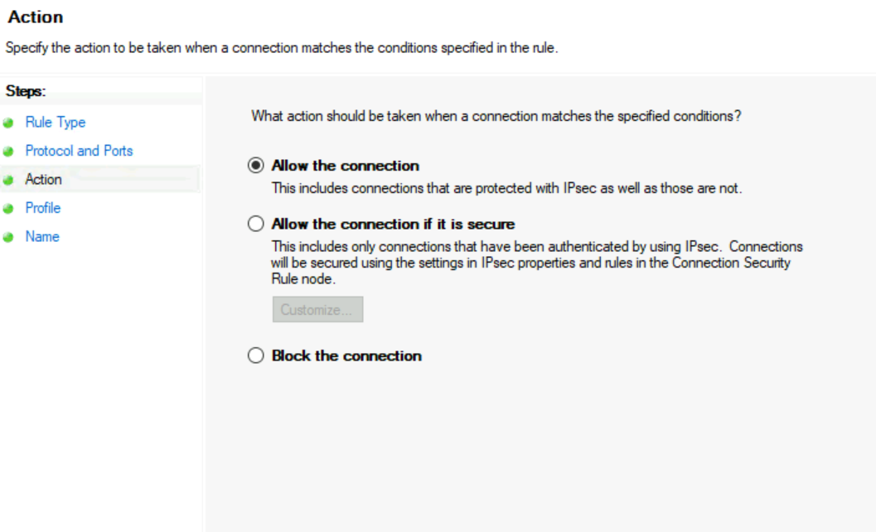

Step 5:

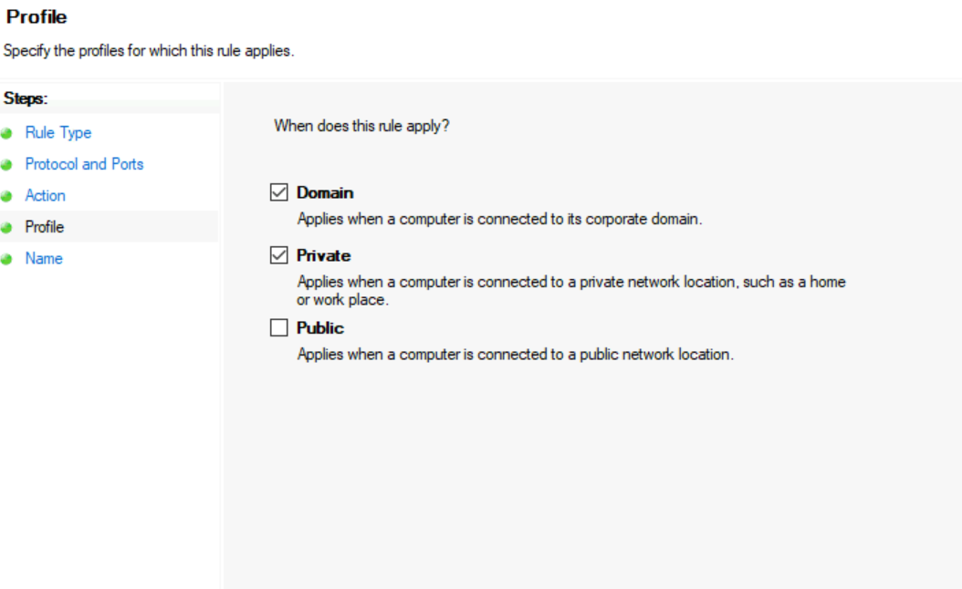

Step 6:

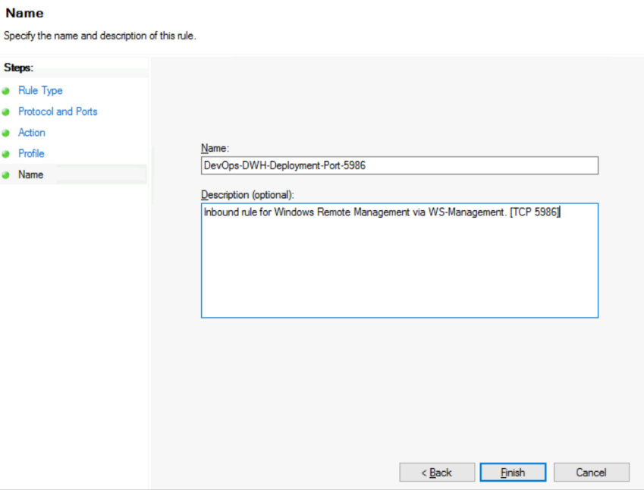

1. **Create Self-signed certificate**

* Logon to the Server using RDP.
* Open Windows PowerShell ISE in admin mode and execute the following command and copy the thumbprint.
* Provide VM DNS name and Friendly Name for below yellow highlighted color- and execute it.

|  |
| --- |
| New-SelfSignedCertificate -DnsName '<vmdatamartdev.hpefs-odessa.com>' -CertStoreLocation Cert:\LocalMachine\My -FriendlyName 'vmdatamartdev' |

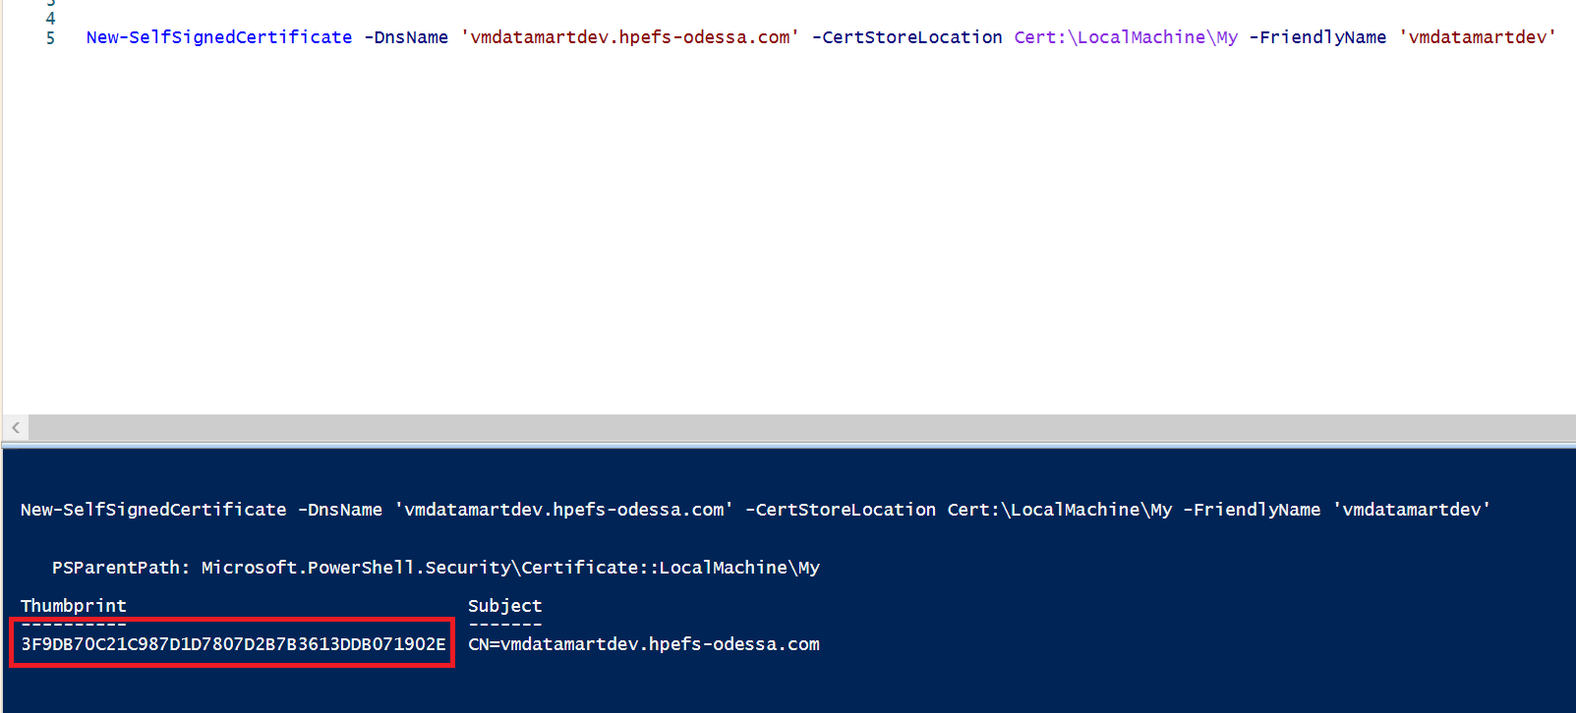

1. **Configure WinRM to listen on 5986.**

* Open command prompt in admin mode
* Run the following command, pasting your new certificate’s thumbprint into the command (all on one line)

|  |
| --- |
| winrm create winrm/config/Listener?Address=*+Transport=HTTPS @{Hostname="vmdatamartdev.hpefs-odessa.com"; CertificateThumbprint="3F9DB70C21C987D1D7807D2B7B3613DDB071902E"} |

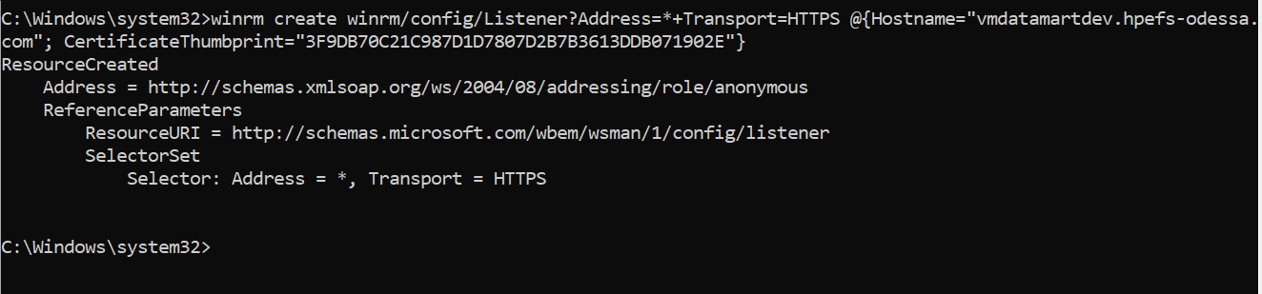

### 5.1.3 Automated Pipeline Deployment Workflow

**Note:**

* **Doc Portal service** is only deployed in **DEV & ITG** environments. This service is not applicable to deploy in STG and Production (As shown in below diagram).
* **For STG and Production, deployment should be done for all HA (High Availability) instances.**

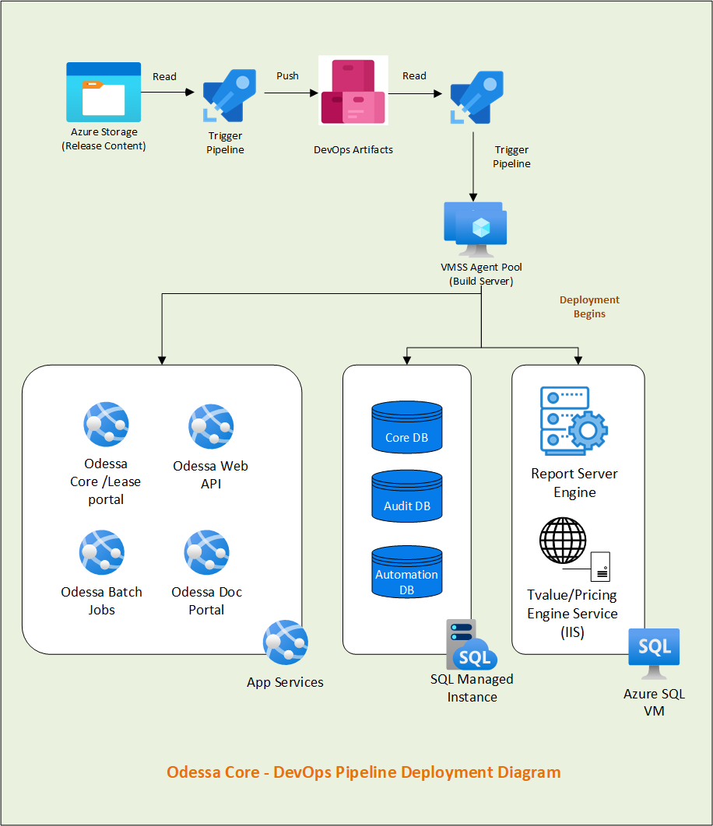

### 5.1.4 Release Pipeline Setup

Automation release pipeline setup for the content deployment to app services as below

**Note – Only DEV environment contains the pipeline for downloading artifacts from Storage Container and Uploading inside Azure DevOps Artifacts section.**

#### **5.1.4.1 Pipeline -** Get & Deploy Artifacts

* + - **Job -** Getting Contents from Storage and Deploy in Artifacts
    - **Task List -**

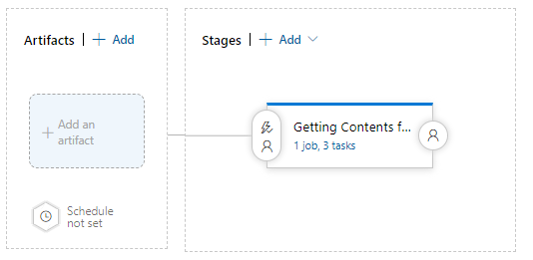

#### **5.1.4.2 Pipeline -** Odessa Core w Artifacts

* + - **Job – Read Artifacts**
    - **Task List –**

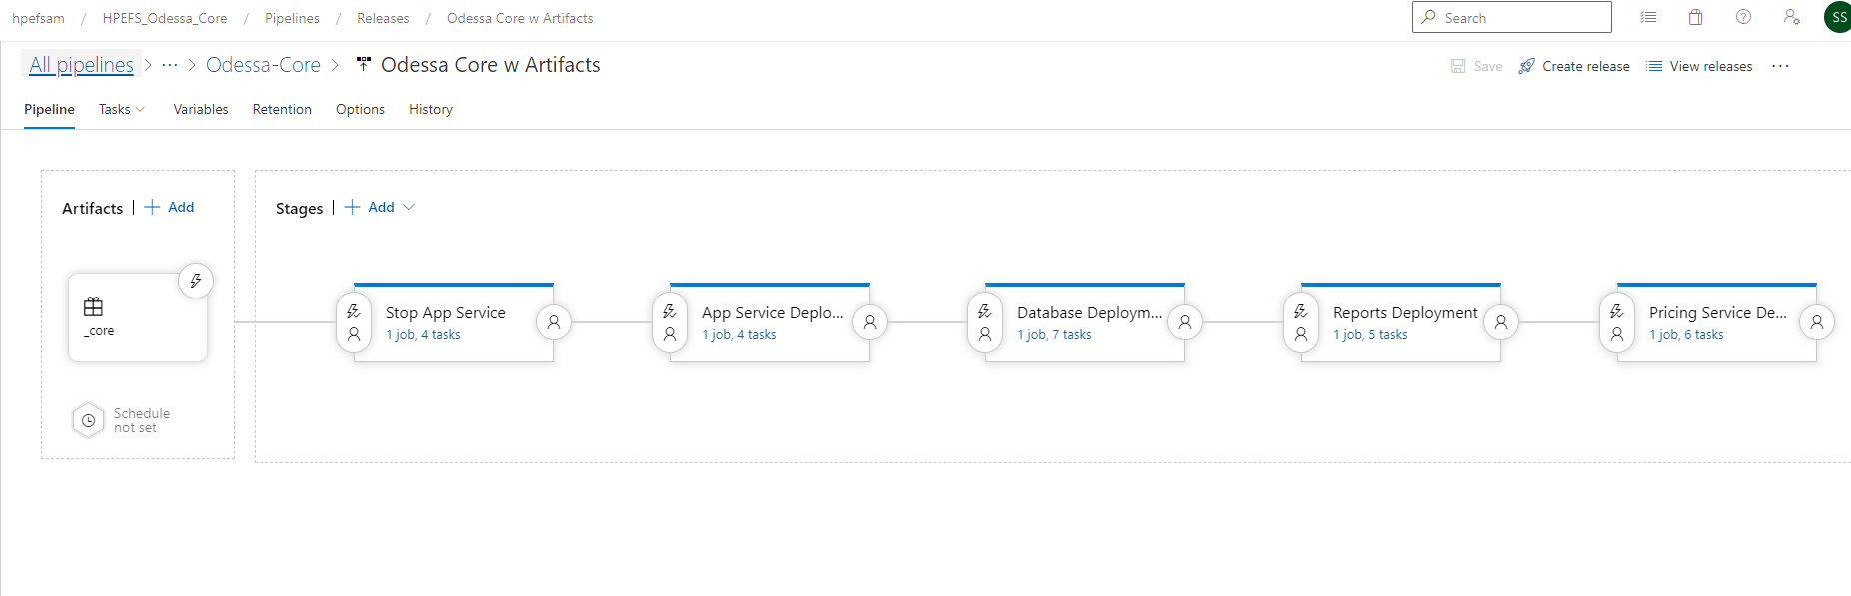

#### 5.1.4.3 Pipeline **-** Restart Core App Services

* **Job –** Start App Services
* **Task List -**

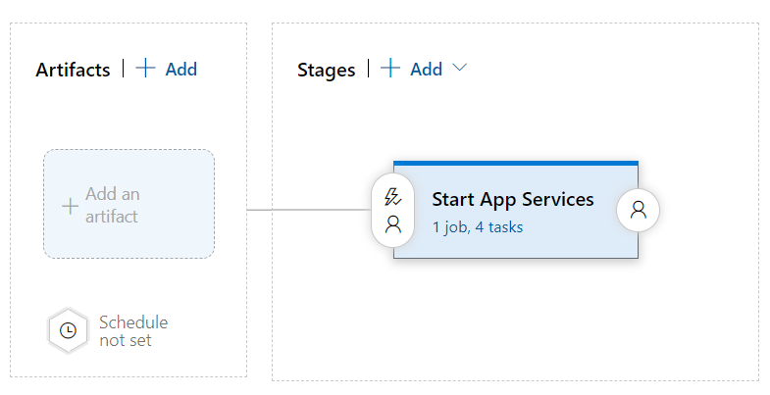

## 5.2 Pipeline Setup – ITG (HPE owned)

### 5.2.1 Prerequisite Configuration/Permissions for ITG

Below table contains the permissions granted for DEV environment and are the pre-requisite configuration for DevOps Pipeline setup.

NOTE: Below access is to be reviewed before proceeding for granting access.

**Note: Similar permissions are required to be granted for higher environments to set up DevOps Pipeline.**

|  |  |  |  |
| --- | --- | --- | --- |
| **Type/**  **Category** | **Pre-configuration Permission Tasks** | **Object/**  **Resource Name** | **Notes** |
| Azure Service Principal | Create DevOps Service Principal (SP) | **Service Connection –**  hpefs-odessa-devops-sp-itg | This is the first step where SP to be created in Azure |
| DevOps  Service Connection | Create DevOps Service Connection (SC) by pointing to above SP | **Service Principal-**  hpefs-odessa-devops-sp-itg | Once we have above SC then create SP in DevOps by pointing to this SP |
| DevOps  Artifacts | Add Contributor Access to Project Collection Build Service | **Path -** Azure Devops->Artifacts->Settings->Permission->  Permission - Contributor | By default, permission is set to – Collaborative which needs to be updated with Contributor access.  This has been already given so no further access is needed for higher environments. |
| Azure VMSS | Granting access to VM Scale-set on Storage Account’s container | **VMSS Name –**vmssdevopsnonp  Storage Container Name – stodessacoreblobdev  **IAM Role -** Storage Blob Data Reader | This access has been given already so no further access is needed for higher environments. |
| Azure App Services | Grant access to SP on Core app services | **App services -**  app-hpefs-odessa-appserver-itg  app-hpefs-odessa-apiserver-itg  app-hpefs-odessa-batchjobs-itg  app-hpefs-odessa-docportal-itg  **IAM Role –** Contributor  **SP -** hpefs-odessa-devops-sp-itg | SP requires IAM permission on App services for deployment |
| Azure Key Vault | Grant access policy to SP on Key Vault Secrets | **Key Vault –**  kv-hpefs-odessa-itg  **SP -** hpefs-odessa-devops-sp-itg  **IAM Role –** Contributor  Access Policy – Get and List | This permission is required to download credentials from Key Vault.  **Keys:**  odessa-hpefs-devops-db-username  odessa-hpefs-devops-db-password  odessa-hpefs-devops-rs-password  odessa-hpefs-devops-rs-username |
| Azure Report Server VM | Grant VM Admin permission to domain account within Report Server VM | **Domain Account** – hpefsoddevopssadev  **Report Server VM** – vmreportsvritg / 10.17.18.5  **Permission** – Administrator Group | This permission is required on VM to deploy bulk RDL, helper files and to start and stop SSRS service. |
| Azure Report Server VM | Grant IAM roles to SP for Report Server VM | **Report Server VM** – vmreportsvritg / 10.17.18.5  **IAM Roles** - Contributor, Virtual Machine Administrator Login | These permissions are needed to have access on Report Server VM. |
| Azure Report Server VM | Create Inbound port within Report Server VM for Remote Powershell script execution | **Port No** – 5986  **Report Server VM** – vmreportsvritg / 10.17.18.5 | Need to create Inbound Port  **Reference link –** [Configuring WinRM over HTTPS to enable PowerShell remoting](https://www.microsoft.com/en-gb/industry/blog/technetuk/2016/02/11/configuring-winrm-over-https-to-enable-powershell-remoting/). |
| Azure Report Server VM | Create certificate within Report Server VM for Remote Powershell script execution | **Self-Signed Certificate –** vmreportsvrdev (Friendly Name)  **Report Server VM –**  vmreportsvritg / 10.17.18.5 | **Reference link –** [Configuring WinRM over HTTPS to enable PowerShell remoting](https://www.microsoft.com/en-gb/industry/blog/technetuk/2016/02/11/configuring-winrm-over-https-to-enable-powershell-remoting/). |
| Azure SQL Mi | Grant IAM role to SQL MI for SP | **SQL Mi** –sqlmi-odessa-dev  **SP** –hpefs-odessa-devops-sp-itg  **IAM Role** - Contributor | Permission to SP for accessing SQL Mi |
| Azure SQL Mi | Create new SQL user for DevOps within SQL Mi and grant sys_admin roles | **Local SQL User –** OdessaDevOpsUser  **SQL Mi –** sqlmi-odessa-dev  **Roles –** sys_admin | Permission needed for deploying DDL, DML and Job creation related scripts |
| Azure App Configuration | Grant IAM role to SP for App Configuration | **App Configuration Name –** appcs-hpefs-odessa-itg  **SP – hpefs-odessa-devops-sp-itg**  **IAM Role -** App Configuration Data Reader Role, Owner/Custom Read/Write/Delete (still pending) | Permission to read/update/delete App configuration keys. |

### **5.2.2 Enable Remote Execution from DevOps Pipeline within Report Server VM**

To enable remove power shell execution, refer the following steps –

Reference Link - [Configuring WinRM over HTTPS to enable PowerShell remoting](https://www.microsoft.com/en-gb/industry/blog/technetuk/2016/02/11/configuring-winrm-over-https-to-enable-powershell-remoting/).

1. **Enable Port 5986**

Login to VM->Open Windows FireWall with Advanced Security->

Verify Port 5986 is allowed or not in Inbound Rule, if not allowed and Rule exist then enable it.

If Rule is not existed create a new inbound Rule

* Open “Windows Defender Firewall” and click on “Advance settings” and click on “Inbound Rules” and create new inbound rule.



* Enable Inbound 5986 port as below -



Step 3:



Step 4:



Step 5:



Step 6:



1. **Create Self-signed certificate**

* Logon to the Server using RDP.
* Open Windows PowerShell ISE in admin mode and execute the following command and copy the thumbprint.
* Provide VM DNS name and Friendly Name for below yellow highlighted color- and execute it.

|  |
| --- |
| New-SelfSignedCertificate -DnsName '<vmdatamartdev.hpefs-odessa.com>' -CertStoreLocation Cert:\LocalMachine\My -FriendlyName 'vmdatamartdev' |



1. **Configure WinRM to listen on 5986.**

* Open command prompt in admin mode
* Run the following command, pasting your new certificate’s thumbprint into the command (all on one line)

|  |
| --- |
| winrm create winrm/config/Listener?Address=*+Transport=HTTPS @{Hostname="vmdatamartdev.hpefs-odessa.com"; CertificateThumbprint="3F9DB70C21C987D1D7807D2B7B3613DDB071902E"} |



### 5.2.3 Automated Pipeline Deployment workflow

**Note:**

* **Doc Portal service** is only deployed in **DEV & ITG** environments. This service is not applicable to deploy in STG and Production (As shown in below diagram).
* **For STG and Production, deployment should be done for all HA (High Availability) instances.**



### 5.2.4 Release Pipeline Setup

Automation release pipeline setup for the content deployment to app services as below

**Note – Only DEV environment contains the pipeline for downloading artifacts from Storage Container and Uploading inside Azure DevOps Artifacts section.**

#### 5.2.4.1 Pipeline – Odessa Core w Artifacts

* + - **Job – Read Artifacts**
    - **Task List –**



#### 5.2.4.2 Pipeline – Start Core App Services

* **Job –** Start App Services
* **Task List -**



## 5.3 Pipeline Setup – STG (HPE Owned)

### 5.3.1 Prerequisite Configuration/Permissions for STG

Below table contains the permissions granted for STG environment and are the pre-requisite configuration for DevOps Pipeline setup.

NOTE: Below access is to be reviewed before proceeding for granting access.

**Note: Similar permissions are required to be granted for higher environments to set up DevOps Pipeline.**

|  |  |  |  |
| --- | --- | --- | --- |
| **Type/**  **Category** | **Pre-configuration Permission Tasks** | **Object/**  **Resource Name** | **Notes** |
| Azure Service Principal | Create DevOps Service Principal (SP) | **Service Connection –**  hpefs-odessa-devops-sp-stg | This is the first step where SP to be created in Azure |
| DevOps  Service Connection | Create DevOps Service Connection (SC) by pointing to above SP | **Service Principal-**  hpefs-odessa-devops-sp-stg | Once we have above SC then create SP in DevOps by pointing to this SP |
| DevOps  Artifacts | Add Contributor Access to Project Collection Build Service | **Path -** Azure Devops->Artifacts->Settings->Permission->  Permission - Contributor | By default, permission is set to – Collaborative which needs to be updated with Contributor access.  This has been already given so no further access is needed for higher environments. |
| Azure VMSS | Granting access to VM Scale-set on Storage Account’s container | **VMSS Name –**vmssdevopsnonp  Storage Container Name – stodessacoreblobdev  **IAM Role -** Storage Blob Data Reader | This access has been given already so no further access is needed for higher environments. |
| Azure App Services | Grant access to SP on Core app services | **App services -**  app-hpefs-odessa-appserver-stg  app-hpefs-odessa-apiserver-stg  app-hpefs-odessa-batchjobs-stg  app-hpefs-odessa-docportal-stg  **IAM Role –** Contributor  **SP -** hpefs-odessa-devops-sp-stg | SP requires IAM permission on App services for deployment |
| Azure Key Vault | Grant access policy to SP on Key Vault Secrets | **Key Vault –**  kv-hpefs-odessa-stg  **SP -** hpefs-odessa-devops-sp-stg  **IAM Role –** Contributor  Access Policy – Get and List | This permission is required to download credentials from Key Vault. |
| Azure Report Server VM | Grant VM Admin permission to domain account within Report Server VM | **Domain Account** – hpefsoddevopssadev  **Report Server VM** – vmreportsvrstg1 / 10.17.26.4  Vmreportsvrstg2 / 10.17.26.7  **Permission** – Administrator Group | This permission is required on VM to deploy bulk RDL, helper files and to start and stop SSRS service. |
| Azure Report Server VM | Grant IAM roles to SP for Report Server VM | **Report Server VM** – vmreportsvrstg1 / 10.17.26.4  Vmreportsvrstg2 / 10.17.26.7  **IAM Roles** - Contributor, Virtual Machine Administrator Login | These permissions are needed to have access to Report Server VM. |
| Azure Report Server VM | Create Inbound port within Report Server VM for Remote Powershell script execution | **Port No** – 5986  **Report Server VM** – vmreportsvrstg1 / 10.17.26.4  Vmreportsvrstg2 / 10.17.26.7 | Need to create Inbound Port  **Reference link –** [Configuring WinRM over HTTPS to enable PowerShell remoting](https://www.microsoft.com/en-gb/industry/blog/technetuk/2016/02/11/configuring-winrm-over-https-to-enable-powershell-remoting/). |
| Azure Report Server VM | Create certificate within Report Server VM for Remote Powershell script execution | **Self-Signed Certificate –** vmreportsvrstg1 (Friendly Name)  **Report Server VM –**  vmreportsvrstg1 / 10.17.26.4  Vmreportsvrstg2 / 10.17.26.7 | **Reference link –** [Configuring WinRM over HTTPS to enable PowerShell remoting](https://www.microsoft.com/en-gb/industry/blog/technetuk/2016/02/11/configuring-winrm-over-https-to-enable-powershell-remoting/). |
| Azure SQL Mi | Grant IAM role to SQL MI for SP | **SQL Mi** –sqlmi-odessa-stg  **SP** –hpefs-odessa-devops-sp-stg  **IAM Role** - Contributor | Permission to SP for accessing SQL Mi |
| Azure SQL Mi | Create new SQL user for DevOps within SQL Mi and grant sys_admin roles | **Local SQL User –** OdessaDevOpsUser  **SQL Mi –** sqlmi-odessa-stg  **Roles –** sys_admin | Permission needed for deploying DDL, DML and Job creation related scripts |
| Azure App Configuration | Grant IAM role to SP for App Configuration | **App Configuration Name –** appcs-hpefs-odessa-stg  **SP – hpefs-odessa-devops-sp-stg**  **IAM Role -** App Configuration Data Reader Role, Owner/Custom Read/Write/Delete (still pending) | Permission to read/update/delete App configuration keys. |

### **5.3.2 Enable Remote Execution from DevOps Pipeline within Report Server VM**

To enable remove power shell execution, refer the following steps –

Reference Link - [Configuring WinRM over HTTPS to enable PowerShell remoting](https://www.microsoft.com/en-gb/industry/blog/technetuk/2016/02/11/configuring-winrm-over-https-to-enable-powershell-remoting/).

1. **Enable Port 5986**

Login to VM->Open Windows FireWall with Advanced Security->

Verify Port 5986 is allowed or not in Inbound Rule, if not allowed and Rule exist then enable it.

If Rule is not existed create a new inbound Rule

* Open “Windows Defender Firewall” and click on “Advance settings” and click on “Inbound Rules” and create new inbound rule.



* Enable Inbound 5986 port as below -



Step 3:



Step 4:



Step 5:



Step 6:



1. **Create Self-signed certificate**

* Logon to the Server using RDP.
* Open Windows PowerShell ISE in admin mode and execute the following command and copy the thumbprint.
* Provide VM DNS name and Friendly Name for below yellow highlighted color- and execute it.

|  |
| --- |
| New-SelfSignedCertificate -DnsName '<vmdatamartdev.hpefs-odessa.com>' -CertStoreLocation Cert:\LocalMachine\My -FriendlyName 'vmdatamartdev' |



1. **Configure WinRM to listen on 5986.**

* Open command prompt in admin mode
* Run the following command, pasting your new certificate’s thumbprint into the command (all on one line)

|  |
| --- |
| winrm create winrm/config/Listener?Address=*+Transport=HTTPS @{Hostname="vmdatamartdev.hpefs-odessa.com"; CertificateThumbprint="3F9DB70C21C987D1D7807D2B7B3613DDB071902E"} |



### 5.3.3 Automated Pipeline Deployment workflow

**Note:**

* **Doc Portal service** is only deployed in **DEV & ITG** environments. This service is not applicable to deploy in STG and Production (As shown in below diagram).
* **For STG and Production, deployment should be done for all HA (High Availability) instances.**

Hight Level Diagram

### 5.3.4 Release Pipeline Setup

Automation release pipeline setup for the content deployment to app services as below

**Note – Only DEV environment contains the pipeline for downloading artifacts from Storage Container and Uploading inside Azure DevOps Artifacts section.**

#### 5.3.4.1 Pipeline – Odessa Core w Artifacts

* + - **Job – Read Artifacts**
    - **Task List –**



#### 5.3.4.2 Pipeline – Start Core App Services

* **Job –** Start App Services
* **Task List -**



# 6. Gold Config - Core Pipeline Setup

## 6.1 Prerequisite Configuration/Permissions

Below table contains the permissions granted for gold config environment and are the pre-requisite configuration for DevOps Pipeline setup.

**Note: Similar permissions are required to be granted for higher environments to set up DevOps Pipeline.**

|  |  |  |  |
| --- | --- | --- | --- |
| **Type/**  **Category** | **Pre-configuration Permission Tasks** | **Object/**  **Resource Name** | **Notes** |
| Azure Service Principal | Create DevOps Service Principal (SP) | **Service Connection –**  odessa-hpefs-devops-sp-dev | This is the first step where SP to be created in Azure |
| DevOps  Service Connection | Create DevOps Service Connection (SC) by pointing to above SP | **Service Principal-**  odessa-hpefs-devops-sp-dev | Once we have above SC then create SP in DevOps by pointing to this SP |
| DevOps  Artifacts | Add Contributor Access to Project Collection Build Service | **Path -** Azure Devops->Artifacts->Settings->Permission->  Permission - Contributor | By default, permission is set to – Collaborative which needs to be updated with Contributor access.  This has already been given so no further access is needed for higher environments. |
| Azure VMSS | Granting access to VM Scale-set on Storage Account’s container | **VMSS Name –**vmssdevopsnonp  Storage Container Name – stodessacoreblobdev  **IAM Role -** Storage Blob Data Reader | This access has been given already so no further access is needed for higher environments. |
| Azure App Services | Grant access to SP on Core app services | **App services -**  app-hpefs-odessa-appserver-config  app-hpefs-odessa-batchjobs-config  **IAM Role –** Contributor  **SP -** odessa-hpefs-devops-sp-dev | SP requires IAM permission on App services for deployment |
| Azure Key Vault | Grant access policy to SP on Key Vault Secrets | **Key Vault –**  kv-hpefs-odessa-dev  **SP -** odessa-hpefs-devops-sp-dev  **IAM Role –** Contributor  Access Policy – Get and List | This permission is required to download credentials from Key Vault.  **Keys:**  odessa-hpefs-devops-db-username  odessa-hpefs-devops-db-password  odessa-hpefs-devops-rs-password  odessa-hpefs-devops-rs-username |
| Azure Report Server VM | Grant VM Admin permission to domain account within Report Server VM | **Domain Account** – hpefsoddevopssadev  **Report Server VM** – vmreportsvrdev / 10.17.10.6  **Permission** – Administrator Group | This permission is required on VM to deploy bulk RDL, helper files and to start and stop SSRS service. |
| Azure Report Server VM | Grant IAM roles to SP for Report Server VM | **Report Server VM** – vmreportsvrdev / 10.17.10.6  **IAM Roles** - Contributor, Virtual Machine Administrator Login | These permissions are needed to have access on Report Server VM. |
| Azure Report Server VM | Create Inbound port within Report Server VM for Remote Powershell script execution | **Port No** – 5986  **Report Server VM** – vmreportsvrdev / 10.17.10.6 | Need to create Inbound Port  **Reference link –** [Configuring WinRM over HTTPS to enable PowerShell remoting](https://www.microsoft.com/en-gb/industry/blog/technetuk/2016/02/11/configuring-winrm-over-https-to-enable-powershell-remoting/). |
| Azure Report Server VM | Create certificate within Report Server VM for Remote Powershell script execution | **Self-Signed Certificate –** vmreportsvrdev (Friendly Name)  **Report Server VM –**  vmreportsvrdev / 10.17.10.6 | For DEV environment, Self-signed certificate is used. TBD if CA certificate can be used.  For Higher environment this is recommended to have CA certificate  **Reference link –** [Configuring WinRM over HTTPS to enable PowerShell remoting](https://www.microsoft.com/en-gb/industry/blog/technetuk/2016/02/11/configuring-winrm-over-https-to-enable-powershell-remoting/). |
| Azure SQL Mi | Grant IAM role to SQL MI for SP | **SQL Mi** –sqlmi-odessa-dev  **SP** –odessa-hpefs-devops-sp-dev  **IAM Role** - Contributor | Permission to SP for accessing SQL Mi |
| Azure SQL Mi | Create new SQL user for DevOps within SQL Mi and grant sys_admin roles | **Local SQL User –** OdessaDevOpsUser  **SQL Mi –** sqlmi-odessa-dev  **Roles –** sys_admin | Permission needed for deploying DDL, DML and Job creation related scripts |
| Azure App Configuration | Grant IAM role to SP for App Configuration | **App Configuration Name –** appcs-hpefs-odessa-dev  **SP –** odessa-hpefs-devops-sp-dev  **IAM Role -** App Configuration Data Reader Role, Owner/Custom Read/Write/Delete (still pending) | Permission to read/update/delete App configuration keys. |

## 6.2 Automated Pipeline Deployment Workflow

**Note:** Odessa Core Gold Config contains App services and Database deployment. Currently, Gold Config deployment happens only within DEV environment. These Gold Config services are in the process of moving to Production. After the movement, releases only happen in Production not in DEV or any other environments.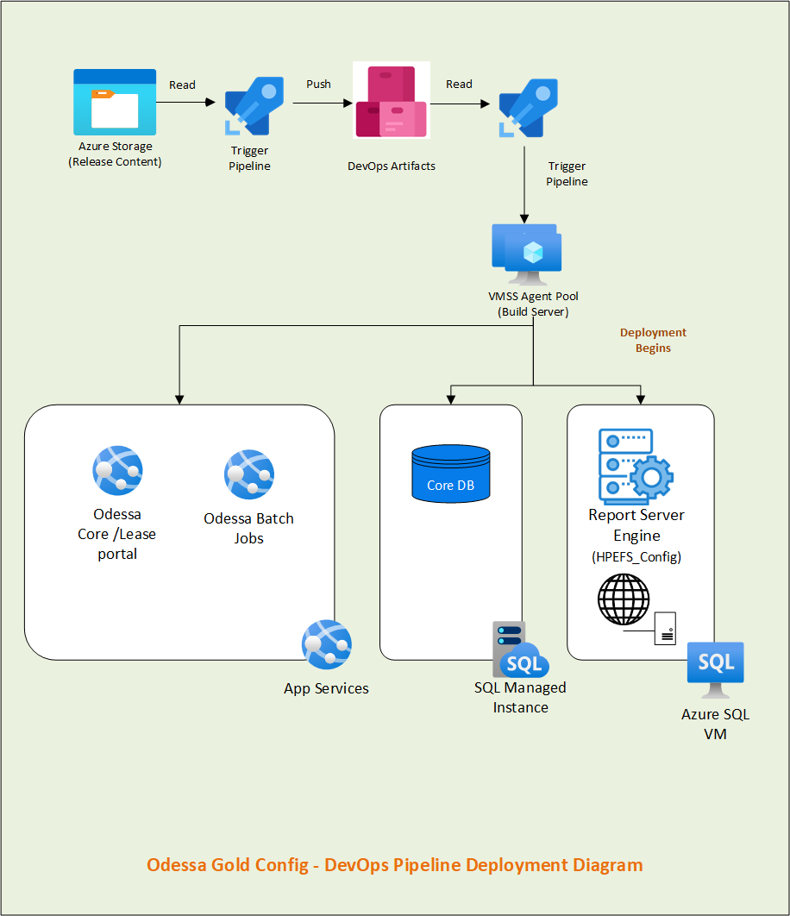

## 6.3 Pipeline Setup

### **6.3.1 Pipeline -** Odessa Core Config w Artifacts

* + - **Job – Read Artifacts**
    - **Task List –**

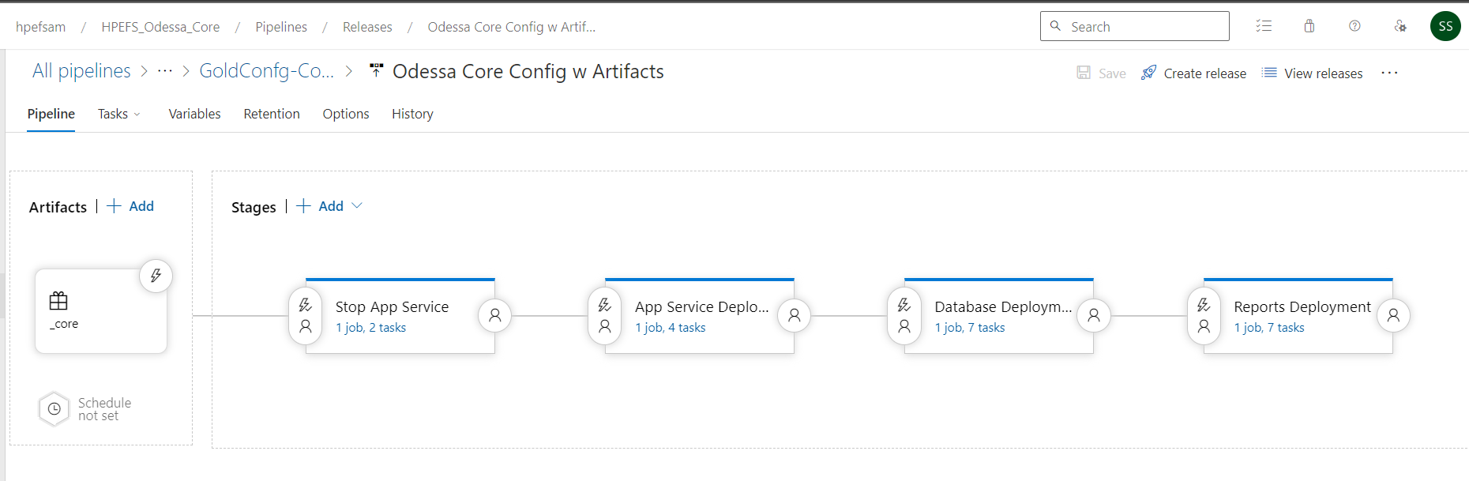

### 6.3.2 Pipeline **-** Restart Core Config App Services

* **Job –** Start App Services
* **Task List -**



# 7. Report Builder Pipeline Setup

## 7.1 Pipeline Setup – DEV

### 7.1.1 Prerequisite Configuration/Permissions for DEV

Below table contains the permissions granted for DEV environment and are the pre-requisite configuration for DevOps Pipeline setup.

**Note: Similar permissions are required to be granted for higher environments to set up DevOps Pipeline.**

|  |  |  |  |
| --- | --- | --- | --- |
| **Type/**  **Category** | **Pre-configuration Permission Tasks** | **Object/**  **Resource Name** | **Notes** |
| Azure Service Principal | Create DevOps Service Principal (SP) | **Service Connection –**  odessa-hpefs-devops-sp-dev | This is the first step where SP to be created in Azure |
| DevOps  Service Connection | Create DevOps Service Connection (SC) by pointing to above SP | **Service Principal-**  odessa-hpefs-devops-sp-dev | Once we have above SC then create SP in DevOps by pointing to this SP |
| DevOps  Artifacts | Add Contributor Access to Project Collection Build Service | **Path -** Azure Devops->Artifacts->Feed Settings->Permission->  Permission - Contributor | By default, permission is set to – Collaborative which needs to be updated with Contributor access.  This has already been given so no further access is needed for higher environments. |
| Azure VMSS | Granting access to VM Scale-set on Storage Account’s container | **VMSS Name –**vmssdevopsnonp  Storage Container Name – stodessacoreblobdev  **IAM Role -** Storage Blob Data Reader | This access has been given already so no further access is needed for higher environments. |
| Azure App Services | Grant access to SP on Core app services | **App services -**  [app-hpefs-odessa-reportbuilder-appserver-dev](https://portal.azure.com/#@hpe.onmicrosoft.com/resource/subscriptions/c32ddae0-5074-46c5-a4a6-b103fe0592d0/resourceGroups/rg-app/providers/Microsoft.Web/sites/app-hpefs-odessa-reportbuilder-appserver-dev)  [app-hpefs-odessa-reportbuilder-batchjobs-dev](https://portal.azure.com/#@hpe.onmicrosoft.com/resource/subscriptions/c32ddae0-5074-46c5-a4a6-b103fe0592d0/resourceGroups/rg-app/providers/Microsoft.Web/sites/app-hpefs-odessa-reportbuilder-batchjobs-dev)  [app-hpefs-odessa-reportgeneration-appservice-dev](https://portal.azure.com/#@hpe.onmicrosoft.com/resource/subscriptions/c32ddae0-5074-46c5-a4a6-b103fe0592d0/resourceGroups/rg-app/providers/Microsoft.Web/sites/app-hpefs-odessa-reportgeneration-appservice-dev)  **IAM Role –** Contributor  **SP -** odessa-hpefs-devops-sp-dev | SP requires IAM permission on App services for deployment |
| Azure Key Vault | Grant access policy to SP on Key Vault Secrets | **Key Vault –**  kv-hpefs-odessa-dev  **SP -** odessa-hpefs-devops-sp-dev  **IAM Role –** Contributor  Access Policy – Get and List | This permission is required to download credentials from Key Vault.  **Keys:**  odessa-hpefs-devops-db-username  odessa-hpefs-devops-db-password |
| Azure SQL Mi | Grant IAM role to SQL MI for SP | **SQL Mi** –sqlmi-odessa-dev  **SP** –odessa-hpefs-devops-sp-dev  **IAM Role** - Contributor | Permission to SP for accessing SQL Mi |
| Azure SQL Mi | Create new SQL user for DevOps within SQL Mi and grant sys_admin roles | **Local SQL User –** OdessaDevOpsUser  **SQL Mi –** sqlmi-odessa-dev  **Roles –** sys_admin | Permission needed for deploying DDL, DML and Job creation related scripts |
| Azure App Configuration | Grant IAM role to SP for App Configuration | **App Configuration Name –** appcs-hpefs-odessa-dev  **SP –** odessa-hpefs-devops-sp-dev  **IAM Role -** App Configuration Data Reader Role, Owner/Custom Read/Write/Delete (still pending) | Permission to read/update/delete App configuration keys. |

### 7.1.2 Automated Pipeline Deployment Workflow

* For DEV & ITG Report Generation Service (RDL Service) is hosted in App services but for STG and PROD it is hosted in Azure VM.

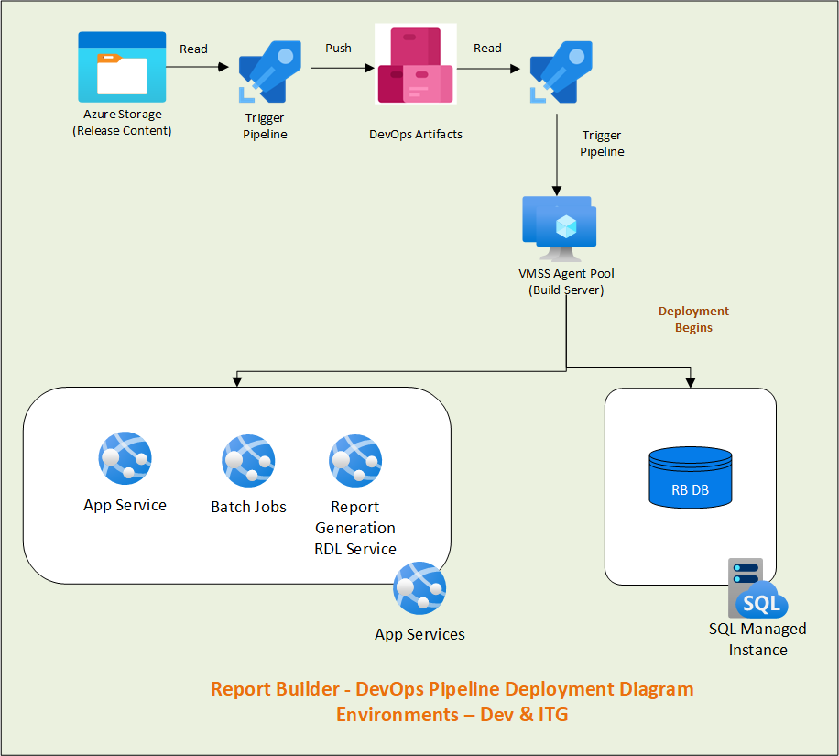

### 7.1.3 Release Pipeline Setup

**DEV**

#### **7.1.3.1 Pipeline -** Get & Deploy Artifacts

* + - **Job -** Getting Contents from Storage and Deploy in Artifacts
    - **Task List -**



#### **7.1.3.2 Pipeline -** ReportBuilder W Artifacts

* + - **Job – Read Artifacts**
    - **Task List –**

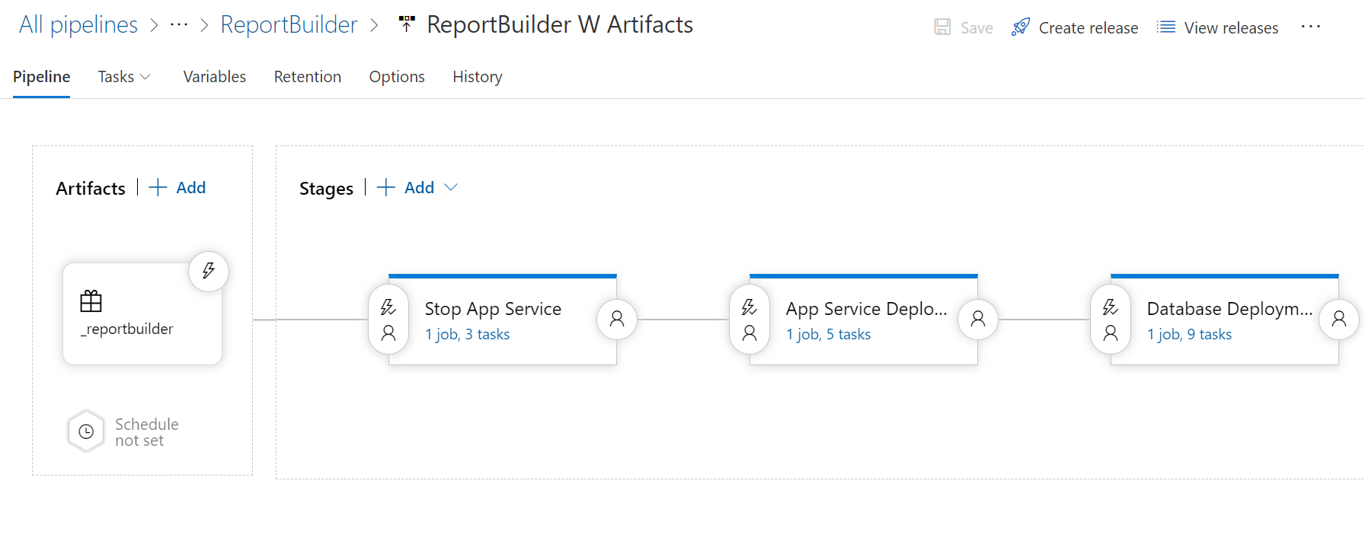

#### 7.1.3.3 Pipeline **-** Restart ReportBuilder App Services

* **Job –** Start App Services
* **Task List -**

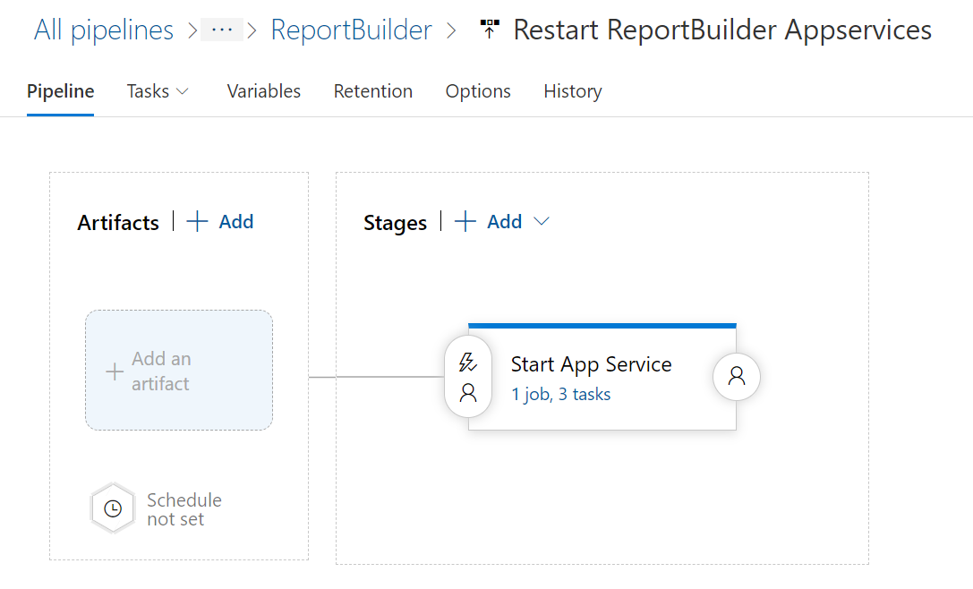

## Pipeline Setup – ITG (HPE owned)

### 7.2.1 Prerequisite Configuration/Permissions for ITG

Below table contains the permissions granted for ITG environment and are the pre-requisite configuration for DevOps Pipeline setup.

|  |  |  |  |
| --- | --- | --- | --- |
| **Type/**  **Category** | **Pre-configuration Permission Tasks** | **Object/**  **Resource Name** | **Notes** |
| Azure Service Principal | Create DevOps Service Principal (SP) | Service Connection –  **hpefs-odessa-devops-sp-itg** | This is the first step where SP to be created in Azure |
| DevOps  Service Connection | Create DevOps Service Connection (SC) by pointing to above SP | Service Principal-  **hpefs-odessa-devops-sp-itg** | Once we have above SC then create SP in DevOps by pointing to this SP |
| Azure App Services | Grant access to SP on Core app services | App services -  **app-hpefs-odessa-reportbuilder-appserver-itg**  **app-hpefs-odessa-reportbuilder-batchjobs-itg**  **app-hpefs-odessa-reportgeneration-appservice-itg**  IAM Role – Contributor  SP - **hpefs-odessa-devops-sp-itg** | SP requires IAM permission on App services for deployment |
| Azure Key Vault | Grant access policy to SP on Key Vault Secrets | Key Vault –  kv-hpefs-odessa-itg  SP - **hpefs-odessa-devops-sp-itg**  IAM Role – Contributor  Access Policy – Get and List | This permission is required to download credentials from Key Vault.  Keys:  odessa-hpefs-devops-db-username  odessa-hpefs-devops-db-password |
| Azure SQL Mi | Grant IAM role to SQL MI for SP | SQL Mi –sqlmi-odessa-dev  SP –**hpefs-odessa-devops-sp-itg**  IAM Role - Contributor | Permission to SP for accessing SQL Mi |

### 7.2.2 Automated Pipeline Deployment Workflow

* For DEV & ITG Report Generation Service (RDL Service) is hosted in App services but for STG and PROD it is hosted in Azure VM.



### Release Pipeline Setup

## 7.3 Pipeline Setup – STG (HPE owned)

### 7.3.1 Prerequisite Configuration/Permissions for STG

Below table contains the list of permissions granted for STG environment and are the pre-requisite configuration for DevOps Pipeline setup.

|  |  |  |  |
| --- | --- | --- | --- |
| **Type/**  **Category** | **Pre-configuration Permission Tasks** | **Object/**  **Resource Name** | **Notes** |
| Virtual Machine Scale Set | Create new VMSS | vmssdevopsstg | This is needed for DevOps Agent Pool.  This VMSS is needed only for one time creation in STG environment and application can use the same VMSS. |
| Azure Service Principal | Create DevOps Service Principal (SP) | Service Connection –  **hpefs-odessa-devops-sp-stg** | This is the first step where SP to be created in Azure |
| DevOps  Service Connection | Create DevOps Service Connection (SC) by pointing to above SP | Service Principal-  **hpefs-odessa-devops-sp-stg** | Once we have above SC then create SP in DevOps by pointing to this SP |
| Azure App Services | Grant access to SP on Core app services | App services -  **app-hpefs-odessa-reportbuilder-appserver-stg**  **app-hpefs-odessa-reportbuilder-batchjobs-stg**  **app-hpefs-odessa-reportgeneration-appservice-stg**  IAM Role – Contributor  SP - **hpefs-odessa-devops-sp-stg** | SP requires IAM permission on App services for deployment |
| Azure Report Server VM | Grant VM Admin permission to domain account within Report Server VM | **Domain Account** – **hpefsoddevopssastg**  **Report Server VM** – vmreportsvrstg1/ 10.17.26.4  **Report Server VM** – vmreportsvrstg2/ 10.17.26.7  **Permission** – Administrator Group | This permission is required on VM to deploy bulk RDL, helper files and to start and stop SSRS service. |
| Azure Report Server VM | Grant IAM roles to SP for Report Server VM | **Report Server VM** – vmreportsvrstg1/ 10.17.26.4  **Report Server VM** – vmreportsvrstg2/ 10.17.26.7  **SA - hpefs-odessa-devops-sp-stg**  **IAM Roles** - Contributor, Virtual Machine Administrator Login | These permissions are needed to have access on Report Server VM. |
| Azure Report Server VM | Create Inbound port within Report Server VM for Remote Powershell script execution | **Port No** – 5986  **Report Server VM** – vmreportsvrstg1/ 10.17.26.4  **Report Server VM** – vmreportsvrstg2/ 10.17.26.7 | Need to create Inbound Port  **Reference link –** [Configuring WinRM over HTTPS to enable PowerShell remoting](https://www.microsoft.com/en-gb/industry/blog/technetuk/2016/02/11/configuring-winrm-over-https-to-enable-powershell-remoting/). |
| Azure Report Server VM | Create certificate within Report Server VM for Remote Powershell script execution | **Self Signed Certificate –** vmreportsvrdev (Friendly Name)  **Report Server VM –**  vmreportsvrdev / 10.17.10.6 | For DEV environment, Self-signed certificate is used. TBD if CA certificate can be used.  For Higher environment this is recommended to have CA certificate.  **Reference link –** [Configuring WinRM over HTTPS to enable PowerShell remoting](https://www.microsoft.com/en-gb/industry/blog/technetuk/2016/02/11/configuring-winrm-over-https-to-enable-powershell-remoting/). |
| Azure Key Vault | Grant access policy to SP on Key Vault Secrets | Key Vault –  kv-hpefs-odessa-stg  SP - **hpefs-odessa-devops-sp-stg**  IAM Role – Contributor  Access Policy – Get and List |  |
| Azure SQL Mi | Grant IAM role to SQL MI for SP | SQL Mi –sqlmi-odessa-dev  SP –**hpefs-odessa-devops-sp-stg**  IAM Role - Contributor | Permission to SP for accessing SQL Mi |

### **7.3.2 Enable Remote Execution from DevOps Pipeline within RDL Service VM**

**NOTE: This configuration is needed only one. If this is already covered as part of Core Pipeline setup, then we can skip this.**

To enable remove power shell execution, refer the following steps –

Reference Link - [Configuring WinRM over HTTPS to enable PowerShell remoting](https://www.microsoft.com/en-gb/industry/blog/technetuk/2016/02/11/configuring-winrm-over-https-to-enable-powershell-remoting/).

1. **Enable Port 5986**

Login to VM->Open Windows FireWall with Advanced Security->

Verify Port 5986 is allowed or not in Inbound Rule, if not allowed and Rule exist then enable it.

If Rule is not existed create a new inbound Rule

* Open “Windows Defender Firewall” and click on “Advance settings” and click on “Inbound Rules” and create new inbound rule.



* Enable Inbound 5986 port as below -



Step 3:



Step 4:



Step 5:



Step 6:

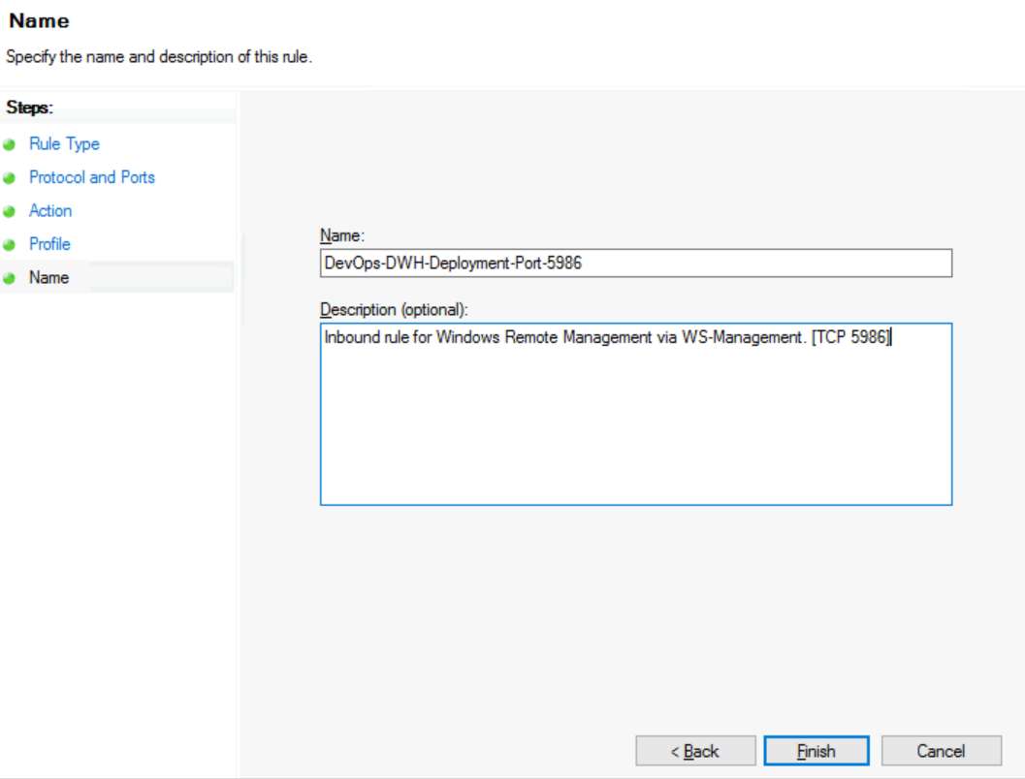

1. **Create Self-signed certificate**

* Logon to the Server using RDP.
* Open Windows PowerShell ISE in admin mode and execute the following command and copy the thumbprint.
* Provide VM DNS name and Friendly Name for below yellow highlighted color- and execute it.

|  |
| --- |
| New-SelfSignedCertificate -DnsName '<vmdatamartdev.hpefs-odessa.com>' -CertStoreLocation Cert:\LocalMachine\My -FriendlyName 'vmdatamartdev' |



1. **Configure WinRM to listen on 5986.**

* Open command prompt in admin mode
* Run the following command, pasting your new certificate’s thumbprint into the command (all on one line)

|  |
| --- |
| winrm create winrm/config/Listener?Address=*+Transport=HTTPS @{Hostname="vmdatamartdev.hpefs-odessa.com"; CertificateThumbprint="3F9DB70C21C987D1D7807D2B7B3613DDB071902E"} |



### 7.3.3 Automated Pipeline Deployment Workflow

**Note:**

* For STG and Production, deployment should be done for all HA instances.
* For STG and Production, Report Generation Service(RDL Service) is hosted in Azure VM.
* Release document from Release Contents is uploaded here -<https://hpe.sharepoint.com/:f:/r/sites/msteams_a09baa/Shared%20Documents/Reporting/Documents?csf=1&web=1&e=muB3c7>

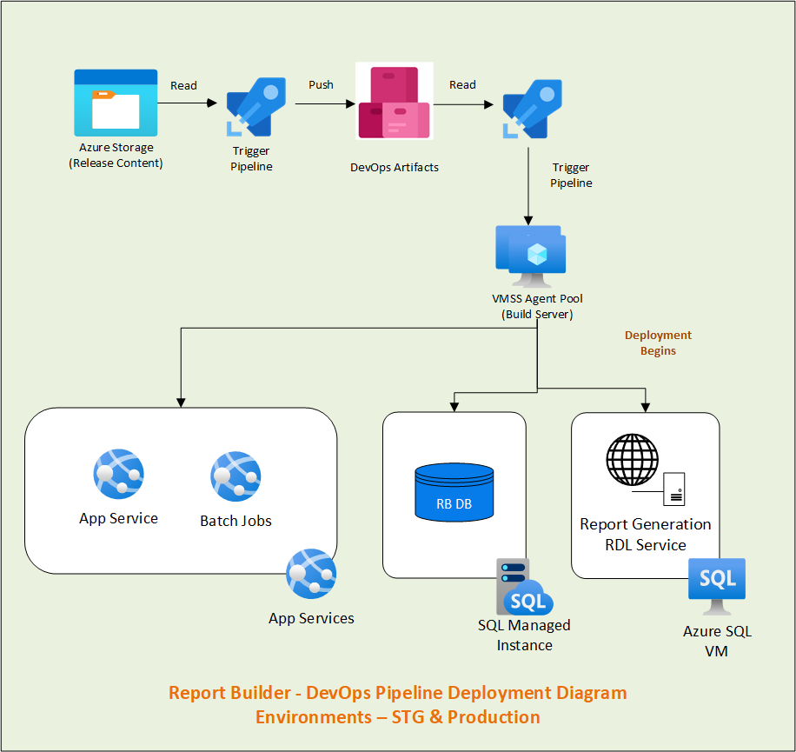

### 7.3.4 Release Pipeline Setup

**PROD (HPE)**

# 8. Data warehouse/Insights Pipeline Setup

## 8.1 Pipeline Setup – DEV

### 8.1.1 Prerequisite Configuration/Permissions for DEV

Below table contains the permissions granted for DEV environment and are the pre-requisite configuration for DevOps Pipeline setup.

**Note: Similar permissions are required to be granted for higher environments to set up DevOps Pipeline.**

|  |  |  |  |
| --- | --- | --- | --- |
| **Type/**  **Category** | **Pre-configuration Permission Tasks** | **Object/**  **Resource Name** | **Notes** |
| Azure Service Principal | Create DevOps Service Principal (SP) | **Service Connection –**  odessa-hpefs-devops-sp-dev | This is the first step where SP to be created in Azure |
| DevOps  Service Connection | Create DevOps Service Connection (SC) by pointing to above SP | **Service Principal-**  odessa-hpefs-devops-sp-dev | Once we have above SC then create SP in DevOps by pointing to this SP |
| DevOps  Artifacts | Add Contributor Access to Project Collection Build Service | **Path -** Azure Devops->Artifacts->Settings->Permission->  Permission - Contributor | By default, permission is set to – Collaborative which needs to be updated with Contributor access.  This has already been given so no further access is needed for higher environments. |
| Azure VMSS | Granting access to VM Scale-set on Storage Account’s container | **VMSS Name –**vmssdevopsnonp  Storage Container Name – stodessacoreblobdev  **IAM Role -** Storage Blob Data Reader | This access has been given already so no further access is needed for higher environments. |
| Azure Key Vault | Grant access policy to SP on Key Vault Secrets | **Key Vault –**  kv-hpefs-odessa-dev  **SP -** odessa-hpefs-devops-sp-dev  **IAM Role –** Contributor  Access Policy – Get and List | This permission is required to download credentials from Key Vault.  **Keys:**  odessa-hpefs-devops-dwhdb-username  odessa-hpefs-devops-db-password  odessa-hpefs-devops-rs-password  odessa-hpefs-devops-rs-username |
| Azure DWH VM | Grant VM Admin permission to domain account within Report Server VM | **Domain Account** – hpefsoddevopssadev  **DWH VM** – vmdatamartdev / 10.17.10.5  **Permission** – Administrator Group | This permission is required on VM to deploy Engine contents and execute DWH release scripts |
| Azure DWH VM | Grant IAM roles to SP for Report Server VM | **DWH VM** – vmdatamartdev / 10.17.10.5  **IAM Roles** - Contributor, Virtual Machine Administrator Login | These permissions are needed to have access to DWH VM. |
| Azure DWH VM | Create Inbound port within Report Server VM for Remote Powershell script execution | **Port No** – 5986  **DWH VM** – vmdatamartdev / 10.17.10.5 | Need to create Inbound Port  **Reference link –** [Configuring WinRM over HTTPS to enable PowerShell remoting](https://www.microsoft.com/en-gb/industry/blog/technetuk/2016/02/11/configuring-winrm-over-https-to-enable-powershell-remoting/). |
| Azure DWH VM | Create certificate within Report Server VM for Remote Powershell script execution | **Self-Signed Certificate –** vmdatamartdev (Friendly Name)  **DWH VM –**  vmdatamartdev / 10.17.10.5 | For DEV environment, Self-signed certificate is used. TBD if CA certificate can be used.  For Higher environment this is recommended to have CA certificate  **Reference link –** [Configuring WinRM over HTTPS to enable PowerShell remoting](https://www.microsoft.com/en-gb/industry/blog/technetuk/2016/02/11/configuring-winrm-over-https-to-enable-powershell-remoting/). |
| SQL Server within Azure DWH VM | Create new SQL user for DevOps within SQL Server and grant sys_admin roles | **Local SQL User –** OdessaDWHDevOps  **SQL Server–** 10.17.10.5  **Roles –** sys_admin | Permission needed for deploying DDL, DML and Job creation related scripts |
| Azure App Configuration | Grant IAM role to SP for App Configuration | **App Configuration Name –** appcs-hpefs-odessa-dev  **SP –** odessa-hpefs-devops-sp-dev  **IAM Role -** App Configuration Data Reader Role, Owner/Custom Read/Write/Delete (still pending) | Permission to read/update/delete App configuration keys. |

### **8.1.2 Enable Remote Execution from DevOps Pipeline within DWH VM**

To enable remove power shell execution, refer the following steps –

Reference Link - [Configuring WinRM over HTTPS to enable PowerShell remoting](https://www.microsoft.com/en-gb/industry/blog/technetuk/2016/02/11/configuring-winrm-over-https-to-enable-powershell-remoting/).

1. **Enable Port 5986**

Login to VM->Open Windows FireWall with Advanced Security->

Verify Port 5986 is allowed or not in Inbound Rule, if not allowed and Rule exist then enable it.

If Rule is not existed create a new inbound Rule

* Open “Windows Defender Firewall” and click on “Advance settings” and click on “Inbound Rules” and create new inbound rule.



* Enable Inbound 5986 port as below -



Step 3:



Step 4:



Step 5:



Step 6:



1. **Create Self-signed certificate**

* Logon to the Server using RDP.
* Open Windows PowerShell ISE in admin mode and execute the following command and copy the thumbprint.
* Provide VM DNS name and Friendly Name for below yellow highlighted color- and execute it.

|  |
| --- |
| New-SelfSignedCertificate -DnsName '<vmdatamartdev.hpefs-odessa.com>' -CertStoreLocation Cert:\LocalMachine\My -FriendlyName 'vmdatamartdev' |



1. **Configure WinRM to listen on 5986.**

* Open command prompt in admin mode
* Run the following command, pasting your new certificate’s thumbprint into the command (all on one line)

|  |
| --- |
| winrm create winrm/config/Listener?Address=*+Transport=HTTPS @{Hostname="vmdatamartdev.hpefs-odessa.com"; CertificateThumbprint="3F9DB70C21C987D1D7807D2B7B3613DDB071902E"} |



### 8.1.3 Automated Pipeline Deployment Workflow

**Note:**

* For STG and Production, deployment should be done for all HA instances.

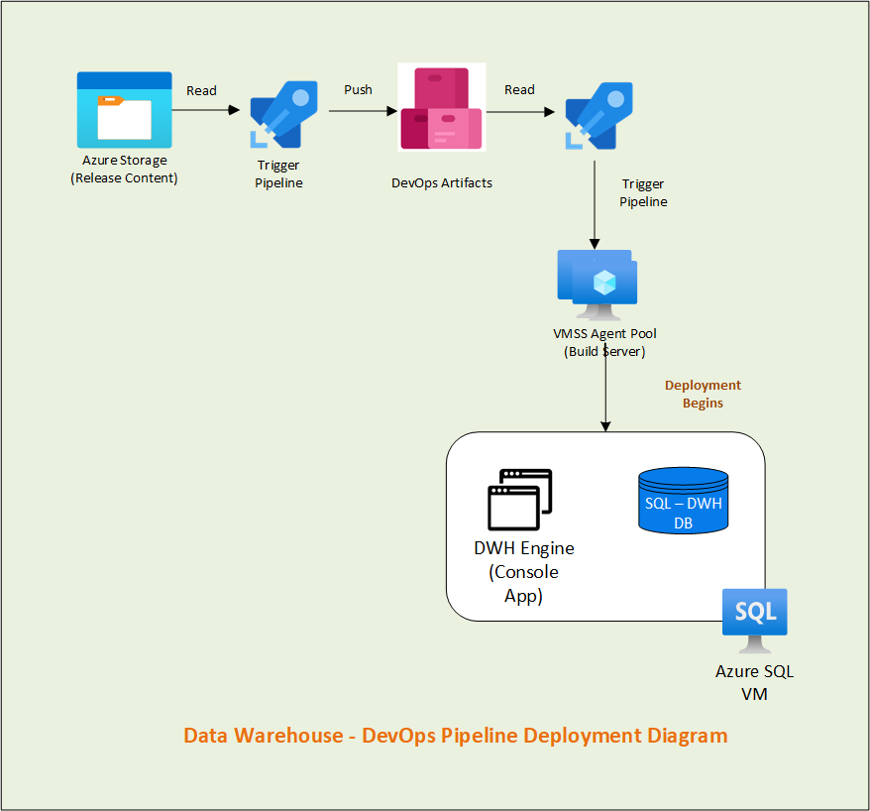

### 8.1.4 Release Pipeline Setup

#### **8.1.4.1 Pipeline -** Get & Deploy Artifacts

* + - **Job -** Getting Contents from Storage and Deploy in Artifacts
    - **Task List -**



#### 8.1.4.2 Pipeline - DWH W Artifacts

* + - **Job – Read Artifacts**
    - **Task List –**

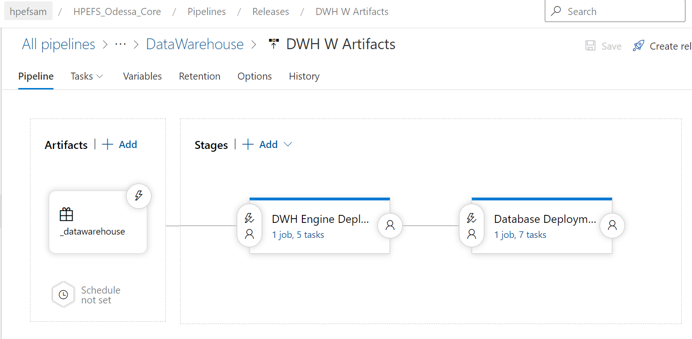

## 8.2 Pipeline Setup – ITG (HPE owned)

### 8.2.1 Prerequisite Configuration/Permissions for ITG

Below table contains the permissions granted for ITG environment and are the pre-requisite configuration for DevOps Pipeline setup.

NOTE: Below access is to be reviewed before proceeding for granting access.

**Note: Similar permissions are required to be granted for higher environments to set up DevOps Pipeline.**

|  |  |  |  |
| --- | --- | --- | --- |
| **Type/**  **Category** | **Pre-configuration Permission Tasks** | **Object/**  **Resource Name** | **Notes** |
| Azure Service Principal | Create DevOps Service Principal (SP) | **Service Connection –**  hpefs-odessa-devops-sp-itg | This is the first step where SP to be created in Azure |
| DevOps  Service Connection | Create DevOps Service Connection (SC) by pointing to above SP | **Service Principal-**  hpefs-odessa-devops-sp-itg | Once we have above SC then create SP in DevOps by pointing to this SP |
| DevOps  Artifacts | Add Contributor Access to Project Collection Build Service | **Path -** Azure Devops->Artifacts->Settings->Permission->  Permission - Contributor | By default, permission is set to – Collaborative which needs to be updated with Contributor access.  This has already been given so no further access is needed for higher environments. |
| Azure VMSS | Granting access to VM Scale-set on Storage Account’s container | **VMSS Name –**vmssdevopsnonp  Storage Container Name – stodessacoreblobdev  **IAM Role -** Storage Blob Data Reader | This access has been given already so no further access is needed for higher environments. |
| Azure Key Vault | Grant access policy to SP on Key Vault Secrets | **Key Vault –**  kv-hpefs-odessa-itg  **SP -** hpefs-odessa-devops-sp-itg  **IAM Role –** Contributor  Access Policy – Get and List | This permission is required to download credentials from Key Vault.  **Keys:**  odessa-hpefs-devops-dwhdb-username  odessa-hpefs-devops-db-password  odessa-hpefs-devops-rs-password  odessa-hpefs-devops-rs-username |
| Azure DWH VM | Grant VM Admin permission to domain account within Report Server VM | **Domain Account** – hpefsoddevopssadev  **DWH VM** – vmdatamartitg / 10.17.18.4  **Permission** – Administrator Group | This permission is required on VM to deploy Engine contents and execute DWH release scripts |
| Azure DWH VM | Grant IAM roles to SP for Report Server VM | **DWH VM** – vmdatamartitg / 10.17.18.4  **IAM Roles** - Contributor, Virtual Machine Administrator Login | These permissions are needed to have access to DWH VM. |
| Azure DWH VM | Create Inbound port within Report Server VM for Remote Powershell script execution | **Port No** – 5986  **DWH VM** – vmdatamartitg / 10.17.18.4 | Need to create Inbound Port  **Reference link –** [Configuring WinRM over HTTPS to enable PowerShell remoting](https://www.microsoft.com/en-gb/industry/blog/technetuk/2016/02/11/configuring-winrm-over-https-to-enable-powershell-remoting/). |
| Azure DWH VM | Create certificate within Report Server VM for Remote Powershell script execution | **Self-Signed Certificate –** vmdatamartitg (Friendly Name)  **DWH VM –**  vmdatamartitg / 10.17.18.4 | For DEV environment, Self-signed certificate is used. TBD if CA certificate can be used.  For Higher environment this is recommended to have CA certificate  **Reference link –** [Configuring WinRM over HTTPS to enable PowerShell remoting](https://www.microsoft.com/en-gb/industry/blog/technetuk/2016/02/11/configuring-winrm-over-https-to-enable-powershell-remoting/). |
| SQL Server within Azure DWH VM | Create new SQL user for DevOps within SQL Server and grant sys_admin roles | **Local SQL User –** OdessaDWHDevOps  **SQL Server–** 10.17.18.4  **Roles –** sys_admin | Permission needed for deploying DDL, DML and Job creation related scripts |

### **8.2.1 Enable Remote Execution from DevOps Pipeline within DWH VM**

To enable remove power shell execution, refer the following steps –

Reference Link - [Configuring WinRM over HTTPS to enable PowerShell remoting](https://www.microsoft.com/en-gb/industry/blog/technetuk/2016/02/11/configuring-winrm-over-https-to-enable-powershell-remoting/).

1. **Enable Port 5986**

Login to VM->Open Windows FireWall with Advanced Security->

Verify Port 5986 is allowed or not in Inbound Rule, if not allowed and Rule exist then enable it.

If Rule is not existed create a new inbound Rule

* Open “Windows Defender Firewall” and click on “Advance settings” and click on “Inbound Rules” and create new inbound rule.



* Enable Inbound 5986 port as below -



Step 3:



Step 4:



Step 5:



Step 6:



1. **Create Self-signed certificate**

* Logon to the Server using RDP.
* Open Windows PowerShell ISE in admin mode and execute the following command and copy the thumbprint.
* Provide VM DNS name and Friendly Name for below yellow highlighted color- and execute it.

|  |
| --- |
| New-SelfSignedCertificate -DnsName '<vmdatamartdev.hpefs-odessa.com>' -CertStoreLocation Cert:\LocalMachine\My -FriendlyName 'vmdatamartdev' |



1. **Configure WinRM to listen on 5986.**

* Open command prompt in admin mode
* Run the following command, pasting your new certificate’s thumbprint into the command (all on one line)

|  |
| --- |
| winrm create winrm/config/Listener?Address=*+Transport=HTTPS @{Hostname="vmdatamartdev.hpefs-odessa.com"; CertificateThumbprint="3F9DB70C21C987D1D7807D2B7B3613DDB071902E"} |



### 8.2.3 Automated Pipeline Deployment Workflow

**Note:**

* For STG and Production, deployment should be done for all HA instances.



### 8.2.4 Release Pipeline Setup

## 8.3 Pipeline Setup – STG (HPE owned)

### 8.3.1 Prerequisite Configuration/Permissions for STG

Below table contains the list of permissions granted for STG environment and are the pre-requisite configuration for DevOps Pipeline setup.

NOTE: Below access is to be reviewed before proceeding for granting access.

**Note: Similar permissions are required to be granted for higher environments to set up DevOps Pipeline.**

|  |  |  |  |
| --- | --- | --- | --- |
| **Type/**  **Category** | **Pre-configuration Permission Tasks** | **Object/**  **Resource Name** | **Notes** |
| Azure Service Principal | Create DevOps Service Principal (SP) | **Service Connection –**  hpefs-odessa-devops-sp-stg | This is the first step where SP to be created in Azure |
| DevOps  Service Connection | Create DevOps Service Connection (SC) by pointing to above SP | **Service Principal-**  hpefs-odessa-devops-sp-stg | Once we have above SC then create SP in DevOps by pointing to this SP |
| DevOps  Artifacts | Add Contributor Access to Project Collection Build Service | **Path -** Azure Devops->Artifacts->Settings->Permission->  Permission - Contributor | By default, permission is set to – Collaborative which needs to be updated with Contributor access.  This has already been given so no further access is needed for higher environments. |
| Azure VMSS | Granting access to VM Scale-set on Storage Account’s container | **VMSS Name –**vmssdevopsnonp  Storage Container Name – stodessacoreblobdev  **IAM Role -** Storage Blob Data Reader | This access has been given already so no further access is needed for higher environments. |
| Azure Key Vault | Grant access policy to SP on Key Vault Secrets | **Key Vault –**  kv-hpefs-odessa-stg  **SP -** hpefs-odessa-devops-sp-itg  **IAM Role –** Contributor  Access Policy – Get and List | This permission is required to download credentials from Key Vault.  **Keys:**  odessa-hpefs-devops-dwhdb-username  odessa-hpefs-devops-db-password  odessa-hpefs-devops-rs-password  odessa-hpefs-devops-rs-username |
| Azure DWH VM | Grant VM Admin permission to domain account within Report Server VM | **Domain Account** – hpefsoddevopssadev  **DWH VM** – vmdatamartstg1 / 10.17.26.5  Vmdatamartstg2 / 10.17.26.6  **Permission** – Administrator Group | This permission is required on VM to deploy Engine contents and execute DWH release scripts |
| Azure DWH VM | Grant IAM roles to SP for Report Server VM | **DWH VM** – vmdatamartstg1 / 10.17.26.5  Vmdatamartstg2 / 10.17.26.6  **IAM Roles** - Contributor, Virtual Machine Administrator Login | These permissions are needed to have access to DWH VM. |
| Azure DWH VM | Create Inbound port within Report Server VM for Remote Powershell script execution | **Port No** – 5986  **DWH VM** – vmdatamartstg1 / 10.17.26.5  Vmdatamartstg2 / 10.17.26.6 | Need to create Inbound Port  **Reference link –** [Configuring WinRM over HTTPS to enable PowerShell remoting](https://www.microsoft.com/en-gb/industry/blog/technetuk/2016/02/11/configuring-winrm-over-https-to-enable-powershell-remoting/). |
| Azure DWH VM | Create certificate within Report Server VM for Remote Powershell script execution | **Self-Signed Certificate –** vmdatamartstg1 (Friendly Name)  Vmdatamartstg2 (Friendly Name)  **DWH VM –**  vmdatamartstg1 / 10.17.26.5  Vmdatamartstg2 / 10.17.26.6 | For DEV environment, Self-signed certificate is used. TBD if CA certificate can be used.  For Higher environment this is recommended to have CA certificate  **Reference link –** [Configuring WinRM over HTTPS to enable PowerShell remoting](https://www.microsoft.com/en-gb/industry/blog/technetuk/2016/02/11/configuring-winrm-over-https-to-enable-powershell-remoting/). |
| SQL Server within Azure DWH VM | Create new SQL user for DevOps within SQL Server and grant sys_admin roles | **Local SQL User –** OdessaDWHDevOps  **SQL Server–** 10.17.26.5  **Roles –** sys_admin | Permission needed for deploying DDL, DML and Job creation related scripts |

### **8.3.2 Enable Remote Execution from DevOps Pipeline within DWH VM**

To enable remove power shell execution, refer the following steps –

Reference Link - [Configuring WinRM over HTTPS to enable PowerShell remoting](https://www.microsoft.com/en-gb/industry/blog/technetuk/2016/02/11/configuring-winrm-over-https-to-enable-powershell-remoting/).

1. **Enable Port 5986**

Login to VM->Open Windows FireWall with Advanced Security->

Verify Port 5986 is allowed or not in Inbound Rule, if not allowed and Rule exist then enable it.

If Rule is not existed create a new inbound Rule

* Open “Windows Defender Firewall” and click on “Advance settings” and click on “Inbound Rules” and create new inbound rule.



* Enable Inbound 5986 port as below -



Step 3:



Step 4:



Step 5:



Step 6:



1. **Create Self-signed certificate**

* Logon to the Server using RDP.
* Open Windows PowerShell ISE in admin mode and execute the following command and copy the thumbprint.
* Provide VM DNS name and Friendly Name for below yellow highlighted color- and execute it.

|  |
| --- |
| New-SelfSignedCertificate -DnsName '<vmdatamartdev.hpefs-odessa.com>' -CertStoreLocation Cert:\LocalMachine\My -FriendlyName 'vmdatamartdev' |



1. **Configure WinRM to listen on 5986.**

* Open command prompt in admin mode
* Run the following command, pasting your new certificate’s thumbprint into the command (all on one line)

|  |
| --- |
| winrm create winrm/config/Listener?Address=*+Transport=HTTPS @{Hostname="vmdatamartdev.hpefs-odessa.com"; CertificateThumbprint="3F9DB70C21C987D1D7807D2B7B3613DDB071902E"} |



### 8.3.3 Automated Pipeline Deployment Workflow

**Note:**

* For STG and Production, deployment should be done for all HA instances.



### 8.3.4 Release Pipeline Setup

**PROD (HPE)**

# 9. Partner Portal Pipeline Setup

## 9.1 Pipeline Setup – DEV

### 9.1.1 Prerequisite Configuration/Permissions

Below table contains the permissions granted for DEV environment and are the pre-requisite configuration for DevOps Pipeline setup.

**Note: Similar permissions are required to be granted for higher environments to set up DevOps Pipeline.**

|  |  |  |  |
| --- | --- | --- | --- |
| **Type/**  **Category** | **Pre-configuration Permission Tasks** | **Object/**  **Resource Name** | **Notes** |
| Azure Service Principal | Create DevOps Service Principal (SP) | **Service Connection –**  hpefs-odessa-devops-sp-pp-dev | This is the first step where SP to be created in Azure |
| DevOps  Service Connection | Create DevOps Service Connection (SC) by pointing to above SP | **Service Principal-**  hpefs-odessa-devops-sp-pp-dev | Once we have above SC then create SP in DevOps by pointing to this SP |
| DevOps  Artifacts | Add Contributor Access to Project Collection Build Service | **Path -** Azure Devops->Artifacts->Settings->Permission->  Permission - Contributor | By default, permission is set to – Collaborative which needs to be updated with Contributor access.  This has already been given so no further access is needed for higher environments. |
| Azure VMSS | Granting access to VM Scale-set on Storage Account’s container | **VMSS Name –**vmssdevopsnonp  Storage Container Name – stodessacoreblobdev  **IAM Role -** Storage Blob Data Reader | This access has been given already so no further access is needed for higher environments. |
| Azure App Services | Grant access to SP on PartnerPortal app services | **App services -**  app-hpefs-odessa-pp-appserver-dev  app-hpefs-odessa-pp-apiserver-dev    app-hpefs-odessa-pp-batchjobs-dev    app-hpefs-odessa-pp-docportal-dev  **IAM Role –** Contributor  **SP - hpefs-odessa-devops-sp-pp-dev** | SP requires IAM permission on App services for deployment |
| Azure Key Vault | Grant access policy to SP on Key Vault Secrets | **Key Vault –**  kv-hpefs-odessa-pp-dev  **SP -** hpefs-odessa-devops-sp-pp-dev  **IAM Role –** Contributor  Access Policy – Get and List | This permission is required to download credentials from Key Vault.  **Keys:**  hpefs-odessa-pp-devops-db-username,  hpefs-odessa-pp-devops-db-password  hpefs-odessa-pp-devops-rs-username,  hpefs-odessa-pp-devops-rs-password |
| Azure Report Server VM | Grant VM Admin permission to domain account within Report Server VM | **Domain Account –** hpefsoddevopssadev **Report Server VM –** vmreportsvrdev / 10.17.10.6 Permission – Administrator Group | This permission is required on VM to deploy bulk RDL, helper files and to start and stop SSRS service. |
| Azure Report Server VM | Grant IAM roles to SP for Report Server VM | **Report Server VM –** vmreportsvrdev / **10.17.10.6 IAM Roles -** Contributor, Virtual Machine Administrator Login | These permissions are needed to have access on Report Server VM. |
| Azure Report Server VM | Create Inbound port within Report Server VM for Remote Powershell script execution | **Port No –** 5986 Report **Server VM –** vmreportsvrdev / 10.17.10.6 | Need to create Inbound Port  **Reference link –** [Configuring WinRM over HTTPS to enable PowerShell remoting](https://www.microsoft.com/en-gb/industry/blog/technetuk/2016/02/11/configuring-winrm-over-https-to-enable-powershell-remoting/). |
| Azure Report Server VM | Create certificate within Report Server VM for Remote Powershell script execution | **Self-Signed Certificate –** vmreportsvrdev (Friendly Name) Report Server VM – vmreportsvrdev / 10.17.10.6 | For DEV environment, Self-signed certificate is used. TBD if CA certificate can be used.  For Higher environment this is recommended to have a CA certificate.  **Reference link –** [Configuring WinRM over HTTPS to enable PowerShell remoting](https://www.microsoft.com/en-gb/industry/blog/technetuk/2016/02/11/configuring-winrm-over-https-to-enable-powershell-remoting/). |
| Azure SQL Mi | Grant IAM role to SQL MI for SP | **SQL Mi** –sqlmi-odessa-dev  **SP** – hpefs-odessa-devops-sp-pp-dev  **IAM Role** - Contributor | Permission to SP for accessing SQL Mi |
| Azure SQL Mi | Create new SQL user for DevOps within SQL Mi and grant sys_admin roles | **Local SQL User –** OdessaDevOpsUser  **SQL Mi –** sqlmi-odessa-dev  **Roles –** sys_admin | Permission needed for deploying DDL, DML and Job creation related scripts |
| Azure App Configuration | Grant IAM role to SP for App Configuration | **App Configuration Name – appcs-hpefs-odessa-pp-dev**  **SP – hpefs-odessa-devops-sp-pp-dev**  **IAM Role -** App Configuration Data Reader Role, Owner/Custom Read/Write/Delete (still pending) | Permission to read/update/delete App configuration keys. |

### **9.1.2 Enable Remote Execution from DevOps Pipeline within Report Server VM**

**NOTE: This configuration is needed only one. If this is already covered as part of Core Pipeline setup, then we can skip this.**

To enable remove power shell execution, refer the following steps –

Reference Link - [Configuring WinRM over HTTPS to enable PowerShell remoting](https://www.microsoft.com/en-gb/industry/blog/technetuk/2016/02/11/configuring-winrm-over-https-to-enable-powershell-remoting/).

1. **Enable Port 5986**

Login to VM->Open Windows FireWall with Advanced Security->

Verify Port 5986 is allowed or not in Inbound Rule, if not allowed and Rule exist then enable it.

If Rule is not existed create a new inbound Rule

* Open “Windows Defender Firewall” and click on “Advance settings” and click on “Inbound Rules” and create new inbound rule.



* Enable Inbound 5986 port as below -



Step 3:



Step 4:



Step 5:



Step 6:



1. **Create Self-signed certificate**

* Logon to the Server using RDP.
* Open Windows PowerShell ISE in admin mode and execute the following command and copy the thumbprint.
* Provide VM DNS name and Friendly Name for below yellow highlighted color- and execute it.

|  |
| --- |
| New-SelfSignedCertificate -DnsName '<vmdatamartdev.hpefs-odessa.com>' -CertStoreLocation Cert:\LocalMachine\My -FriendlyName 'vmdatamartdev' |



1. **Configure WinRM to listen on 5986.**

* Open command prompt in admin mode
* Run the following command, pasting your new certificate’s thumbprint into the command (all on one line)

|  |
| --- |
| winrm create winrm/config/Listener?Address=*+Transport=HTTPS @{Hostname="vmdatamartdev.hpefs-odessa.com"; CertificateThumbprint="3F9DB70C21C987D1D7807D2B7B3613DDB071902E"} |

### 9.1.3 Automated Pipeline Deployment Workflow

**Note:**

* Doc Portal service is only deployed in DEV & ITG environments. This service is not applicable to deploy in STG and Production
* For STG and Production, deployment should be done for all HA instances.

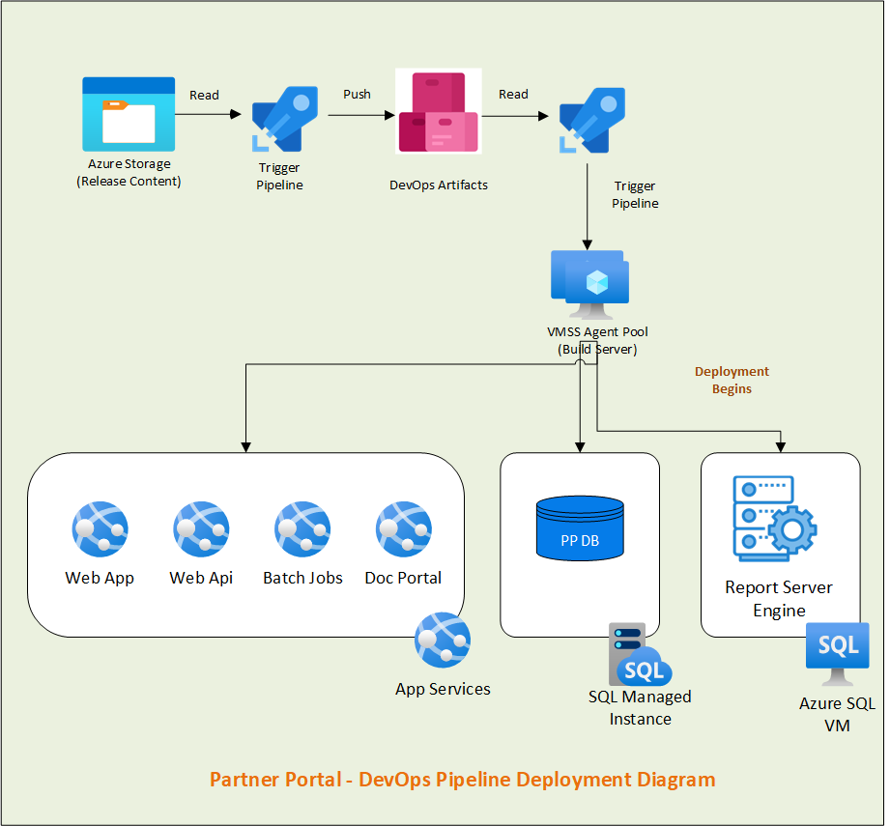

### 9.1.4 Release Pipeline Setup

#### **9.1.4.1 Pipeline -** Get & Deploy Artifacts

* + - **Job -** Getting Contents from Storage and Deploy in Artifacts
    - **Task List -**

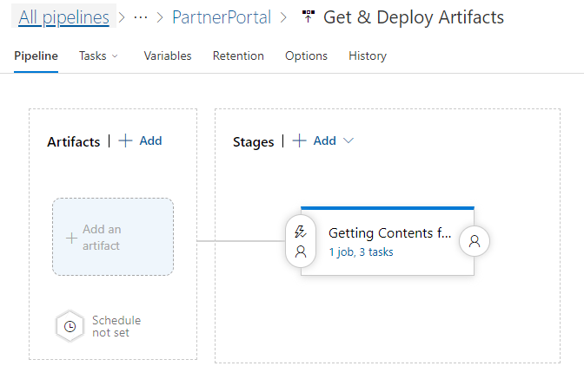

#### 9.1.4.2 Pipeline - PartnerPortal W Artifacts

* + - **Job – Read Artifacts**
    - **Task List –**

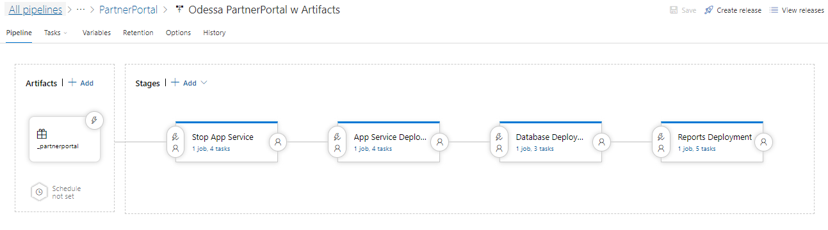

#### 9.1.4.3 Pipeline **-** Restart PartnerPortal App Services

* **Job –** Start App Services
* **Task List -**

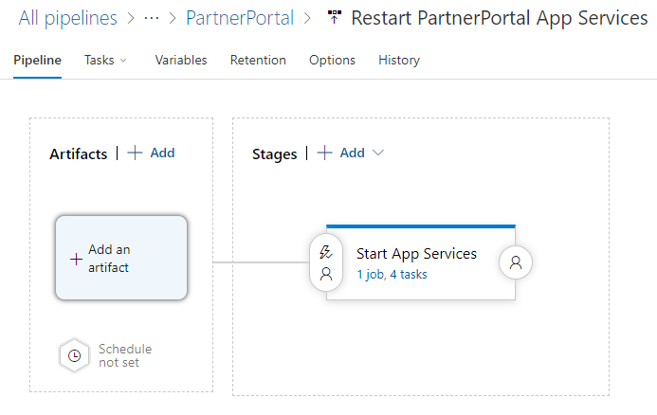

## 9.2 Pipeline Setup – ITG (HPE owned)

### 9.2.1 Prerequisite Configuration/Permissions

Below table contains the permissions granted for ITG environment and are the pre-requisite configuration for DevOps Pipeline setup.

NOTE: Below access is to be reviewed before proceeding for granting access.

**Note: Similar permissions are required to be granted for higher environments to set up DevOps Pipeline.**

|  |  |  |  |
| --- | --- | --- | --- |
| **Type/**  **Category** | **Pre-configuration Permission Tasks** | **Object/**  **Resource Name** | **Notes** |
| Azure Service Principal | Create DevOps Service Principal (SP) | **Service Connection –**  hpefs-odessa-devops-sp-pp-itg | This is the first step where SP to be created in Azure |
| DevOps  Service Connection | Create DevOps Service Connection (SC) by pointing to above SP | **Service Principal-**  hpefs-odessa-devops-sp-pp-itg | Once we have above SC then create SP in DevOps by pointing to this SP |
| DevOps  Artifacts | Add Contributor Access to Project Collection Build Service | **Path -** Azure Devops->Artifacts->Settings->Permission->  Permission - Contributor | By default, permission is set to – Collaborative which needs to be updated with Contributor access.  This has already been given so no further access is needed for higher environments. |
| Azure VMSS | Granting access to VM Scale-set on Storage Account’s container | **VMSS Name –**vmssdevopsnonp  Storage Container Name – stodessacoreblobdev  **IAM Role -** Storage Blob Data Reader | This access has been given already so no further access is needed for higher environments. |
| Azure App Services | Grant access to SP on PartnerPortal app services | **App services -**  app-hpefs-odessa-pp-appserver-itg  app-hpefs-odessa-pp-apiserver-itg    app-hpefs-odessa-pp-batchjobs-itg    app-hpefs-odessa-pp-docportal-itg  **IAM Role –** Contributor  **SP - hpefs-odessa-devops-sp-pp-itg** | SP requires IAM permission on App services for deployment |
| Azure Key Vault | Grant access policy to SP on Key Vault Secrets | **Key Vault –**  kv-hpefs-odessa-pp-itg  **SP -** hpefs-odessa-devops-sp-pp-itg  **IAM Role –** Contributor  Access Policy – Get and List | This permission is required to download credentials from Key Vault.  **Keys:**  hpefs-odessa-pp-devops-db-username,  hpefs-odessa-pp-devops-db-password  hpefs-odessa-pp-devops-rs-username,  hpefs-odessa-pp-devops-rs-password |
| Azure Report Server VM | Grant VM Admin permission to domain account within Report Server VM | **Domain Account –** hpefsoddevopssaitg **Report Server VM –** vmreportsvritg / 10.17.18.5 Permission – Administrator Group | This permission is required on VM to deploy bulk RDL, helper files and to start and stop SSRS service. |
| Azure Report Server VM | Grant IAM roles to SP for Report Server VM | **Report Server VM –** vmreportsvritg / **10.17.18.5 IAM Roles -** Contributor, Virtual Machine Administrator Login | These permissions are needed to have access on Report Server VM. |
| Azure Report Server VM | Create Inbound port within Report Server VM for Remote Powershell script execution | **Port No –** 5986 Report **Server VM –** vmreportsvritg / 10.17.18.5 | Need to create Inbound Port  **Reference link –** [Configuring WinRM over HTTPS to enable PowerShell remoting](https://www.microsoft.com/en-gb/industry/blog/technetuk/2016/02/11/configuring-winrm-over-https-to-enable-powershell-remoting/). |
| Azure Report Server VM | Create certificate within Report Server VM for Remote Powershell script execution | **Self-Signed Certificate –** vmreportsvritg (Friendly Name) Report Server VM – vmreportsvritg / 10.17.18.5 | For DEV environment, Self-signed certificate is used. TBD if CA certificate can be used.  For Higher environment this is recommended to have a CA certificate.  **Reference link –** [Configuring WinRM over HTTPS to enable PowerShell remoting](https://www.microsoft.com/en-gb/industry/blog/technetuk/2016/02/11/configuring-winrm-over-https-to-enable-powershell-remoting/). |
| Azure SQL Mi | Grant IAM role to SQL MI for SP | **SQL Mi** –sqlmi-odessa-itg  **SP** – hpefs-odessa-devops-sp-pp-itg  **IAM Role** - Contributor | Permission to SP for accessing SQL Mi |
| Azure SQL Mi | Create new SQL user for DevOps within SQL Mi and grant sys_admin roles | **Local SQL User –** OdessaDevOpsUser  **SQL Mi –** sqlmi-odessa-itg  **Roles –** sys_admin | Permission needed for deploying DDL, DML and Job creation related scripts |
| Azure App Configuration | Grant IAM role to SP for App Configuration | **App Configuration Name – appcs-hpefs-odessa-pp-itg**  **SP – hpefs-odessa-devops-sp-pp-itg**  **IAM Role -** App Configuration Data Reader Role, Owner/Custom Read/Write/Delete (still pending) | Permission to read/update/delete App configuration keys. |

### **9.2.2 Enable Remote Execution from DevOps Pipeline within Report Server VM**

**NOTE: This configuration is needed only one. If this is already covered as part of Core Pipeline setup, then we can skip this.**

To enable remove power shell execution, refer the following steps –

Reference Link - [Configuring WinRM over HTTPS to enable PowerShell remoting](https://www.microsoft.com/en-gb/industry/blog/technetuk/2016/02/11/configuring-winrm-over-https-to-enable-powershell-remoting/).

1. **Enable Port 5986**

Login to VM->Open Windows FireWall with Advanced Security->

Verify Port 5986 is allowed or not in Inbound Rule, if not allowed and Rule exist then enable it.

If Rule is not existed create a new inbound Rule

* Open “Windows Defender Firewall” and click on “Advance settings” and click on “Inbound Rules” and create new inbound rule.



* Enable Inbound 5986 port as below -



Step 3:



Step 4:



Step 5:



Step 6:



1. **Create Self-signed certificate**

* Logon to the Server using RDP.
* Open Windows PowerShell ISE in admin mode and execute the following command and copy the thumbprint.
* Provide VM DNS name and Friendly Name for below yellow highlighted color- and execute it.

New-SelfSignedCertificate -DnsName '<vmdatamartitg.hpefs-odessa.com>' -CertStoreLocation Cert:\LocalMachine\My -FriendlyName 'vmdatamartitg'



1. **Configure WinRM to listen on 5986.**

* Open command prompt in admin mode
* Run the following command, pasting your new certificate’s thumbprint into the command (all on one line)

winrm create winrm/config/Listener?Address=*+Transport=HTTPS @{Hostname="vmdatamartitg.hpefs-odessa.com"; CertificateThumbprint="3F9DB70C21C987D1D7807D2B7B3613DDB071902E"}

### 9.2.3 Automated Pipeline Deployment Workflow

**Note:**

* Doc Portal service is only deployed in DEV & ITG environments. This service is not applicable to deploy in STG and Production
* For STG and Production, deployment should be done for all HA instances.



### 9.2.4 Release Pipeline Setup

#### 9.2.4.1 Pipeline - PartnerPortal W Artifacts

* + - **Job – Read Artifacts**
    - **Task List –**



#### 9.2.4.2 Pipeline **-** Restart PartnerPortal App Services

* **Job –** Start App Services
* **Task List -**



## 9.3 Pipeline Setup – STG (HPE owned)

### 9.3.1 Prerequisite Configuration/Permissions

Below table contains the permissions granted for STG environment and are the pre-requisite configuration for DevOps Pipeline setup.

NOTE: Below access is to be reviewed before proceeding for granting access.

**Note: Similar permissions are required to be granted for higher environments to set up DevOps Pipeline.**

|  |  |  |  |
| --- | --- | --- | --- |
| **Type/**  **Category** | **Pre-configuration Permission Tasks** | **Object/**  **Resource Name** | **Notes** |
| Azure Service Principal | Create DevOps Service Principal (SP) | **Service Connection –**  hpefs-odessa-devops-sp-pp-stg | This is the first step where SP to be created in Azure |
| DevOps  Service Connection | Create DevOps Service Connection (SC) by pointing to above SP | **Service Principal-**  hpefs-odessa-devops-sp-pp-stg | Once we have above SC then create SP in DevOps by pointing to this SP |
| DevOps  Artifacts | Add Contributor Access to Project Collection Build Service | **Path -** Azure Devops->Artifacts->Settings->Permission->  Permission - Contributor | By default, permission is set to – Collaborative which needs to be updated with Contributor access.  This has already been given so no further access is needed for higher environments. |
| Azure VMSS | Granting access to VM Scale-set on Storage Account’s container | **VMSS Name –**vmssdevopsnonp  Storage Container Name – stodessacoreblobdev  **IAM Role -** Storage Blob Data Reader | This access has been given already so no further access is needed for higher environments. |
| Azure App Services | Grant access to SP on PartnerPortal app services | **App services -**  app-hpefs-odessa-pp-appserver-stg    app-hpefs-odessa-pp-appserver-stg    app-hpefs-odessa-pp-batchjobs-stg    app-hpefs-odessa-pp-docportal-stg  **IAM Role –** Contributor  **SP - hpefs-odessa-devops-sp-pp-stg** | SP requires IAM permission on App services for deployment |
| Azure Key Vault | Grant access policy to SP on Key Vault Secrets | **Key Vault –**  kv-hpefs-odessa-pp-stg  **SP -** hpefs-odessa-devops-sp-pp-stg  **IAM Role –** Contributor  Access Policy – Get and List | This permission is required to download credentials from Key Vault.  **Keys:**  odessa-hpefs-pp-devops-db-username    odessa-hpefs-pp-devops-db-password |
| Azure SQL Mi | Grant IAM role to SQL MI for SP | **SQL Mi** –sqlmi-odessa-stg  **SP** – hpefs-odessa-devops-sp-pp-stg  **IAM Role** - Contributor | Permission to SP for accessing SQL Mi |
| Azure SQL Mi | Create new SQL user for DevOps within SQL Mi and grant sys_admin roles | **Local SQL User –** OdessaDevOpsUser  **SQL Mi –** sqlmi-odessa-stg  **Roles –** sys_admin | Permission needed for deploying DDL, DML and Job creation related scripts |
| Azure App Configuration | Grant IAM role to SP for App Configuration | **App Configuration Name – appcs-hpefs-odessa-pp-dev**  **SP – hpefs-odessa-devops-sp-pp-stg**  **IAM Role -** App Configuration Data Reader Role, Owner/Custom Read/Write/Delete (still pending) | Permission to read/update/delete App configuration keys. |

### **9.3.2 Enable Remote Execution from DevOps Pipeline within Report Server VM**

**NOTE: This configuration is needed only one. If this is already covered as part of Core Pipeline setup, then we can skip this.**

To enable remove power shell execution, refer the following steps –

Reference Link - [Configuring WinRM over HTTPS to enable PowerShell remoting](https://www.microsoft.com/en-gb/industry/blog/technetuk/2016/02/11/configuring-winrm-over-https-to-enable-powershell-remoting/).

1. **Enable Port 5986**

Login to VM->Open Windows FireWall with Advanced Security->

Verify Port 5986 is allowed or not in Inbound Rule, if not allowed and Rule exist then enable it.

If Rule is not existed create a new inbound Rule

* Open “Windows Defender Firewall” and click on “Advance settings” and click on “Inbound Rules” and create new inbound rule.



* Enable Inbound 5986 port as below -



Step 3:



Step 4:



Step 5:



Step 6:



1. **Create Self-signed certificate**

* Logon to the Server using RDP.
* Open Windows PowerShell ISE in admin mode and execute the following command and copy the thumbprint.
* Provide VM DNS name and Friendly Name for below yellow highlighted color- and execute it.

New-SelfSignedCertificate -DnsName '<vmdatamartdev.hpefs-odessa.com>' -CertStoreLocation Cert:\LocalMachine\My -FriendlyName 'vmdatamartdev'



1. **Configure WinRM to listen on 5986.**

* Open command prompt in admin mode
* Run the following command, pasting your new certificate’s thumbprint into the command (all on one line)

winrm create winrm/config/Listener?Address=*+Transport=HTTPS @{Hostname="vmdatamartdev.hpefs-odessa.com"; CertificateThumbprint="3F9DB70C21C987D1D7807D2B7B3613DDB071902E"}

### 9.3.3 Automated Pipeline Deployment Workflow

**Note:**

* Doc Portal service is only deployed in DEV & ITG environments. This service is not applicable to deploy in STG and Production
* For STG and Production, deployment should be done for all HA instances.

Flow diagram

### 9.3.4 Release Pipeline Setup

#### 9.3.4.1 Pipeline - PartnerPortal W Artifacts

* + - **Job – Read Artifacts**
    - **Task List –**



#### 9.3.4.2 Pipeline **-** Restart PartnerPortal App Services

* **Job –** Start App Services
* **Task List -**



**PROD**

# 10. Data Hub Pipeline Setup

## 10.1 Pipeline Setup – DEV

### 10.1.1 Prerequisite Configuration/Permissions for DEV

Below table contains the permissions granted for DEV environment and are the pre-requisite configuration for DevOps Pipeline setup.

**Note: Similar permissions are required to be granted for higher environments to set up DevOps Pipeline.**

|  |  |  |  |
| --- | --- | --- | --- |
| **Type/**  **Category** | **Pre-configuration Permission Tasks** | **Object/**  **Resource Name** | **Notes** |
| Azure Service Principal | Create DevOps Service Principal (SP) | **Service Connection –**  hpefs-odessa-devops-sp-dev | This is the first step where SP to be created in Azure |
| DevOps  Service Connection | Create DevOps Service Connection (SC) by pointing to above SP | **Service Principal-**  hpefs-odessa-devops-sp-dev | Once we have above SC then create SP in DevOps by pointing to this SP |
| DevOps  Artifacts | Add Contributor Access to Project Collection Build Service | **Path -** Azure Devops->Artifacts->Settings->Permission->  Permission - Contributor | By default, permission is set to – Collaborative which needs to be updated with Contributor access.  This has already been given so no further access is needed for higher environments. |
| Azure VMSS | Granting access to VM Scale-set on Storage Account’s container | **VMSS Name –**vmssdevopsnonp  Storage Container Name – stodessacoreblobdev  **IAM Role -** Storage Blob Data Reader | This access has been given already so no further access is needed for higher environments. |
| Azure Key Vault | Grant access policy to SP on Key Vault Secrets | **Key Vault –**  kv-hpefs-odessa-dev  **SP -** hpefs-odessa-devops-sp-dev  **IAM Role –** Contributor  Access Policy – Get and List | This permission is required to download credentials from Key Vault.  **Keys:**  odessa-hpefs-devops-db-username  odessa-hpefs-devops-db-password  odessa-hpefs-devops-dhdb-username  odessa-hpefs-devops-dhdb- password |
| Azure DH VM | Grant VM Admin permission to domain account within Report Server VM | **Domain Account** – hpefsoddevopssadev  **DH VM** – vmdatamartdev / 10.17.10.5  **Permission** – Administrator Group | This permission is required on VM to deploy Engine contents |
| Azure DH VM | Grant IAM roles to SP for Report Server VM | **DH VM** – vmdatamartdev / 10.17.10.5  **IAM Roles** - Contributor, Virtual Machine Administrator Login | These permissions are needed to have access to DWH VM. |
| Azure DH VM | Create Inbound port within Report Server VM for Remote Powershell script execution | **Port No** – 5986  **DH VM** – vmdatamartdev / 10.17.10.5  vmsqlrepldev2 | Need to create Inbound Port  **Reference link –** [Configuring WinRM over HTTPS to enable PowerShell remoting](https://www.microsoft.com/en-gb/industry/blog/technetuk/2016/02/11/configuring-winrm-over-https-to-enable-powershell-remoting/). |
| Azure DH VM | Create certificate within Report Server VM for Remote Powershell script execution | **Self-Signed Certificate –** vmdatamartdev (Friendly Name)  vmsqlrepldev2(Friendly Name)  **DH VM –**  vmdatamartdev / 10.17.10.5  (Friendly Name)  vmsqlrepldev2(Friendly Name) | For DEV environment, Self-signed certificate is used. TBD if CA certificate can be used.  For Higher environment this is recommended to have CA certificate  **Reference link –** [Configuring WinRM over HTTPS to enable PowerShell remoting](https://www.microsoft.com/en-gb/industry/blog/technetuk/2016/02/11/configuring-winrm-over-https-to-enable-powershell-remoting/). |
| SQL Server within Azure DH VM | Create new SQL user for DevOps within SQL Server and grant sys_admin roles | **Local SQL User –** OdessaDHDevOps  **SQL Server–** vmsqlrepldev2\hpfsids_OdessaDM  10.17.227.136\hpfsids_OdessaDM  **Roles –** sys_admin | Permission needed for deploying DDL, DML and Job creation related scripts |
| Azure App Configuration | Grant IAM role to SP for App Configuration | **App Configuration Name –** appcs-hpefs-odessa-dev  **SP –** odessa-hpefs-devops-sp-dev  **IAM Role -** App Configuration Data Reader Role, Owner/Custom Read/Write/Delete (still pending) | Permission to read/update/delete App configuration keys. |

### **10.1.2 Enable Remote Execution from DevOps Pipeline within Data Hub VM**

To enable remove power shell execution, refer the following steps –

Reference Link - [Configuring WinRM over HTTPS to enable PowerShell remoting](https://www.microsoft.com/en-gb/industry/blog/technetuk/2016/02/11/configuring-winrm-over-https-to-enable-powershell-remoting/).

1. **Enable Port 5986**

Login to VM->Open Windows FireWall with Advanced Security->

Verify Port 5986 is allowed or not in Inbound Rule, if not allowed and Rule exist then enable it.

If Rule is not existed create a new inbound Rule

* Open “Windows Defender Firewall” and click on “Advance settings” and click on “Inbound Rules” and create new inbound rule.



* Enable Inbound 5986 port as below -



Step 3:



Step 4:



Step 5:



Step 6:



1. **Create Self-signed certificate**

* Logon to the Server using RDP.
* Open Windows PowerShell ISE in admin mode and execute the following command and copy the thumbprint.
* Provide VM DNS name and Friendly Name for below yellow highlighted color- and execute it.

|  |
| --- |
| New-SelfSignedCertificate -DnsName '<vmdatamartdev.hpefs-odessa.com>' -CertStoreLocation Cert:\LocalMachine\My -FriendlyName 'vmdatamartdev' |



1. **Configure WinRM to listen on 5986.**

* Open command prompt in admin mode
* Run the following command, pasting your new certificate’s thumbprint into the command (all on one line)

|  |
| --- |
| winrm create winrm/config/Listener?Address=*+Transport=HTTPS @{Hostname="vmdatamartdev.hpefs-odessa.com"; CertificateThumbprint="3F9DB70C21C987D1D7807D2B7B3613DDB071902E"} |



### 10.1.3 Automated Pipeline Deployment Workflow

The below infrastructure of Data Hub is same for all HPE Environments (DEV, ITG, STG and Production).

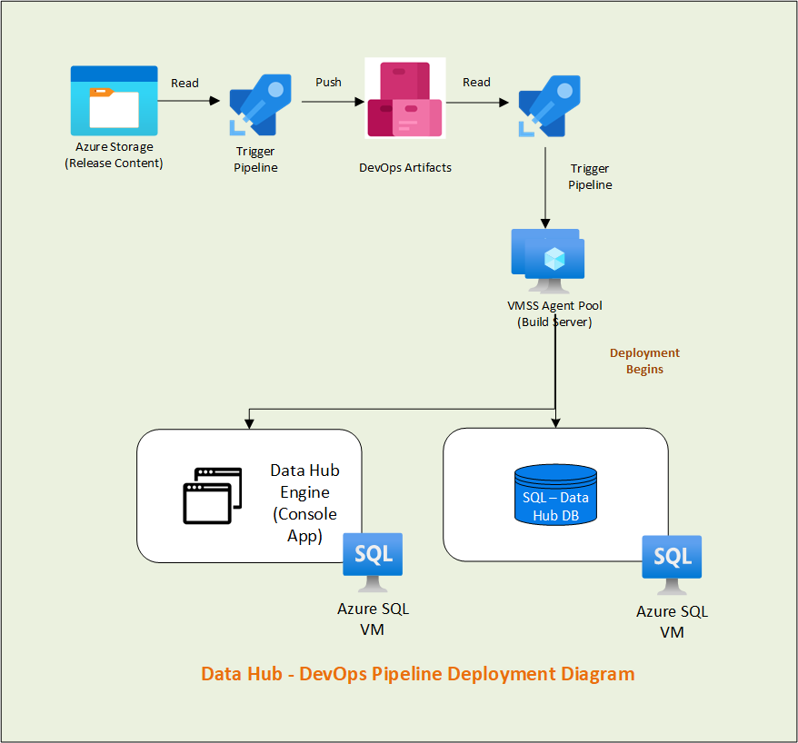

### 10.1.4 Release Pipeline Setup

#### **10.1.4.1 Pipeline -** Get & Deploy Artifacts

* + - **Job -** Getting Contents from Storage and Deploy in Artifacts
    - **Task List -**



#### 10.1.4.2 Pipeline - DH W Artifacts

* + - **Job – Read Artifacts**
    - **Task List –**

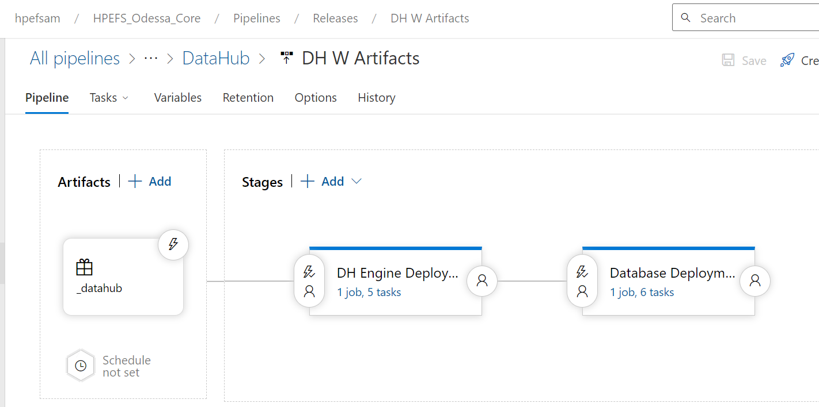

## 10.2 Pipeline Setup – ITG (HPE owned)

### 10.2.1 Prerequisite Configuration/Permissions for ITG

Below table contains the permissions granted for DEV environment and are the pre-requisite configuration for DevOps Pipeline setup.

NOTE: Below access is to be reviewed before proceeding for granting access.

**Note: Similar permissions are required to be granted for higher environments to set up DevOps Pipeline.**

|  |  |  |  |
| --- | --- | --- | --- |
| **Type/**  **Category** | **Pre-configuration Permission Tasks** | **Object/**  **Resource Name** | **Notes** |
| Azure Service Principal | Create DevOps Service Principal (SP) | **Service Connection –**  hpefs-odessa-devops-sp-itg | This is the first step where SP to be created in Azure |
| DevOps  Service Connection | Create DevOps Service Connection (SC) by pointing to above SP | **Service Principal-**  hpefs-odessa-devops-sp-itg | Once we have above SC then create SP in DevOps by pointing to this SP |
| DevOps  Artifacts | Add Contributor Access to Project Collection Build Service | **Path -** Azure Devops->Artifacts->Settings->Permission->  Permission - Contributor | By default, permission is set to – Collaborative which needs to be updated with Contributor access.  This has already been given so no further access is needed for higher environments. |
| Azure VMSS | Granting access to VM Scale-set on Storage Account’s container | **VMSS Name –**vmssdevopsnonp  Storage Container Name – stodessacoreblobdev  **IAM Role -** Storage Blob Data Reader | This access has been given already so no further access is needed for higher environments. |
| Azure Key Vault | Grant access policy to SP on Key Vault Secrets | **Key Vault –**  kv-hpefs-odessa-dev  **SP -** hpefs-odessa-devops-sp-itg  **IAM Role –** Contributor  Access Policy – Get and List | This permission is required to download credentials from Key Vault.  **Keys:**  odessa-hpefs-devops-db-username  odessa-hpefs-devops-db-password |
| Azure DH VM | Grant VM Admin permission to domain account within Report Server VM | **Domain Account** – hpefsoddevopssadev  **DH VM** – vmdatamartitg / 10.17.10.5  **Permission** – Administrator Group | This permission is required on VM to deploy Engine contents |
| Azure DH VM | Grant IAM roles to SP for Report Server VM | **DH VM** – vmdatamartitg / 10.17.18.4  **IAM Roles** - Contributor, Virtual Machine Administrator Login | These permissions are needed to have access to DWH VM. |
| Azure DH VM | Create Inbound port within Report Server VM for Remote Powershell script execution | **Port No** – 5986  **DH VM** – vmdatamartitg / 10.17.10.5  vmsqlrepldev2 | Need to create Inbound Port  **Reference link –** [Configuring WinRM over HTTPS to enable PowerShell remoting](https://www.microsoft.com/en-gb/industry/blog/technetuk/2016/02/11/configuring-winrm-over-https-to-enable-powershell-remoting/). |
| Azure DH VM | Create certificate within Report Server VM for Remote Powershell script execution | **Self-Signed Certificate –** vmdatamartdev (Friendly Name)  vmsqlrepldev2(Friendly Name)  **DH VM –**  vmdatamartdev / 10.17.10.5  (Friendly Name)  vmsqlrepldev2(Friendly Name) | For DEV environment, Self-signed certificate is used. TBD if CA certificate can be used.  For Higher environment this is recommended to have CA certificate  **Reference link –** [Configuring WinRM over HTTPS to enable PowerShell remoting](https://www.microsoft.com/en-gb/industry/blog/technetuk/2016/02/11/configuring-winrm-over-https-to-enable-powershell-remoting/). |
| SQL Server within Azure DH VM | Create new SQL user for DevOps within SQL Server and grant sys_admin roles | **Local SQL User –** OdessaDHDevOps  **SQL Server–** vmsqlrepldev2\hpfsids_OdessaDM  **Roles –** sys_admin | Permission needed for deploying DDL, DML and Job creation related scripts |
| Azure App Configuration | Grant IAM role to SP for App Configuration | **App Configuration Name –** appcs-hpefs-odessa-dev  **SP –** odessa-hpefs-devops-sp-dev  **IAM Role -** App Configuration Data Reader Role, Owner/Custom Read/Write/Delete (still pending) | Permission to read/update/delete App configuration keys. |

### **10.2.2 Enable Remote Execution from DevOps Pipeline within Data Hub VM**

To enable remove power shell execution, refer the following steps –

Reference Link - [Configuring WinRM over HTTPS to enable PowerShell remoting](https://www.microsoft.com/en-gb/industry/blog/technetuk/2016/02/11/configuring-winrm-over-https-to-enable-powershell-remoting/).

1. **Enable Port 5986**

Login to VM->Open Windows FireWall with Advanced Security->

Verify Port 5986 is allowed or not in Inbound Rule, if not allowed and Rule exist then enable it.

If Rule is not existed create a new inbound Rule

* Open “Windows Defender Firewall” and click on “Advance settings” and click on “Inbound Rules” and create new inbound rule.



* Enable Inbound 5986 port as below -



Step 3:



Step 4:



Step 5:



Step 6:



1. **Create Self-signed certificate**

* Logon to the Server using RDP.
* Open Windows PowerShell ISE in admin mode and execute the following command and copy the thumbprint.
* Provide VM DNS name and Friendly Name for below yellow highlighted color- and execute it.

|  |
| --- |
| New-SelfSignedCertificate -DnsName '<vmdatamartdev.hpefs-odessa.com>' -CertStoreLocation Cert:\LocalMachine\My -FriendlyName 'vmdatamartdev' |



1. **Configure WinRM to listen on 5986.**

* Open command prompt in admin mode
* Run the following command, pasting your new certificate’s thumbprint into the command (all on one line)

|  |
| --- |
| winrm create winrm/config/Listener?Address=*+Transport=HTTPS @{Hostname="vmdatamartdev.hpefs-odessa.com"; CertificateThumbprint="3F9DB70C21C987D1D7807D2B7B3613DDB071902E"} |



### 10.2.3 Automated Pipeline Deployment Workflow

The below infrastructure of Data Hub is same for all HPE Environments (DEV, ITG, STG and Production).



### 10.2.4 Release Pipeline Setup

## 10.3 Pipeline Setup – STG (HPE owned)

### 10.3.1 Prerequisite Configuration/Permissions for STG

Below table contains the permissions granted for DEV environment and are the pre-requisite configuration for DevOps Pipeline setup.

NOTE: Below access is to be reviewed before proceeding for granting access.

**Note: Similar permissions are required to be granted for higher environments to set up DevOps Pipeline.**

|  |  |  |  |
| --- | --- | --- | --- |
| **Type/**  **Category** | **Pre-configuration Permission Tasks** | **Object/**  **Resource Name** | **Notes** |
| Azure Service Principal | Create DevOps Service Principal (SP) | **Service Connection –**  odessa-hpefs-devops-sp-dev | This is the first step where SP to be created in Azure |
| DevOps  Service Connection | Create DevOps Service Connection (SC) by pointing to above SP | **Service Principal-**  odessa-hpefs-devops-sp-dev | Once we have above SC then create SP in DevOps by pointing to this SP |
| DevOps  Artifacts | Add Contributor Access to Project Collection Build Service | **Path -** Azure Devops->Artifacts->Settings->Permission->  Permission - Contributor | By default, permission is set to – Collaborative which needs to be updated with Contributor access.  This has already been given so no further access is needed for higher environments. |
| Azure VMSS | Granting access to VM Scale-set on Storage Account’s container | **VMSS Name –**vmssdevopsnonp  Storage Container Name – stodessacoreblobdev  **IAM Role -** Storage Blob Data Reader | This access has been given already so no further access is needed for higher environments. |
| Azure Key Vault | Grant access policy to SP on Key Vault Secrets | **Key Vault –**  kv-hpefs-odessa-dev  **SP -** odessa-hpefs-devops-sp-dev  **IAM Role –** Contributor  Access Policy – Get and List | This permission is required to download credentials from Key Vault.  **Keys:**  odessa-hpefs-devops-db-username  odessa-hpefs-devops-db-password |
| Azure DH VM | Grant VM Admin permission to domain account within Report Server VM | **Domain Account** – hpefsoddevopssadev  **DH VM** – vmdatamartdev / 10.17.10.5  **Permission** – Administrator Group | This permission is required on VM to deploy Engine contents |
| Azure DH VM | Grant IAM roles to SP for Report Server VM | **DH VM** – vmdatamartdev / 10.17.10.5  **IAM Roles** - Contributor, Virtual Machine Administrator Login | These permissions are needed to have access to DWH VM. |
| Azure DH VM | Create Inbound port within Report Server VM for Remote Powershell script execution | **Port No** – 5986  **DH VM** – vmdatamartdev / 10.17.10.5  vmsqlrepldev2 | Need to create Inbound Port  **Reference link –** [Configuring WinRM over HTTPS to enable PowerShell remoting](https://www.microsoft.com/en-gb/industry/blog/technetuk/2016/02/11/configuring-winrm-over-https-to-enable-powershell-remoting/). |
| Azure DH VM | Create certificate within Report Server VM for Remote Powershell script execution | **Self-Signed Certificate –** vmdatamartdev (Friendly Name)  vmsqlrepldev2(Friendly Name)  **DH VM –**  vmdatamartdev / 10.17.10.5  (Friendly Name)  vmsqlrepldev2(Friendly Name) | For DEV environment, Self-signed certificate is used. TBD if CA certificate can be used.  For Higher environment this is recommended to have CA certificate  **Reference link –** [Configuring WinRM over HTTPS to enable PowerShell remoting](https://www.microsoft.com/en-gb/industry/blog/technetuk/2016/02/11/configuring-winrm-over-https-to-enable-powershell-remoting/). |
| SQL Server within Azure DH VM | Create new SQL user for DevOps within SQL Server and grant sys_admin roles | **Local SQL User –** OdessaDWHDevOps  **SQL Server–** vmsqlrepldev2\hpfsids_OdessaDM  **Roles –** sys_admin | Permission needed for deploying DDL, DML and Job creation related scripts |
| Azure App Configuration | Grant IAM role to SP for App Configuration | **App Configuration Name –** appcs-hpefs-odessa-dev  **SP –** odessa-hpefs-devops-sp-dev  **IAM Role -** App Configuration Data Reader Role, Owner/Custom Read/Write/Delete (still pending) | Permission to read/update/delete App configuration keys. |

### **10.3.2 Enable Remote Execution from DevOps Pipeline within Data Hub VM**

To enable remove power shell execution, refer the following steps –

Reference Link - [Configuring WinRM over HTTPS to enable PowerShell remoting](https://www.microsoft.com/en-gb/industry/blog/technetuk/2016/02/11/configuring-winrm-over-https-to-enable-powershell-remoting/).

1. **Enable Port 5986**

Login to VM->Open Windows FireWall with Advanced Security->

Verify Port 5986 is allowed or not in Inbound Rule, if not allowed and Rule exist then enable it.

If Rule is not existed create a new inbound Rule

* Open “Windows Defender Firewall” and click on “Advance settings” and click on “Inbound Rules” and create new inbound rule.



* Enable Inbound 5986 port as below -



Step 3:



Step 4:



Step 5:



Step 6:



1. **Create Self-signed certificate**

* Logon to the Server using RDP.
* Open Windows PowerShell ISE in admin mode and execute the following command and copy the thumbprint.
* Provide VM DNS name and Friendly Name for below yellow highlighted color- and execute it.

|  |
| --- |
| New-SelfSignedCertificate -DnsName '<vmdatamartdev.hpefs-odessa.com>' -CertStoreLocation Cert:\LocalMachine\My -FriendlyName 'vmdatamartdev' |



1. **Configure WinRM to listen on 5986.**

* Open command prompt in admin mode
* Run the following command, pasting your new certificate’s thumbprint into the command (all on one line)

|  |
| --- |
| winrm create winrm/config/Listener?Address=*+Transport=HTTPS @{Hostname="vmdatamartdev.hpefs-odessa.com"; CertificateThumbprint="3F9DB70C21C987D1D7807D2B7B3613DDB071902E"} |



### 10.3.3 Automated Pipeline Deployment Workflow

The below infrastructure of Data Hub is same for all HPE Environments (DEV, ITG, STG and Production).



### 10.3.4 Release Pipeline Setup

# 11. Steps for Creating/Updating Azure Key Vault **Secrets**

To know Key Vault resource names, refer to [Resource List](https://odessatechnologies.sharepoint.com/:x:/r/sites/HPE/Shared%20Documents/Technical/Sizing%20%26%20Environments/Deployment%20Guide/HPEF-Odessa%20Applications%20-%20Resource%20List.xlsx?d=wd33be1590dcf4fedb7d2863a9b02970b&csf=1&web=1&e=gUtj48) document.

## 11.1 Sample for Creating new Secret –

**Key Name:** Lw.Reports.LoginName

**Key Value:** Db_Job

1. Log in to Azure Portal -> Search Key Vaults -> Select Key Vault based on environment.

Here is a sample where DEV Key Vault is used.

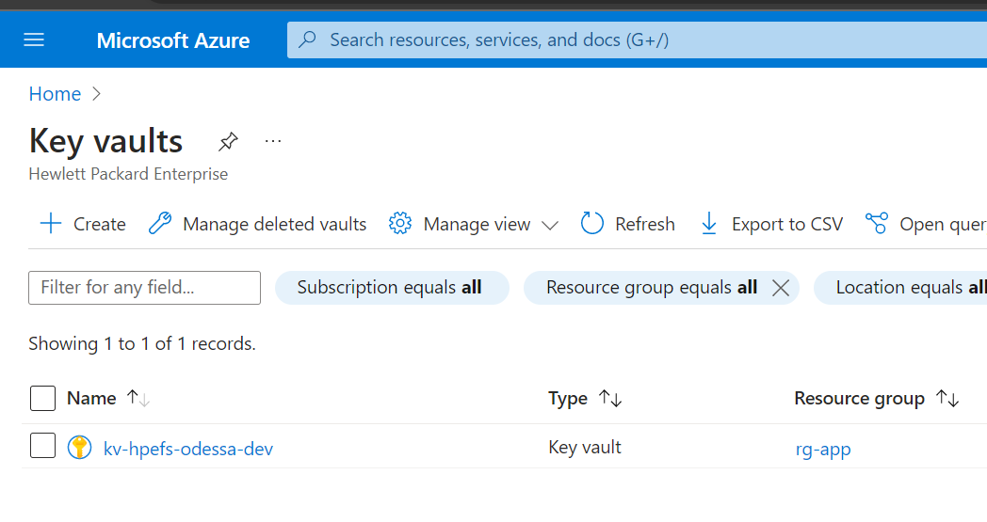

1. Select Secrets -> To Add a new Secret Click on Generate/Import

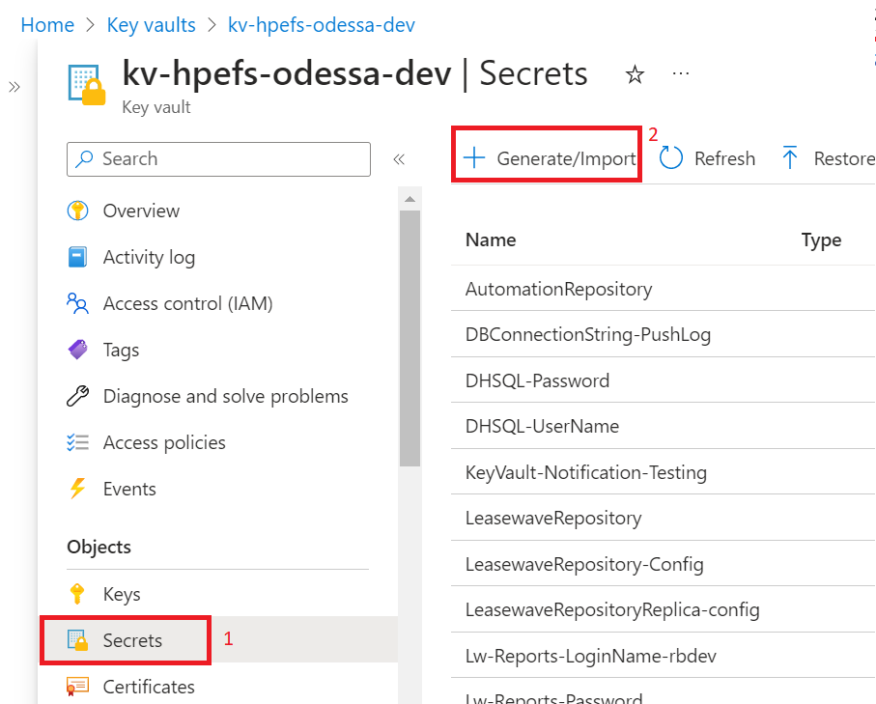

1. Please Note KeyVault Secret doesnot support dot ‘.’ In Key Name, so instead of dot we are using ‘- ‘like below-> Provide value -> Click Create

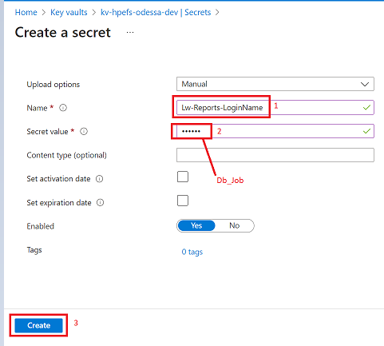

1. You can find the newly created Key in the Secret Section.

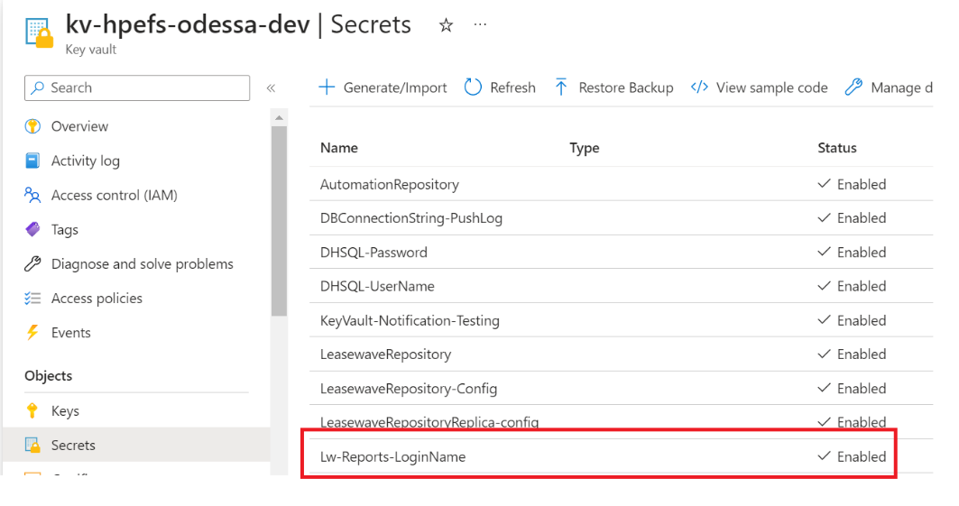

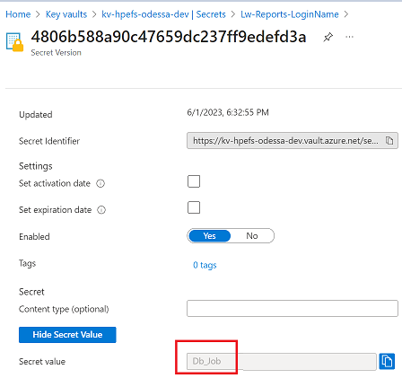

## 11.2 Sample for Updating an existing Secret –

Suppose we want to change the Report Login Name from DB_Job to Db_Job1.

Key Name: Lw.Reports.LoginName

Old Key value: Db_Job

New Key value: Db_Job1

1. Log in to Azure Portal -> Search Key Vaults -> Select Keyvalut based on environment.

Here is a sample where DEV Key Vault is used.



1. Select Secrets -> To Update existing Secret search your Secret name -> Click on Secret Name

In our case Key name is Lw-Reports-LoginName

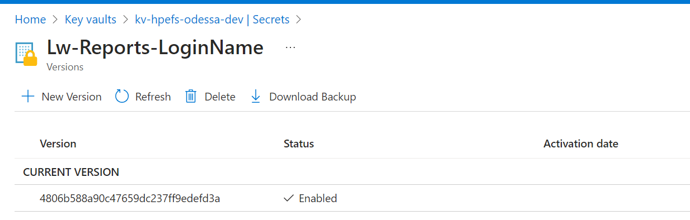

1. Click on Current version -> Disable -> Apply.

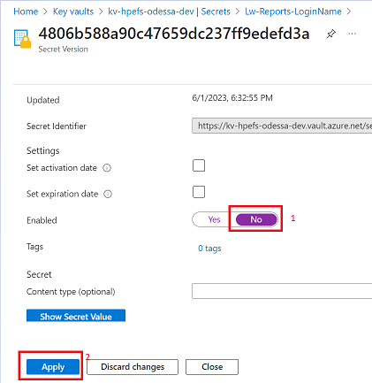

1. Go to KeyVault Homepage-> Secrets -> Click on Secret Name -> Add a new version.

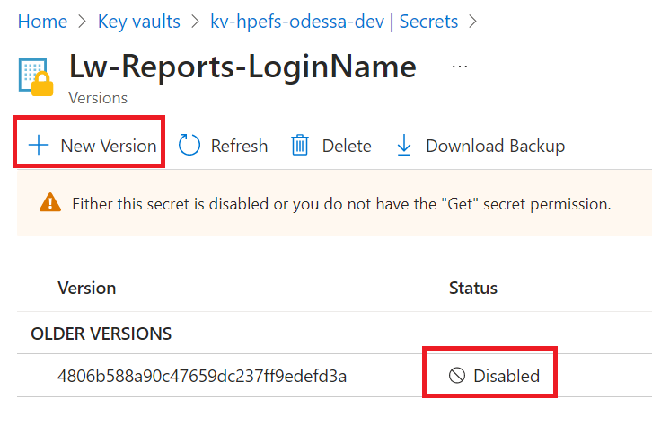

1. Provide New value for this key and Click on Create

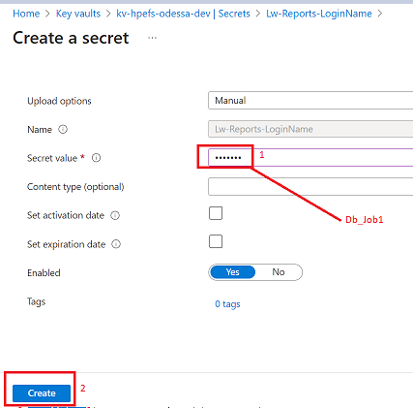

1. Go to keyvault Secret again and verify there should be only 1 value Enabled which is current version.

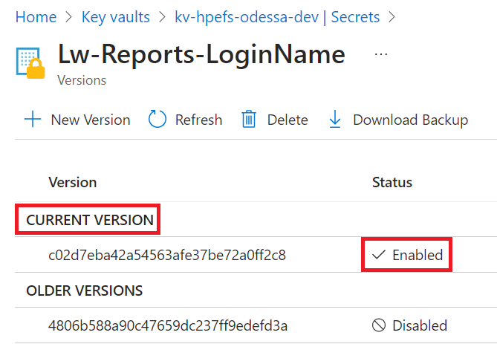

1. You can Validate the value of current Version by clicking on it-> Show Secret Value

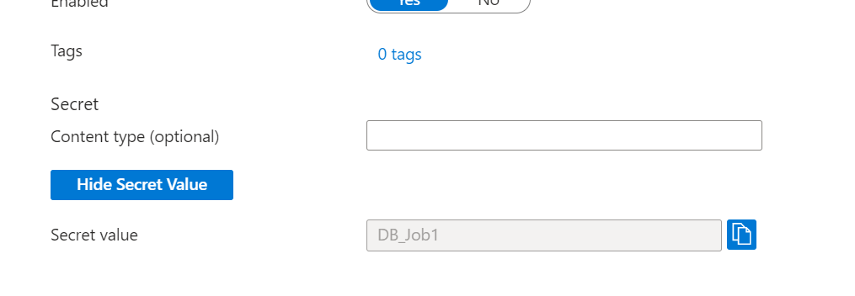

# 12. Steps for Creating/Updating Azure App Configuration Keys

Azure App Configuration Comes into picture when we want to use same App Configuration for different environments. For Example, Dev Resource Group Contains both Core Dev and Core Gold Config. If we want to use take Report login name from Key Vault, it is not possible because already we have defined 1 key for core DEV.

In this situation, we can use Azure App Configuration.

We can directly add keys in Azure App Configuration with **Label,** or we can add from key vault references like below.

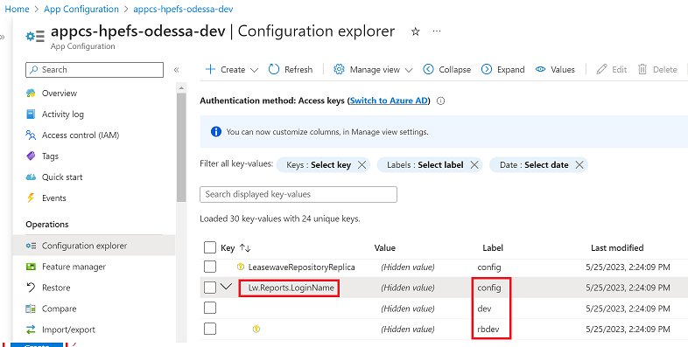

To know Key Vault resource names, refer to [Resource List](https://odessatechnologies.sharepoint.com/:x:/r/sites/HPE/Shared%20Documents/Technical/Sizing%20%26%20Environments/Deployment%20Guide/HPEF-Odessa%20Applications%20-%20Resource%20List.xlsx?d=wd33be1590dcf4fedb7d2863a9b02970b&csf=1&web=1&e=gUtj48) document.

## 12.1 Sample for Creating new Key –

**Key Name:** Lw.Reports.LoginName

**Key Value:** Db_Job

1. Log in to Azure Portal -> Search App Configuration -> Select App Configuration based on environment.

Here is a sample where DEV App Configuration is used.

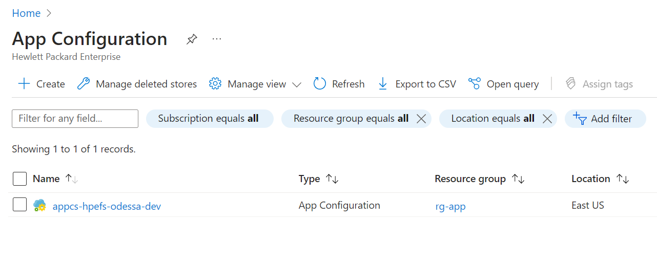

1. Open App Configuration -> Click on Configuration Explorer -> Click on Create.

Here you can find 2 Options Key-Value & Key Vault reference.

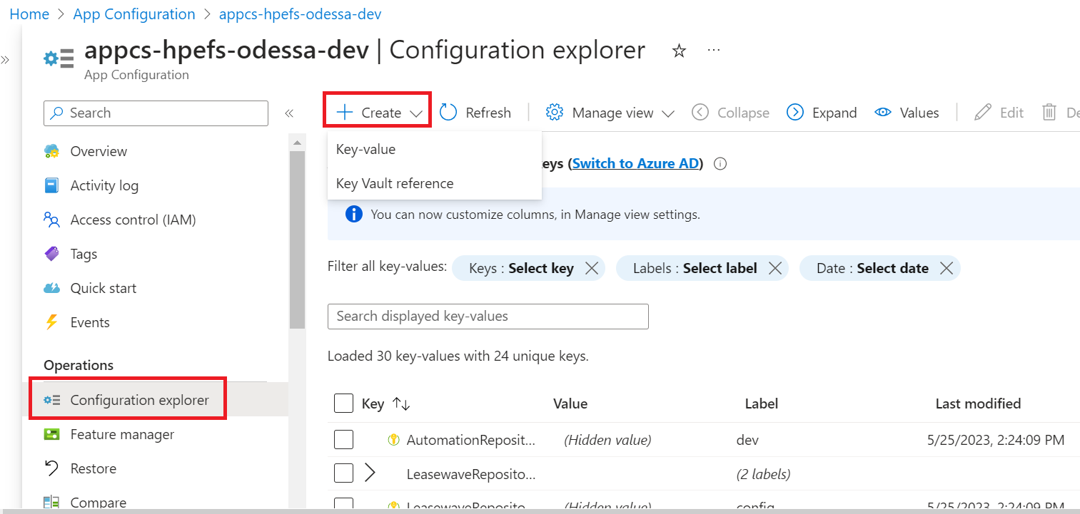

### 12.1.1 Key-value

Here we can directly add the key name and Value like below.

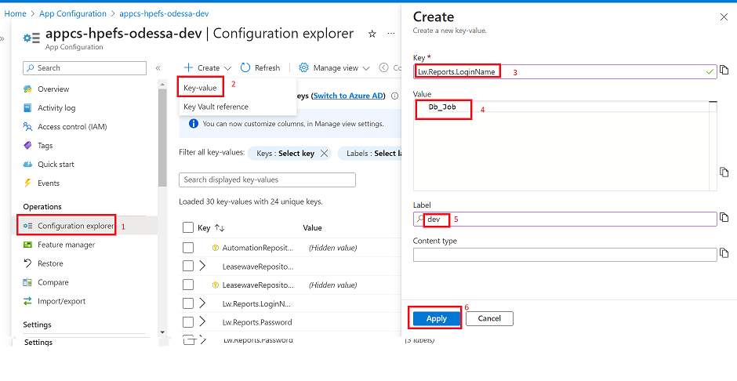

Once you click Apply, the key will appear in Configuration Explorer.

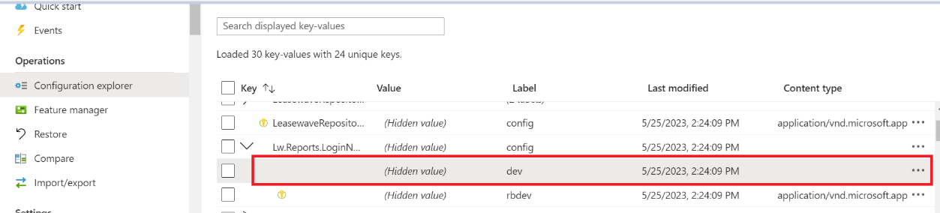

### 12.1.2 Key Vault reference

Here we need to fetch the key and value from Key Vault like below.

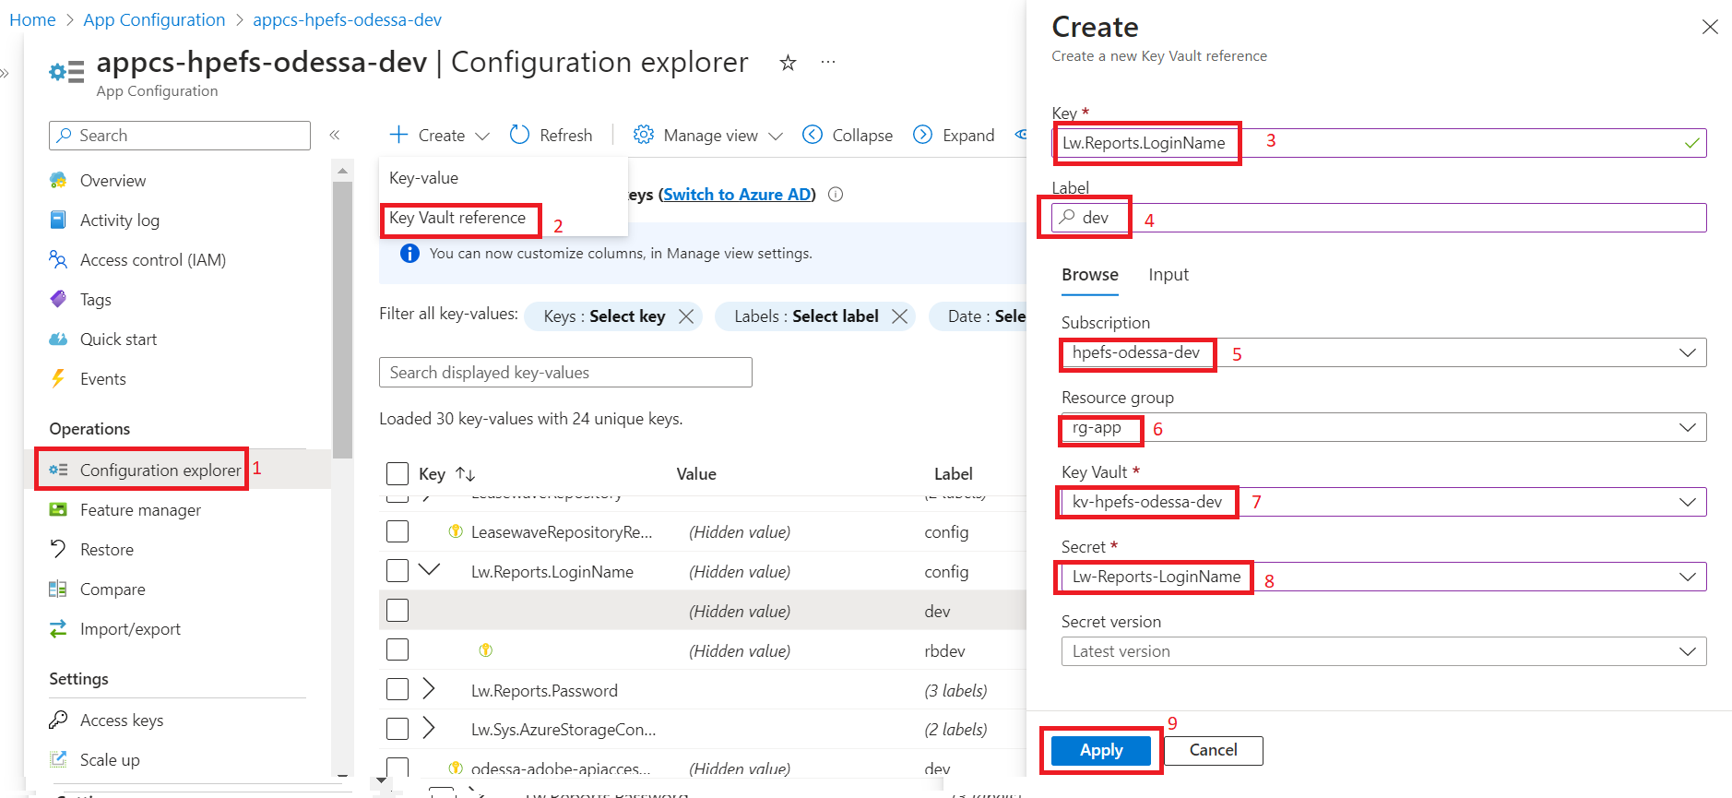

## 12.2 Sample for Updating an existing key –

For Updating App Configuration, we can follow the steps below.

### 12.1.1 Update Key-value

1. Open App Configuration -> Config Explorer -> Search your keyname -> Verify the label -> Click on … -> Edit

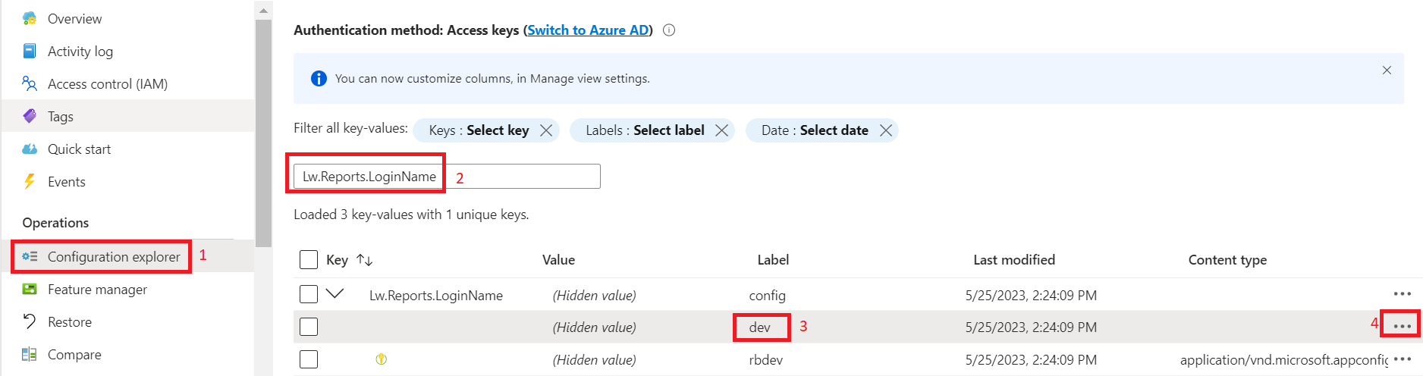

1. Suppose you want to modify the keyname from DB_Job to Odessa

Modify the Value as shown below-> Apply.

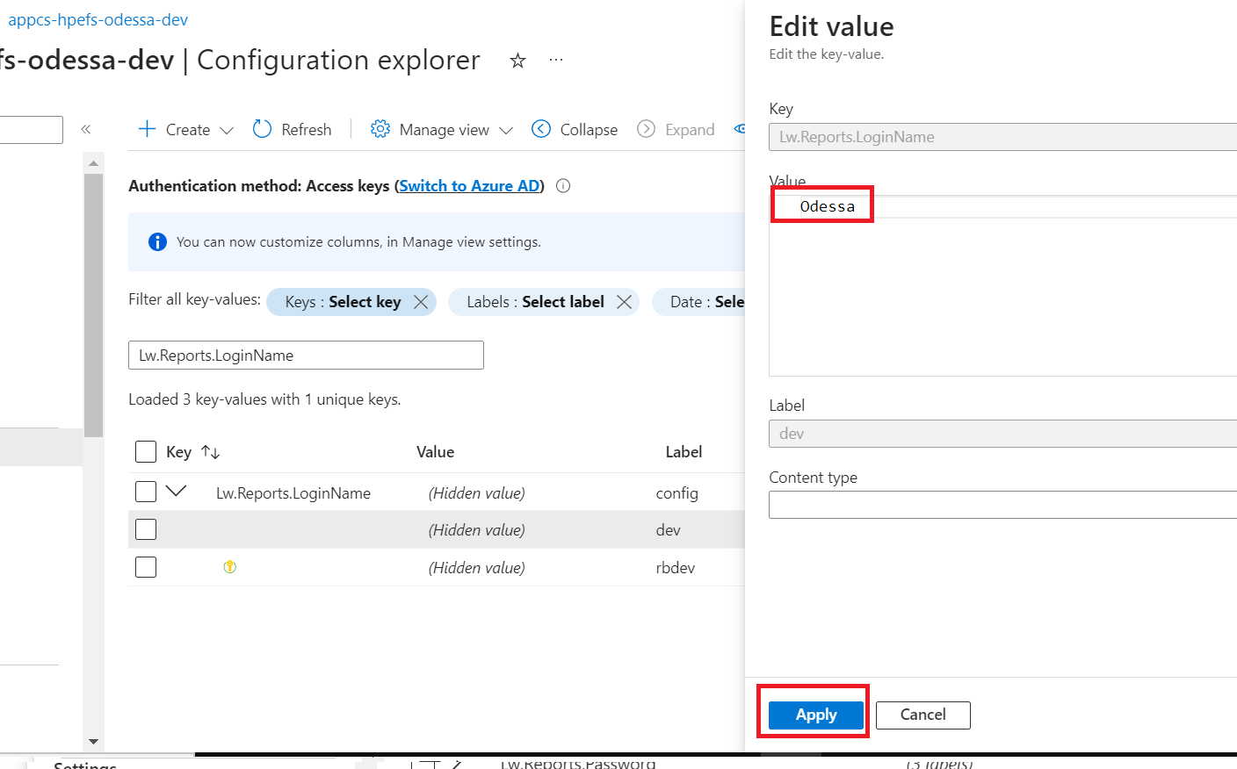

### 12.1.2 Update Key Vault reference

For Key Vault reference we need to update the value in Keyvault, please refer Section 11.2 to Update Keyvault Secrets.

Once Keyvault Secrets are Updated we can link the keyvault again from App Configuration

Open App Configuration -> Config Explorer -> Search your keyname -> Verify the label -> Click on … -> Edit -> Provide all required details as mentioned below -> Click on Apply

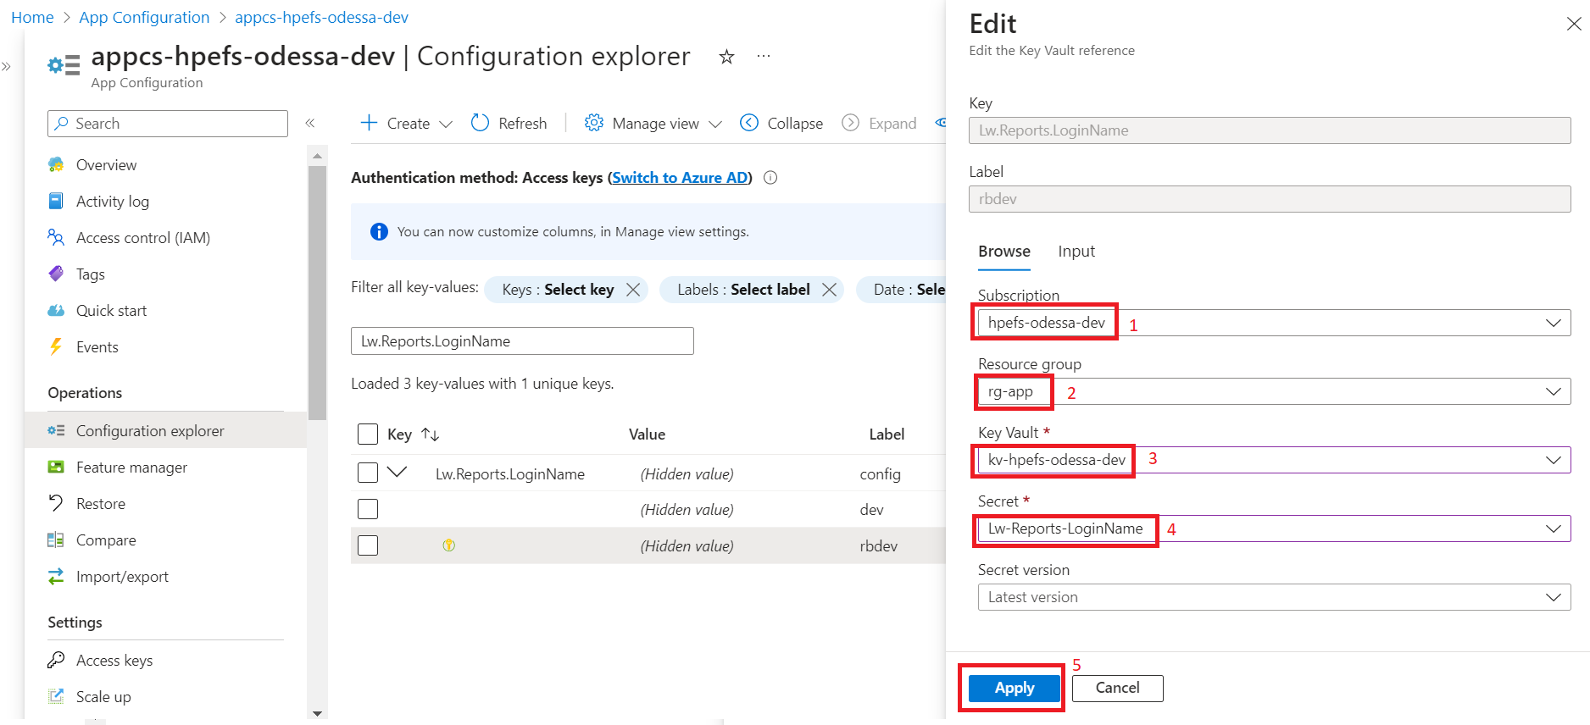

# 13. Odessa Core Deployment

Odessa core deployment follows the hybrid model. There are some components which **require manual steps** for deployment. Please refer to the below list with **sequence** for deploying the application.

For deployment, users should be using **Create Release** option to trigger the deployment. Below is the list of tasks which explain both **automated** and **manual** steps.

For creating a release, refer to section 13.2.

## 13.1 Automated and Manual Release Tasks

|  |  |  |  |
| --- | --- | --- | --- |
| Sequence No. | **Component/Task** | **Deployment Mode**  **(Automated/Manual)** | **Instructions** |
| 1 | **Validate Audit Jobs Completion**  Ensure that Audit Jobs are completed within Core Application | Manual **(Odessa Team/Bala will inform about Jobs to take care before release deployment)** | Refer section 13.2 |
| 2 | **Create Release**  Trigger Pipeline for reading release content from storage container and uploading within DevOps Artifacts | Automated | **Pipeline Name -**  Get & Deploy Artifacts  Refer section 13.3 |
| 3. | **Deploy Core Components**  Trigger Pipeline for Deploying contents | Automated | **Pipeline Name -**  Odessa Core w Artifacts  Refer section 13.4 |
| 4. | **Update Config Changes**  Configuration Changes | Manual | Refer section 13.5 |
| 5. | **Restart Core Services**  Trigger Pipeline for Restart Core Services | Automated | **Pipeline Name -**  Restart Core App Services  Refer section 13.6. |
| 6. | **Upload Business Configuration** | Manual | **Manual Steps-**  Refer section 13.7 |
| 7. | **Upload RBS** | Manual | **Manual Steps –**  Refer section 13.8 |
| 8. | **Executing Workflow Setup** | Manual | **Manual Steps-**  Refer section 13.9 |
| 9. | **Execute Extract SP in both MAIN & Replica DB** | Manual (This is applicable only those environments where team has added Replica Connection)­­ | **Manual Steps-**  Refer section 13.10 |
|  |  |  |  |

## 13.2 Steps for – Validate Audit Jobs Completion

* Ensure the Audit job is completed in the Job Instances module.
  + **Steps: -**

Login->Search -> Job Instances-> check status of Auditing – Temp Data Capture job = Completed

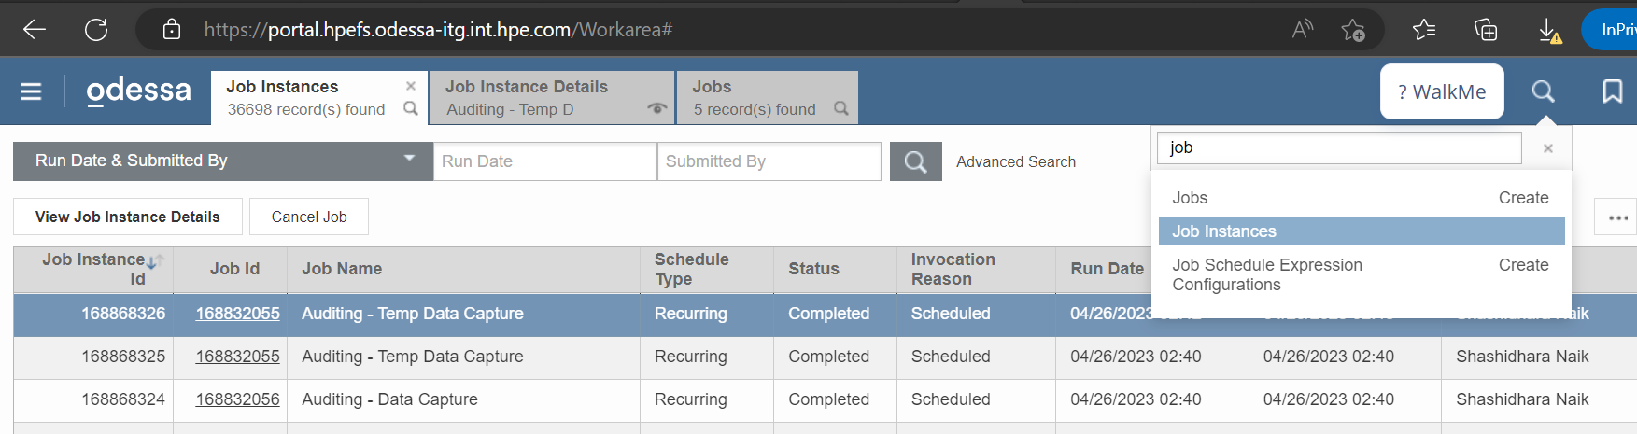

## 13.3 Steps for - Create Release

* Trigger Pipeline to download and Upload content in DevOps Artifacts.
  + **Steps: -**

Release Pipeline -> HPE-DEV -> Odessa-Core -> **Get & Deploy Artifacts** -> Create Release

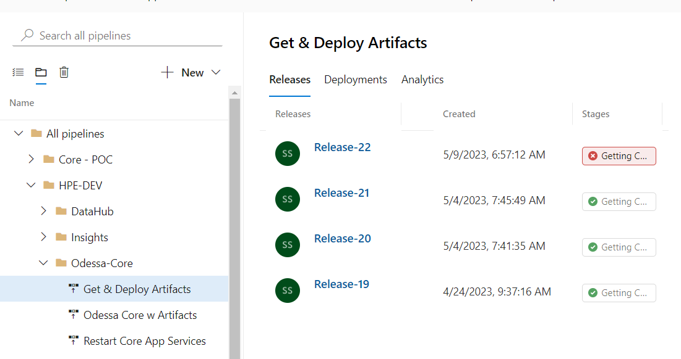

Provide Release version shared by Odessa team -> Create

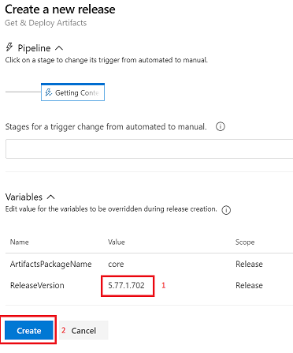

## 13.4 Steps for – Deploy Core Components

* Trigger release. Steps: -

Release Pipeline -> HPE-DEV -> Odessa-Core -> Odessa Core w Artifacts -> Create Release

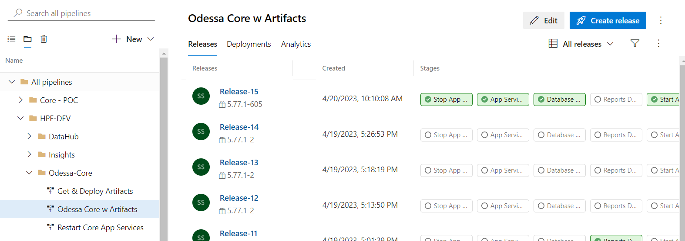

Select Artifacts version from dropdown-> Provide Release version -> Create

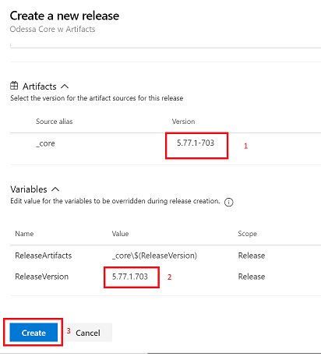

## 13.5 Steps for – Update Config Changes

* Update Configuration file.
  + **Steps: -**

Login to Jump box->Open WinSCP -> Login to specific Web App’s (APP, Web API, Job Service) FTP Credentials.

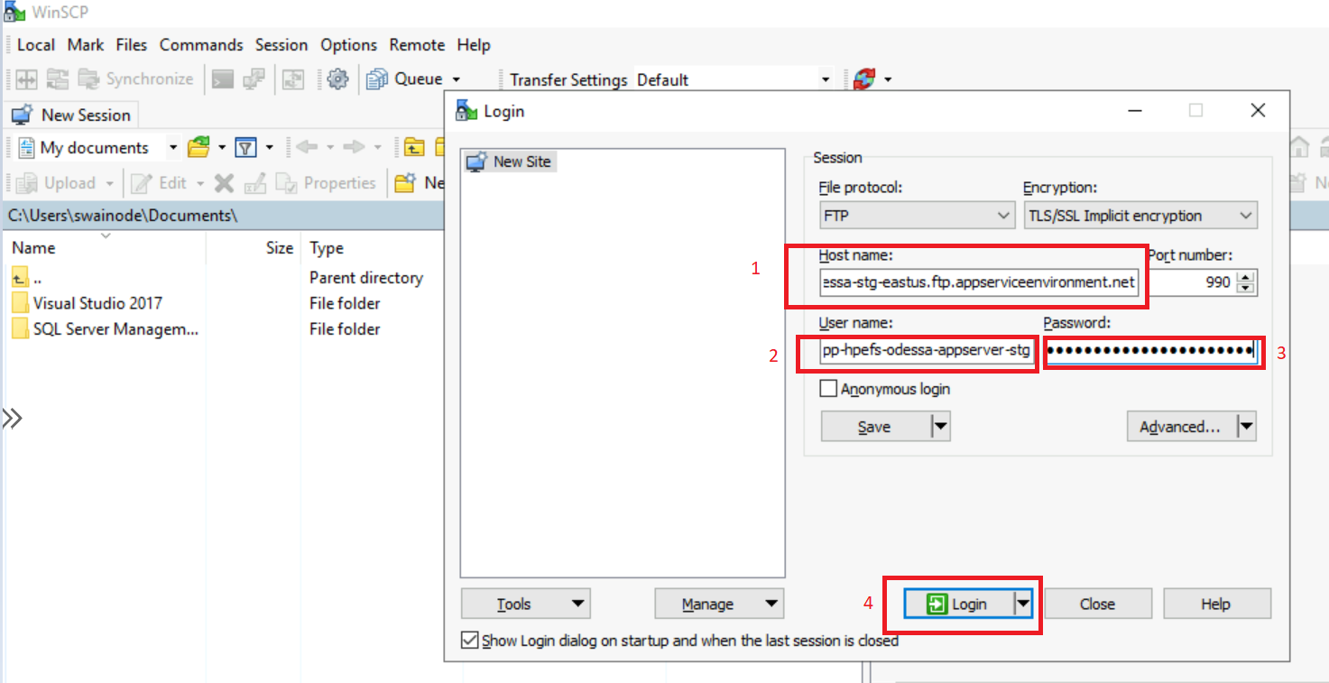

* For App and Web API update Following file according to readme.txt file.
* Appsettings.config
* Connectionstings.config
* Web.config
* For Jobs/Windows Service update following file according to readme.txt file
* Appsettings.config
* Connectionstings.config
* LW.WindowsService.exe.config

## 13.6 Steps for – Restart Core Services

* Restart Services. Steps: -

Release Pipeline -> HPE-DEV -> Odessa-Core -> Restart Core App Services -> Create Release

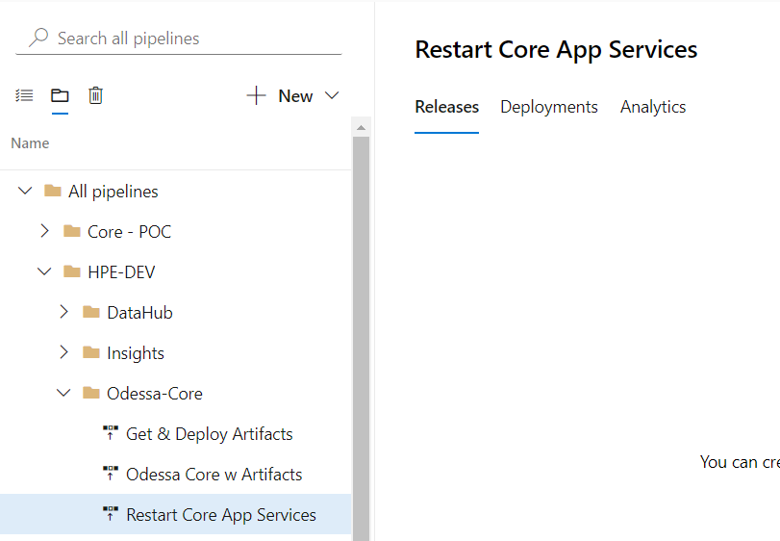

## 13.7 Steps for - Uploading Business Configuration

* Odessa POC Support

|  |  |  |
| --- | --- | --- |
| Name | Email Id | Roles |
| Avinesh Gupta | avinesh.gupta@odessainc.com | Lead Escalation |
| Pappu Yadav | pappu.yadav@odessainc.com | DevOps Team Member |
| Satyabrata Swain | satyabrata.swain@odessainc.com | DevOps Team Member |
| Sai Pavethra | sai.s@odessainc.com | Business Config Support Member |
| Jayanth S | jayanth.s@odessainc.com | Lead Escalation |
| Sudhanshu Gupta | sudhanshu.gupta@odessainc.com | Lead Escalation |

* Uploading Business configuration has two parts, upload MDC and running script. Steps for Uploading MDC:

Login to Odessa Core UI as Business User-> Import Master Data Release Pipeline -> Provide User Define Name -> Select MDC file -> Submit.

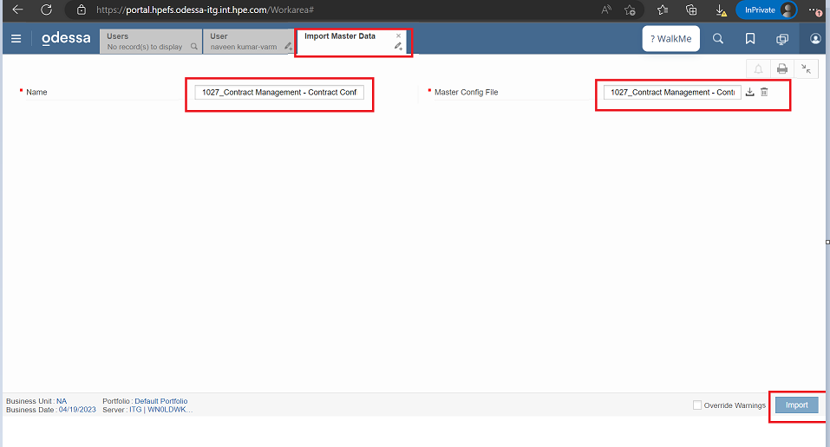

* Steps for running script: -

Login to SQL MI using SSMS > select DB -> run script.

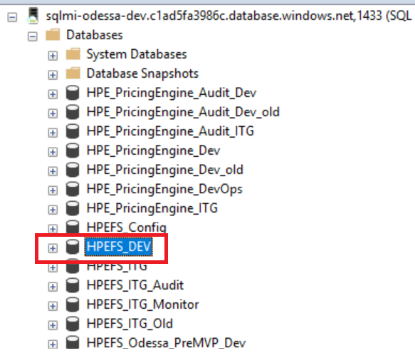

## 13.8 Steps for - Uploading RBS.

* Login Odessa Core UI as Security admin -> Search -> User Permission Files -> Create.

To login as security admin run below query by changing the Login Name (You can find your login name by removing @hpe.com from hpe Email).

UPDATE RolesForUsers SET RoleId=(SELECT Id FROM Roles WHERE Name='Security Administrator' AND IsActive=1)

WHERE UserId IN(SELECT Id FROM Users WHERE LoginName='Satyabrata.Swain-odessa') AND RoleId

IN(SELECT Id FROM Roles WHERE Name='Full Access' AND IsActive=1)

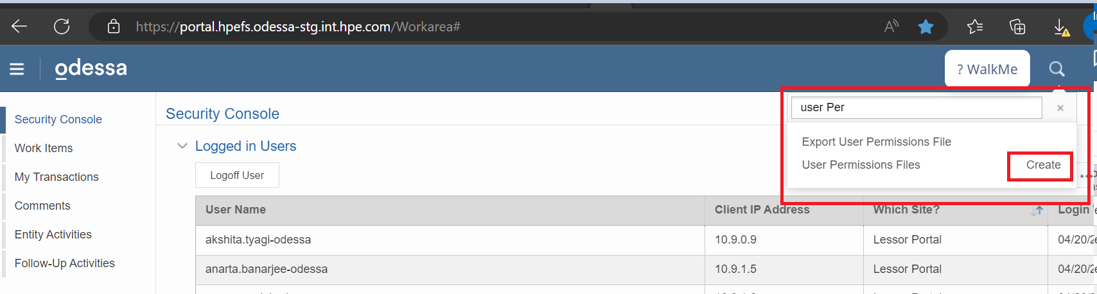

* Provie Name -> Upload RBS -> Submit.

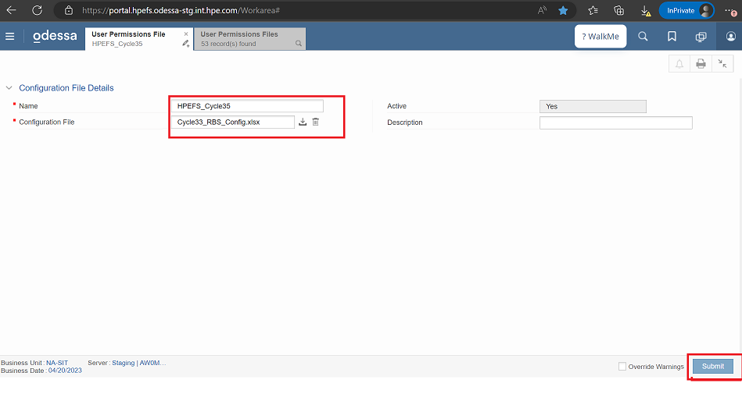

## 13.9 Steps for - Executing Workflow Setup

* Steps for running workflow set up with reference screen shot: -
* Login Odessa Core UI as Business User -> Search -> Workflow setup -> Submit

To login as Business User run below query by changing the Login Name (You can find your login name by removing @hpe.com from hpe Email).

UPDATE RolesForUsers SET RoleId=(SELECT Id FROM Roles WHERE Name=' Full Access' AND IsActive=1)

WHERE UserId IN(SELECT Id FROM Users WHERE LoginName='Satyabrata.Swain-odessa') AND RoleId

IN(SELECT Id FROM Roles WHERE Name=' Security Administrator' AND IsActive=1)

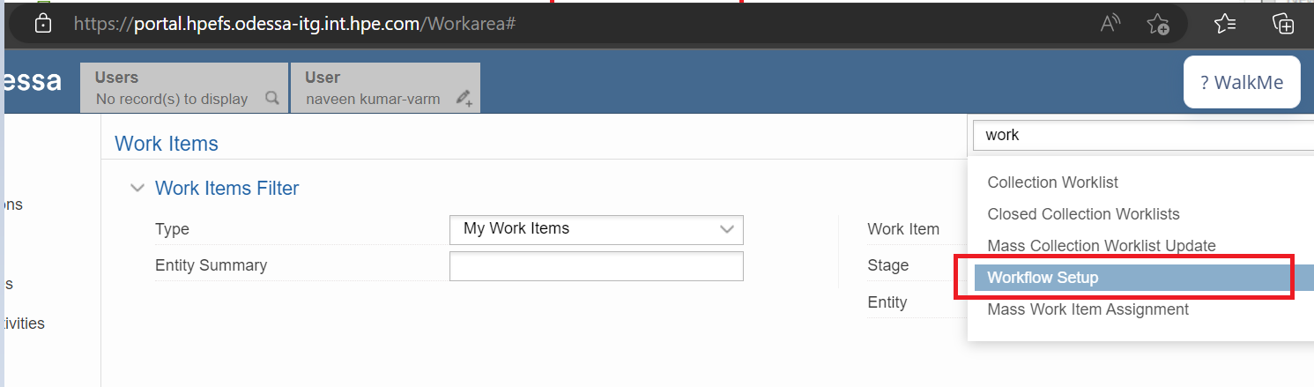

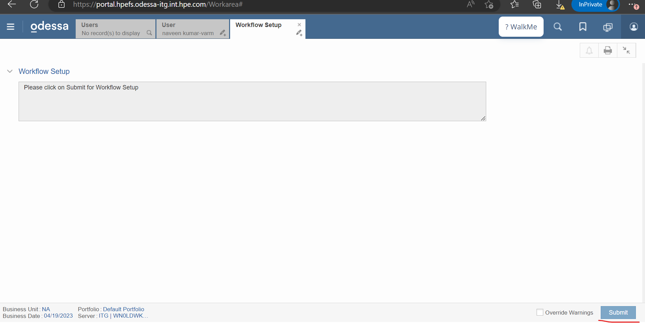

## 13.10 Steps for - Execute Extract SP in Main and Replica DB

The Odessa Dev Team is brainstorming this approach which might change in future.

### 13.10.1 Main DB

1. Open SSMS -> Provide Login Credentials -> Click on Options

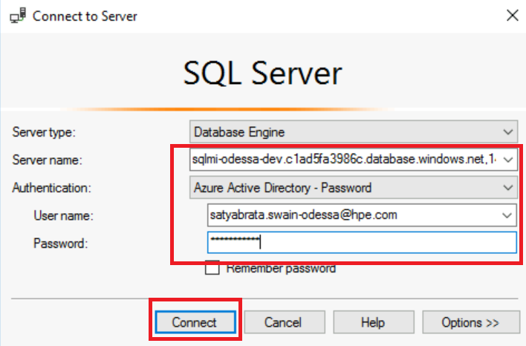

1. Open a new query window for respective environment DB. To Validate the Connection team can execute the below query and it should display READ_ONLY in output.

Query: **SELECT DATABASEPROPERTYEX(DB_NAME(), 'Updateability');**

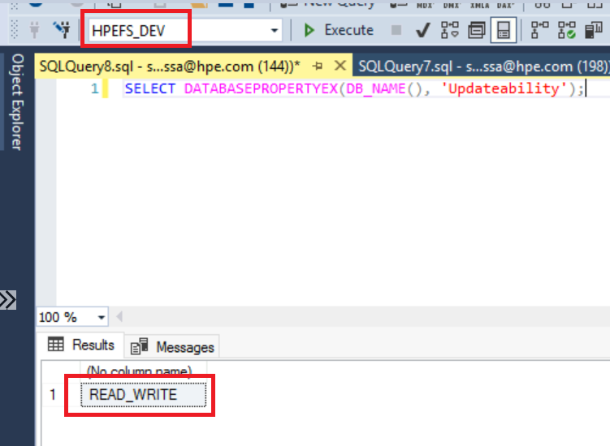

1. Execute Below Query to create Extract tables.

**EXEC CreateSynonymForJobs 1**

**GO**

**EXEC CreateExtractTables**

**GO**

**EXEC [dbo].[AlterUserAssignPermissions] @dbUserName = N'OdessaCore'**

**GO**

**DECLARE @DatabaseName SYSNAME =DB_NAME()**

**DECLARE @LoginName NVARCHAR(1000) = N'OdessaCore'**

**EXEC CreateSQLJobToCreateExtractTable @DatabaseName, @LoginName**

**GO**

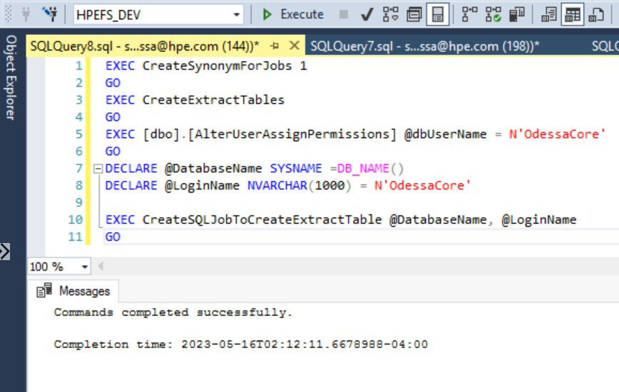

### Replica DB

1. Open SSMS -> Provide Login Credentials -> Click on Options

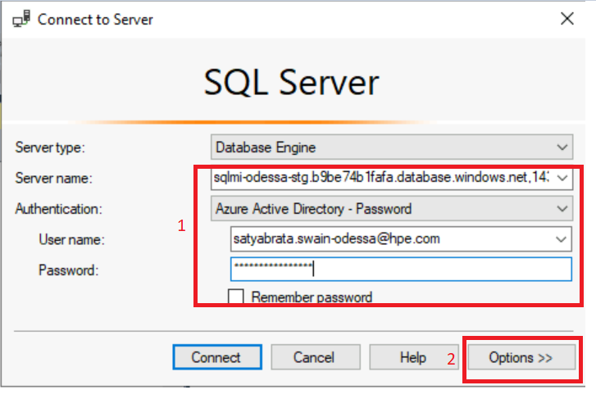

1. Click on Additional Connection Parameters -> Add **ApplicationIntent=READONLY** -> Click on Connect.

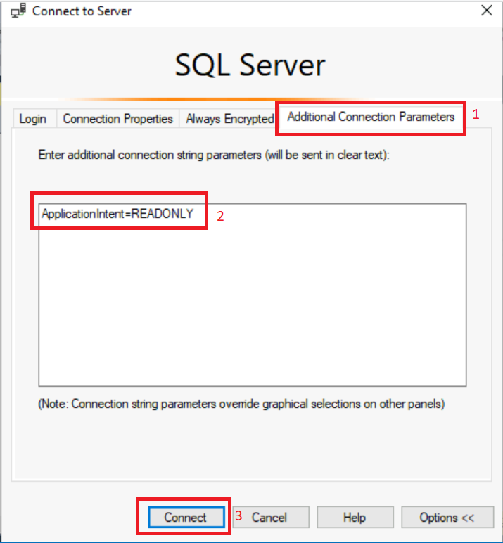

1. To Validate the ReadOnly Connection team can execute the below query and it should display READ_ONLY in output.

Query: **SELECT DATABASEPROPERTYEX(DB_NAME(), 'Updateability');**

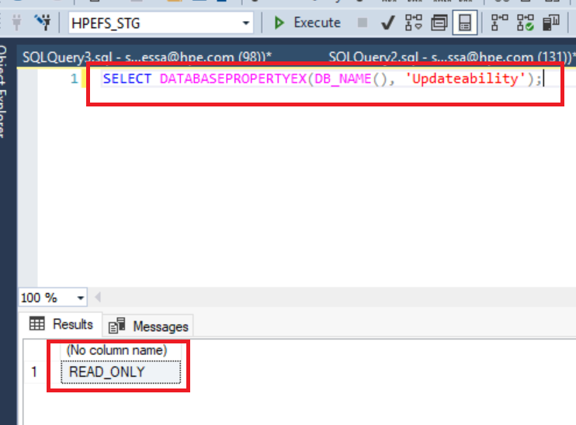

1. Execute Below Query to create Extract tables.

**EXEC CreateExtractTables**

**GO**

**EXEC [dbo].[AlterUserAssignPermissions] @dbUserName = N'OdessaCore'**

**GO**

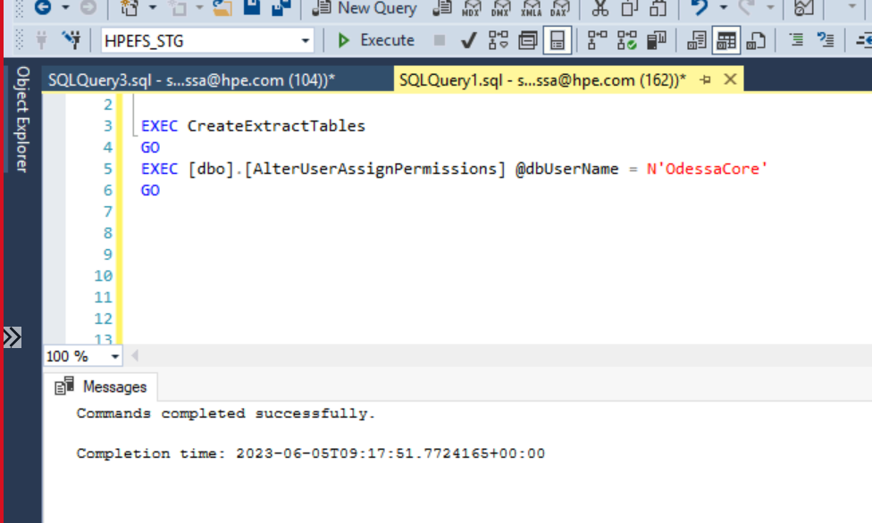

# 14. Golden Config – Core Deployment

Golden Config deployment follows the hybrid model. There are some components which require manual steps for deployment. Please refer to the below list with sequence for deploying this application.

## 14.1 Automated and Manual Release Tasks

|  |  |  |  |
| --- | --- | --- | --- |
| Sequence No. | **Component/Task** | **Deployment Mode**  **(Automated/Manual)** | **Instructions** |
| 1 | **Create Release**  Trigger Pipeline for reading release content from storage container and uploading within DevOps Artifacts | Automated | **Pipeline Name -**  Get & Deploy Artifacts  Refer section 14.2 |
| 2. | **Deploy GoldConfig-Core Components**  Trigger Pipeline for Deploying contents | Automated | **Pipeline Name -**  Odessa Core Config w Artifacts  Refer section 14.3 |
| 3. | **Update Config Changes**  Configuration Changes | Manual | Refer section 14.4 |
| 4. | **Restart GoldConfig-Core Services**  Trigger Pipeline for Restart Core Services | Automated | **Pipeline Name -**  Restart Core Config App Services  Refer section 14.5. |
| 5. | **Upload Business Configuration** | Manual | **Manual Steps-**  Refer section 14.6 |
| 6. | **Upload RBS** | Manual | **Manual Steps –**  Refer section 14.7 |
| 7. | **Executing Workflow Setup** | Manual | **Manual Steps-**  Refer section 14.8 |
| 8. | **Execute Extract SP in Replica DB** | Manual (This is applicable only those environments where team has added Replica Connection)­­ | **Manual Steps-**  Refer section 14.9 |
|  |  |  |  |

## 14.2 Steps for - Create Release

* Trigger Pipeline to download and Upload content in DevOps Artifacts.
  + **Steps: -**

Release Pipeline -> HPE-DEV -> GoldConfig-Core -> **Get & Deploy Artifacts** -> Create Release



Provide Release version shared by Odessa team -> Create



## 14.3 Steps for – Deploy GoldConfig-Core Components

* Trigger release. Steps: -

Release Pipeline -> HPE-DEV -> GoldConfig-Core -> Odessa Core Config w Artifacts -> Create Release

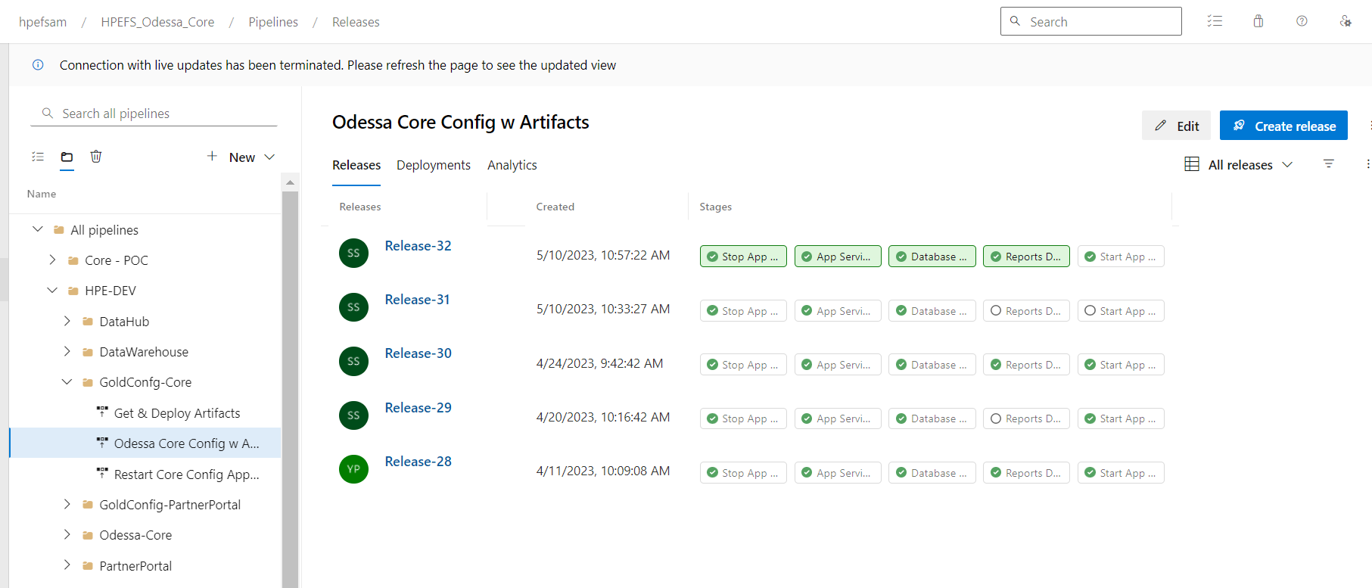

Select Artifacts version from dropdown-> Provide Release version -> Create



## 14.4 Steps for – Update Config Changes

* Update Configuration file.
  + **Steps: -**

Login to Jump box->Open WinSCP -> Login to specific Web App’s (APP, Web API, Job Service) FTP Credentials.



* For App update Following file according to readme.txt file.
* Appsettings.config
* Connectionstings.config
* Web.config
* For Jobs/Windows Service update following file according to readme.txt file
* Appsettings.config
* Connectionstings.config
* LW.WindowsService.exe.config

## 14.5 Steps for – Restart Core Config Services

* Restart Services. Steps: -

Release Pipeline -> HPE-DEV -> GoldConfig-Core -> Restart Core Config App Services -> Create Release



## 14.6 Steps for - Uploading Business Configuration

* Uploading Business configuration has two parts, upload MDC and running script. Steps for Uploading MDC:

Login to Odessa Core UI as Business User-> Import Master Data Release Pipeline -> Provide User Define Name -> Select MDC file -> Submit.



* Steps for running script: -

Login to SQL MI using SSMS > select DB -> run script.

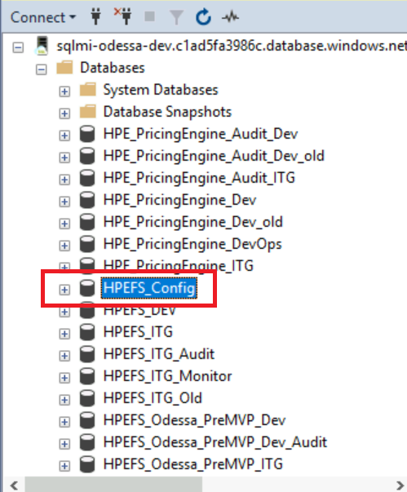

## 14.7 Steps for - Uploading RBS

* Login Odessa Core UI as Security admin -> Search -> User Permission Files -> Create.

To login as security admin run below query by changing the Login Name (You can find your login name by removing @hpe.com from hpe Email).

UPDATE RolesForUsers SET RoleId=(SELECT Id FROM Roles WHERE Name='Security Administrator' AND IsActive=1)

WHERE UserId IN(SELECT Id FROM Users WHERE LoginName='Satyabrata.Swain-odessa') AND RoleId

IN(SELECT Id FROM Roles WHERE Name='Full Access' AND IsActive=1)



* Provie Name -> Upload RBS -> Submit.



## 14.8 Steps for - Executing Workflow Setup

* Steps for running workflow set up with reference screen shot: -
* Login Odessa Core UI as Business User -> Search -> Workflow setup -> Submit

To login as Business User run below query by changing the Login Name (You can find your login name by removing @hpe.com from hpe Email).

UPDATE RolesForUsers SET RoleId=(SELECT Id FROM Roles WHERE Name=' Full Access' AND IsActive=1)

WHERE UserId IN(SELECT Id FROM Users WHERE LoginName='Satyabrata.Swain-odessa') AND RoleId

IN(SELECT Id FROM Roles WHERE Name=' Security Administrator' AND IsActive=1)





## 14.9 Steps for - Execute Extract SP in Main and Replica DB

### 14.9.1 Main DB

1. Open SSMS -> Provide Login Credentials -> Click on Options



1. Open a New query window for respective environment DB. To Validate the Connection team can execute the below query and it should display READ_ONLY in output.

Query: **SELECT DATABASEPROPERTYEX(DB_NAME(), 'Updateability');**

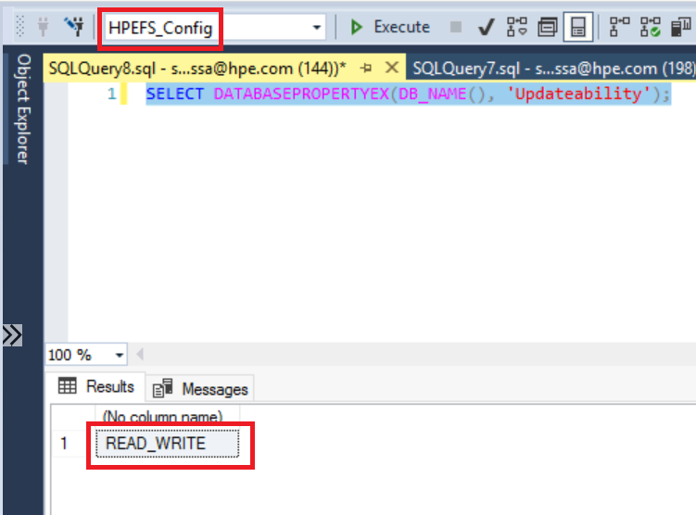

1. Execute Below Query to create Extract tables.

**EXEC CreateSynonymForJobs 1**

**GO**

**EXEC CreateExtractTables**

**GO**

**EXEC [dbo].[AlterUserAssignPermissions] @dbUserName = N'OdessaCore'**

**GO**

**DECLARE @DatabaseName SYSNAME =DB_NAME()**

**DECLARE @LoginName NVARCHAR(1000) = N'OdessaCore'**

**EXEC CreateSQLJobToCreateExtractTable @DatabaseName, @LoginName**

**GO**

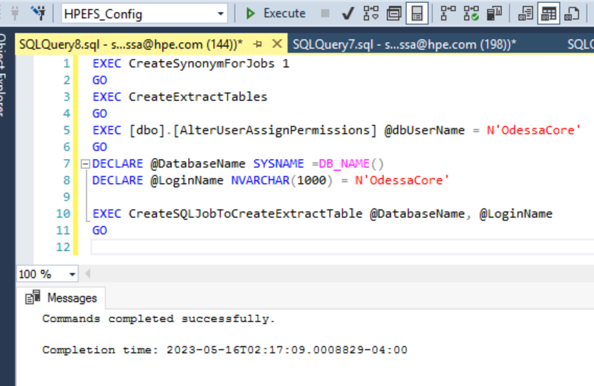

### Replica DB

1. Open SSMS -> Provide Login Credentials -> Click on Options



1. Click on Additional Connection Parameters -> Add **ApplicationIntent=READONLY** -> Click on Connect.



1. To Validate the ReadOnly Connection team can execute the below query and it should display READ_ONLY in output.

Query: **SELECT DATABASEPROPERTYEX(DB_NAME(), 'Updateability');**



1. Execute Below Query to create Extract tables.

**EXEC CreateExtractTables**

**GO**

**EXEC [dbo].[AlterUserAssignPermissions] @dbUserName = N'OdessaCore'**

**GO**



# 15. Report Builder Deployment

Report Builder deployment follows the hybrid model. There are some components which require manual steps for deployment. Please refer to the below list with sequence for deploying this application.

## 15.1 Automated and Manual Release Tasks

|  |  |  |  |
| --- | --- | --- | --- |
| Sequence No. | **Component/Task** | **Deployment Mode**  **(Automated/Manual)** | **Instructions** |
| 1 | **Create Release**  Trigger Pipeline for reading release content from storage container and uploading within DevOps Artifacts | Automated | **Pipeline Name -**  Get & Deploy Artifacts  Refer section 15.2 |
| 2 | **Deploy ReportBuilder Components**  Trigger Pipeline for Deploying contents | Automated | **Pipeline Name -**  ReportBuilder W Artifacts  Refer section 15.3 |
| 3. | **Update Config Changes**  Configuration Changes | Manual | Refer section 15.4 |
| 4. | **Restart ReportBuilder Services**  Trigger Pipeline for Restart ReportBuilder Services | Automated | **Pipeline Name -**  Restart ReportBuilder AppServices  Refer section 15.5 |
| 5. |  |  |  |
| 6. |  |  |  |

## 15.2 Steps for - Create Release

* Trigger Pipeline to download and Upload content in DevOps Artifacts.
  + **Steps: -**

Release Pipeline -> HPE-DEV -> ReportBuilder -> **Get & Deploy Artifacts** -> Create Release

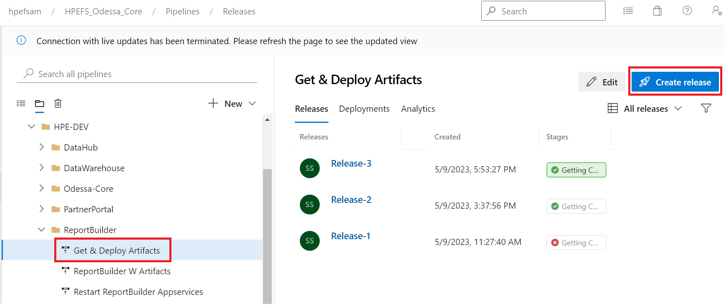

Provide Releaseversion shared by Odessa team is release template -> Create

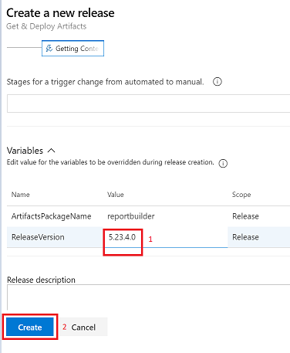

## 15.3 Steps for – Deploy ReportBuilder Components

* Trigger release. Steps: -

Release Pipeline -> HPE-DEV -> ReportBuilder -> ReportBuilder W Artifacts -> Create Release

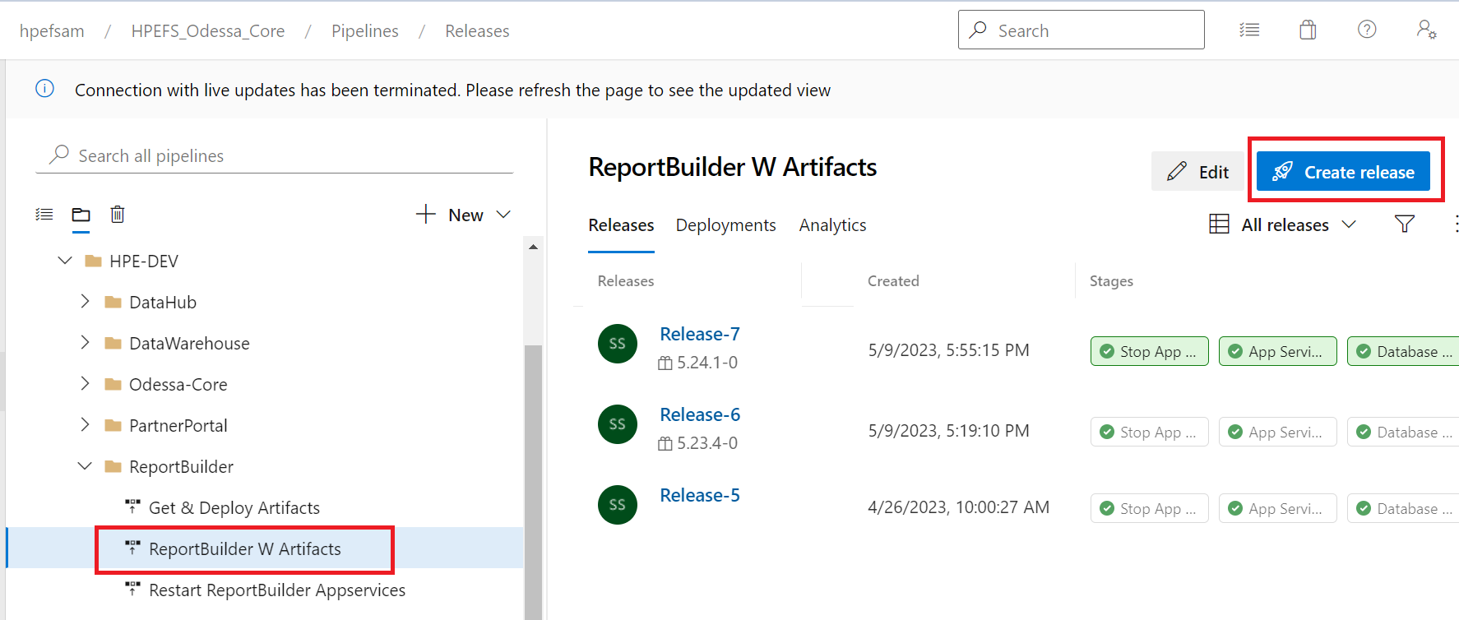

Choose artifacts version from dropdown-> Provide Release version -> Create

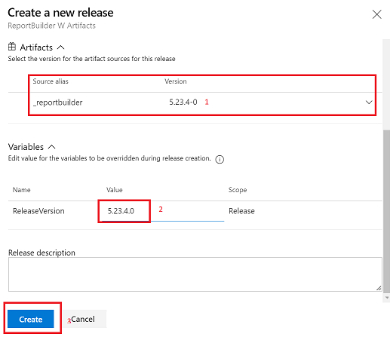

## 15.4 Steps for – Update Config Changes

* Update Configuration file.
  + **Steps: -**

Login to Jump box->Open WinSCP -> Login to specific Web App’s (APP, Report Generation Service, Job Service) FTP Credentials.



* For WebApp update Following file according to readme.txt file.
* Appsettings.config
* Connectionstings.config
* Web.config
* For Jobs/Windows Service update following file according to readme.txt file
* Appsettings.config
* Connectionstings.config
* LW.WindowsService.exe.config
* For Report Generation Service update following file according to readme.txt file
* Web.config

## 15.5 Steps for – Restart ReportBuilder Services

* Restart Services. Steps: -

Release Pipeline -> HPE-DEV -> ReportBuilder -> Restart ReportBuilder AppServices -> Create Release

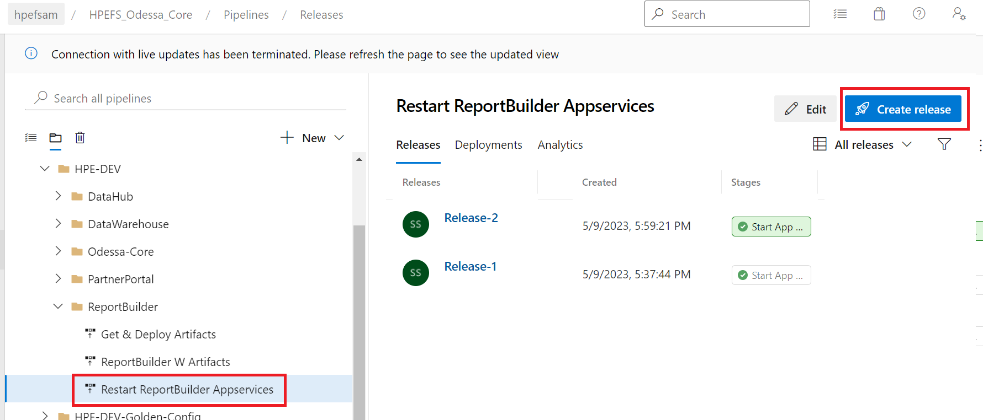

# 16. Data Warehouse Deployment

Data Warehouse/Insights deployment follows the hybrid model. There are some components which require manual steps for deployment. Please refer to the below list with sequence for deploying this application.

## 16.1 Automated and Manual Release Tasks

|  |  |  |  |
| --- | --- | --- | --- |
| Sequence No. | **Component/Task** | **Deployment Mode**  **(Automated/Manual)** | **Instructions** |
| 1 | Run Measures Job from OdessaCore | Manual | Refer section 16.2 |
| 2 | **Create Release**  Trigger Pipeline for reading release content from storage container and uploading within DevOps Artifacts | Automated | **Pipeline Name -**  Get & Deploy Artifacts  Refer section 16.3 |
| 3. | **Deploy DWH Components**  Trigger Pipeline for Deploying contents | Automated | **Pipeline Name -**  DWH W Artifacts  Refer section 16.4 |
| 4. | **Update Config Changes**  Configuration Changes | Manual | Refer section 16.5 |
| 5. | Run ETL | Manual | Refer section 16.6 |
| 6. | Upload Documents | Manual | Refer section 16.8 |

## 16.2 Steps for – Run Measure Jobs from odessacore

**Confirm with Odessacore team that corresponding release has been completed,** if release has been completed in odessacore team can proceed for this step.

Login to Odessacore->Search Jobs->Click on Create

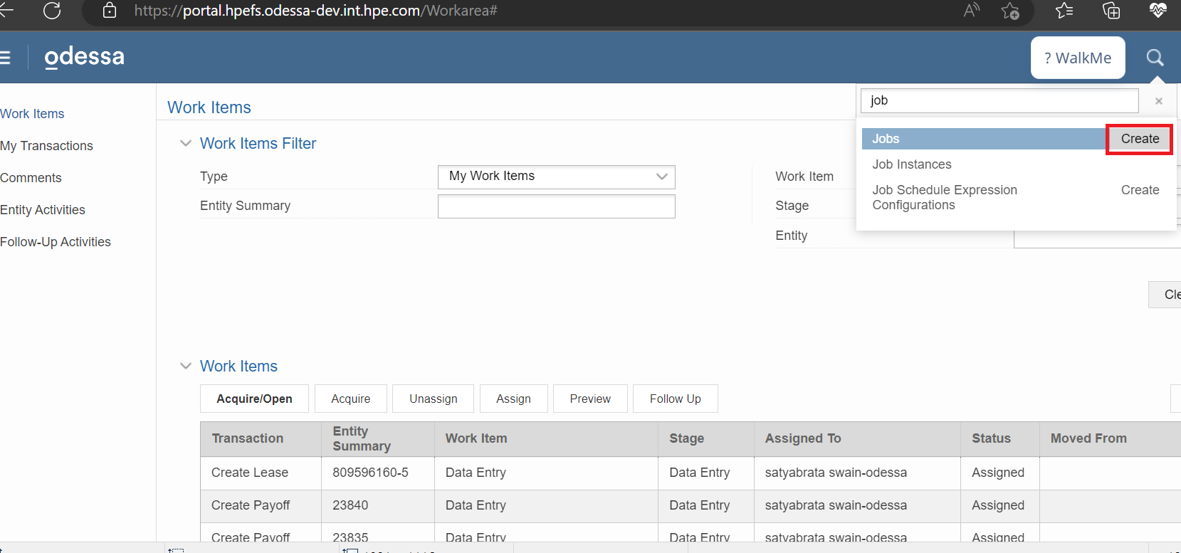

Provide Job name -> Click on Add

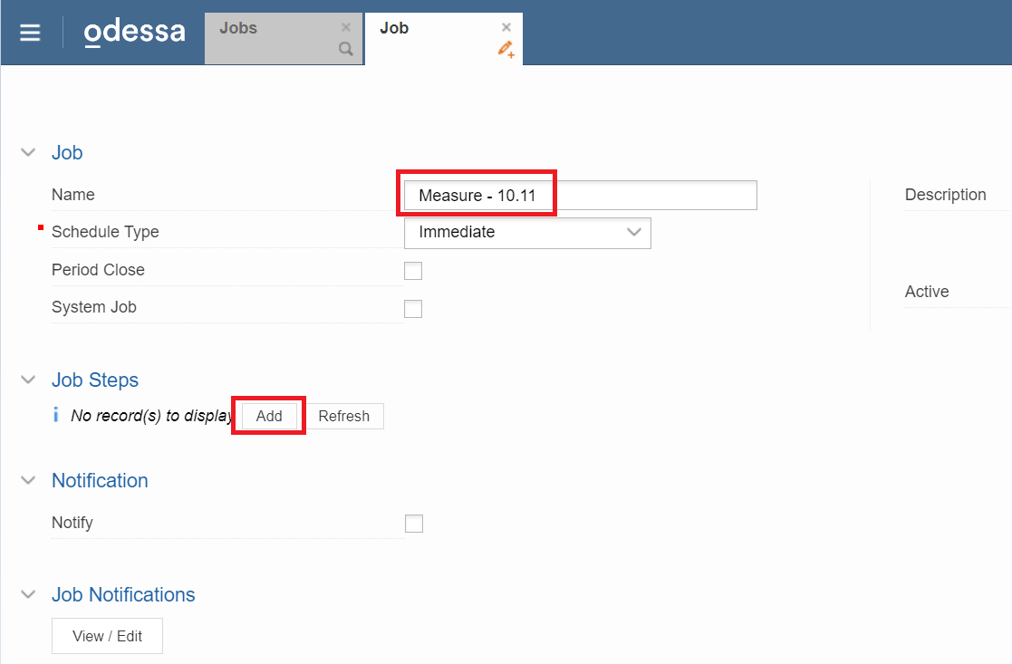

In JobSteps provide task name as Measures Computation Task -> Click on Setup Parameters

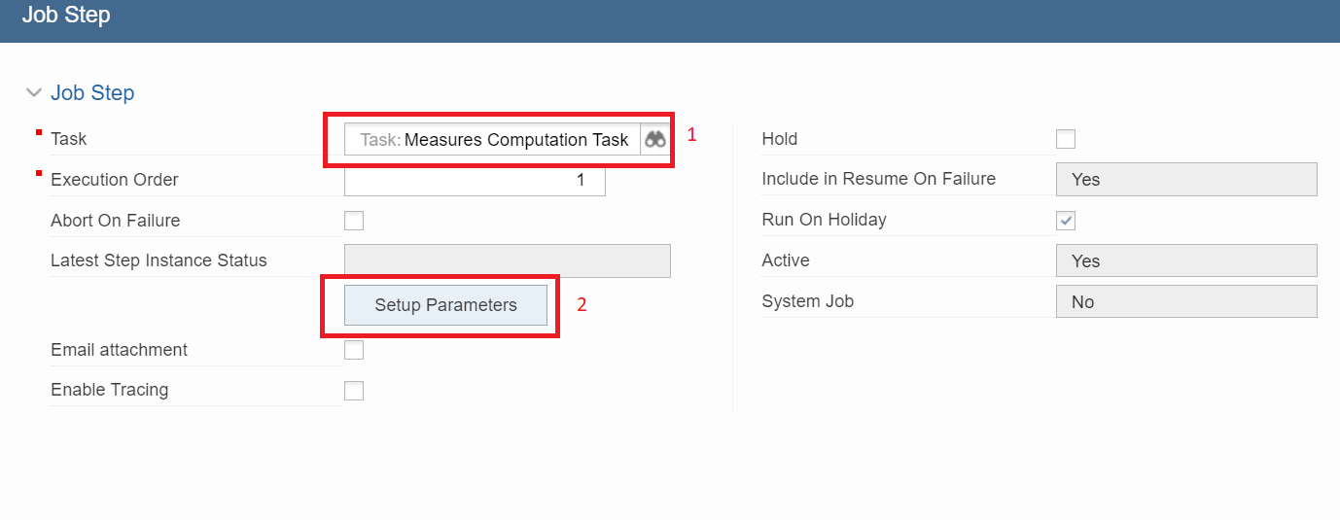

Click on Import Measure Configs

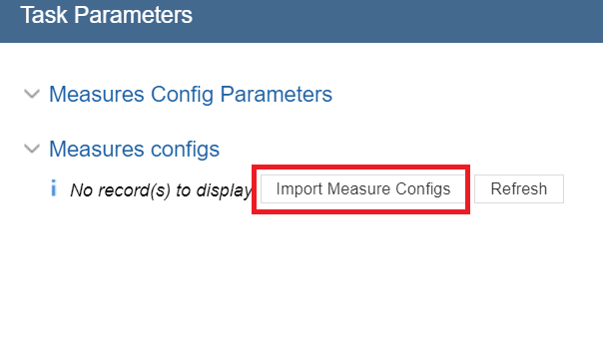

Select the parameters based on Odessa team (shared the details in Release Template)-> Click OK

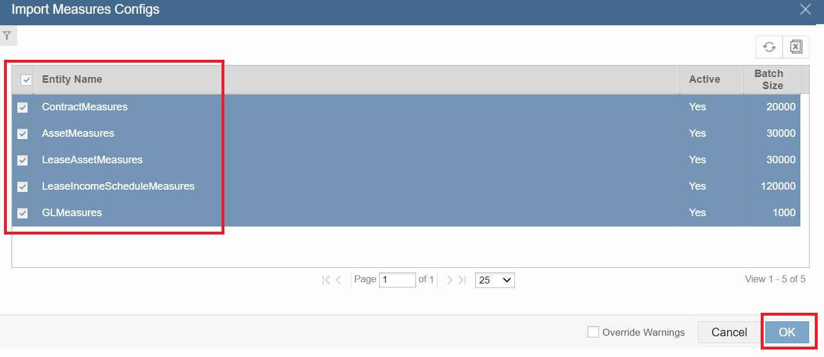

Once JobSteps is added click on submit.

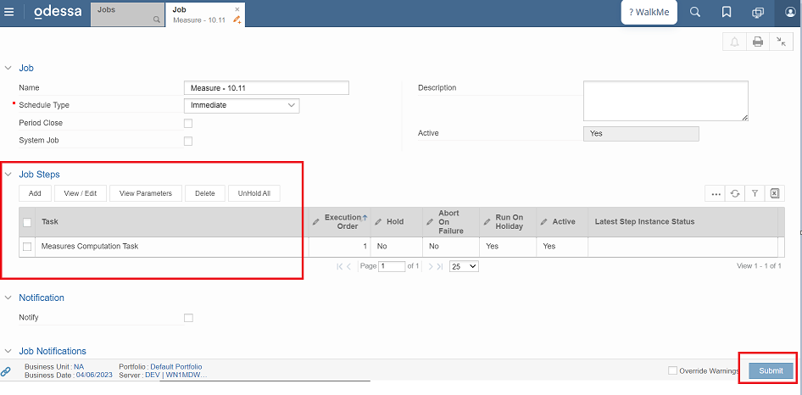

Once you submit the job automatically an instance will be running in JobInstances, make sure the status will be completed.

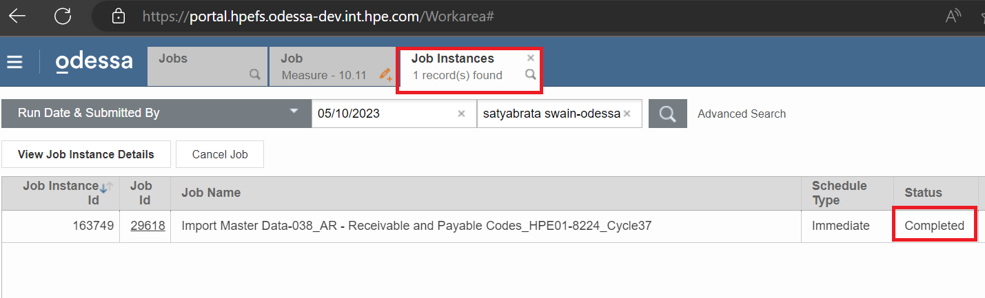

## 16.3 Steps for - Create Release

* Trigger Pipeline to download and Upload content in DevOps Artifacts.
  + **Steps: -**

Release Pipeline -> HPE-DEV -> DataWarehouse -> **Get & Deploy Artifacts** -> Create Release

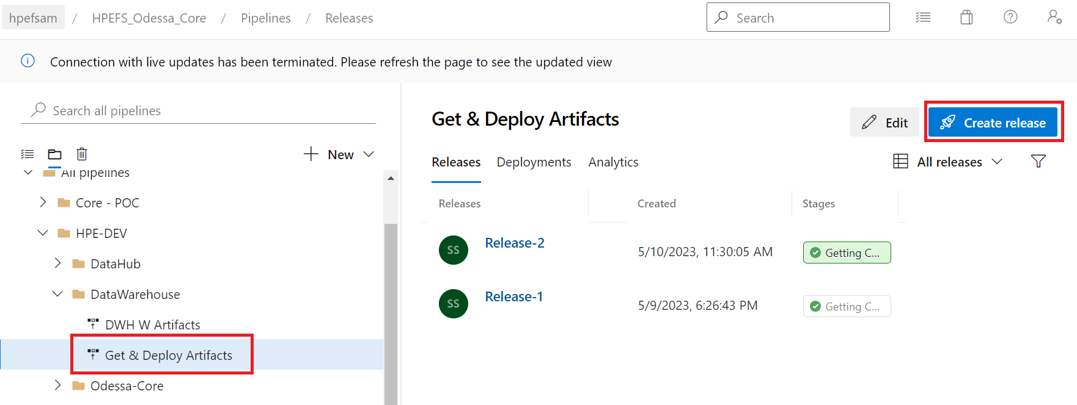

Provide Releaseversion shared by Odessa team is release template -> Create

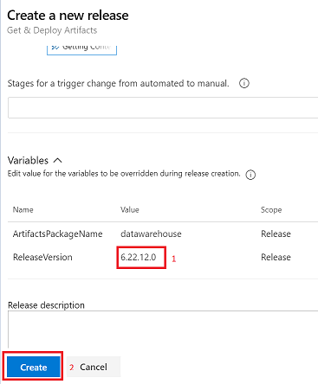

## 16.4 Steps for – Deploy DWH Components

* Trigger release. Steps: -

Release Pipeline -> HPE-DEV -> DataWarehouse -> DWH W Artifacts -> Create Release

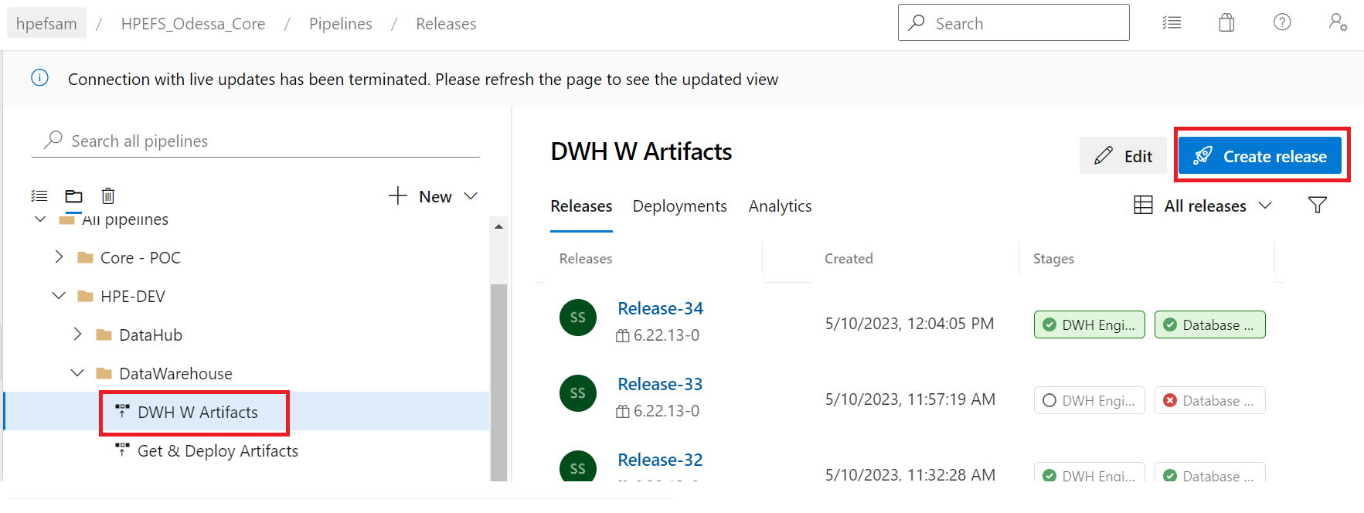

Choose artifacts version from dropdown-> Provide Release version -> Create

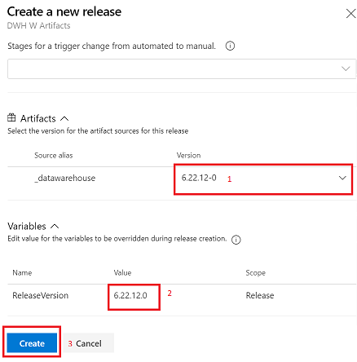

## 16.5 Steps for – Update Config Changes

Login To jumpbox -> From jumpbox login to DWH VM -> Go to Engine Path

Update Odessa.DW.exe.config based on release template.

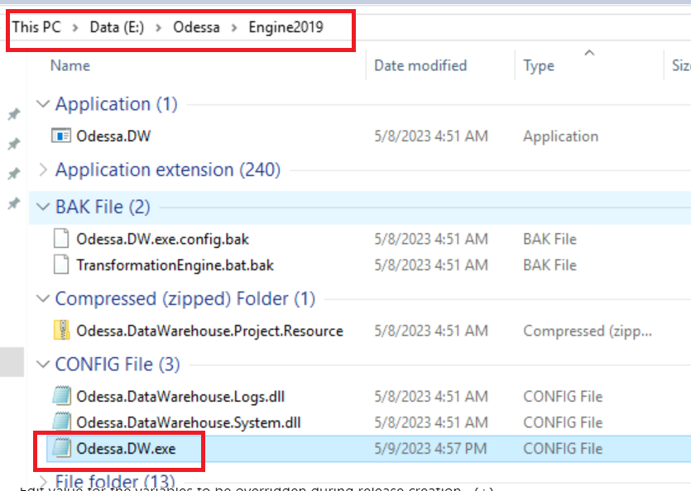

## 16.6 Steps for – Run ETL

Login To jumpbox -> From jumpbox login to DWH VM -> Go to Engine Path -> Open cmd -> Go to Engine Path in cmd -> Odessa.DW.exe -> Hit enter

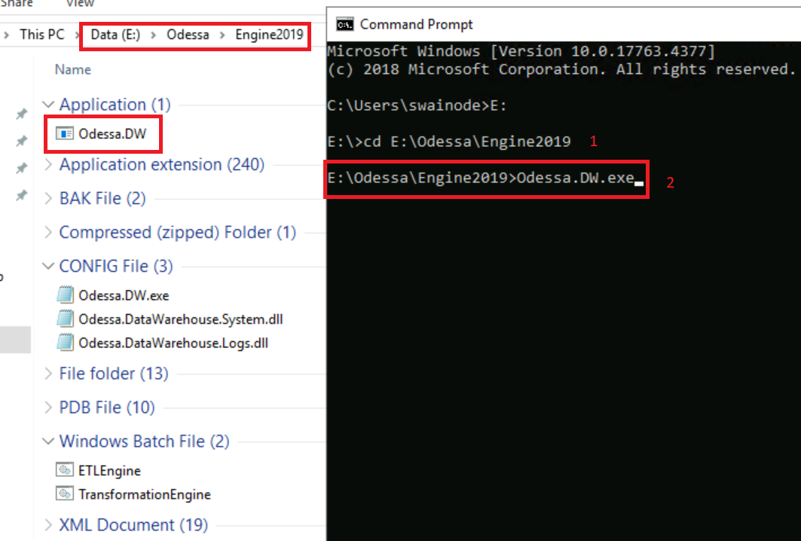

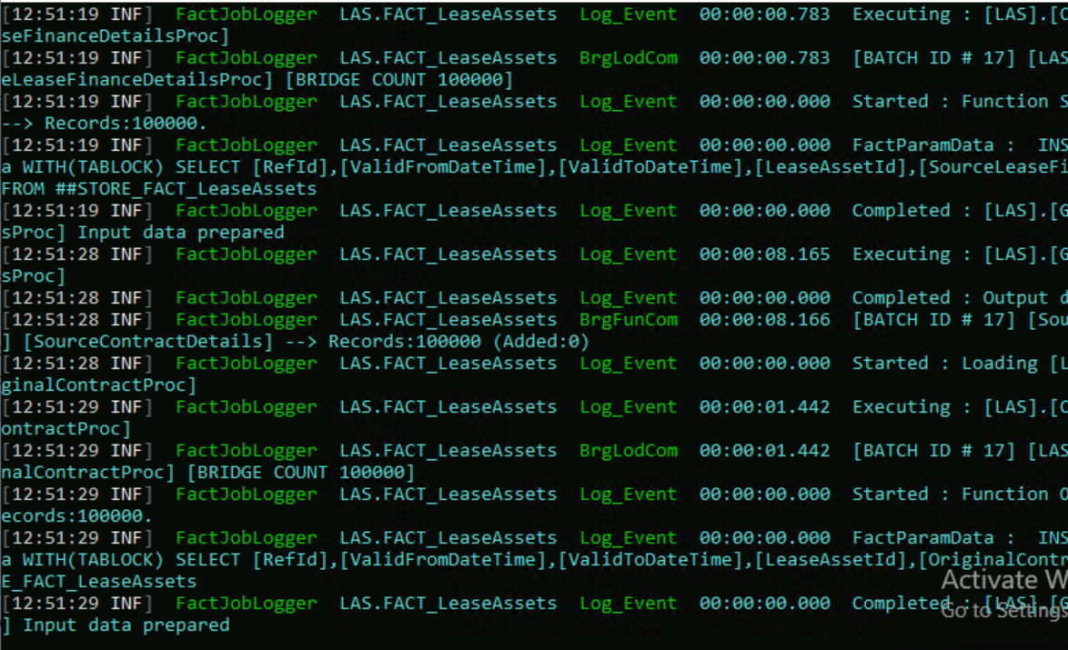

## 16.7 Non-Production (Data Repopulation) Workflow Diagram

Below diagram represents the end-to-end workflow for data repopulation.

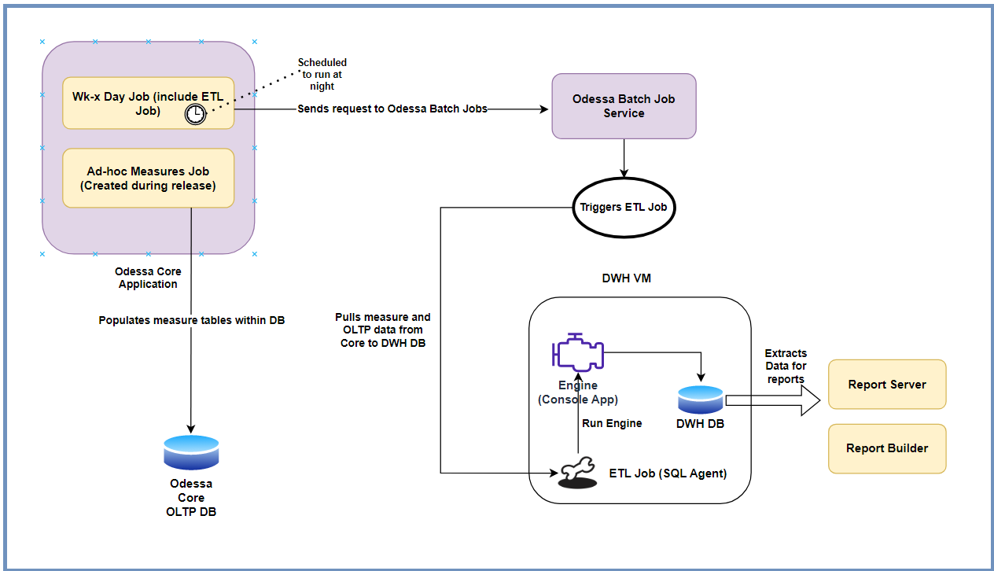

## 16.8 Steps for – Upload Documents

* Release document from Release Contents is uploaded here -<https://hpe.sharepoint.com/:f:/r/sites/msteams_a09baa/Shared%20Documents/Reporting/Documents?csf=1&web=1&e=muB3c7>
* These documents are uploaded only one time during ITG and STG deployment. There are no specific release documents for different environments.
* You can find the Documents from Release Contents.

**Team’s Path –**

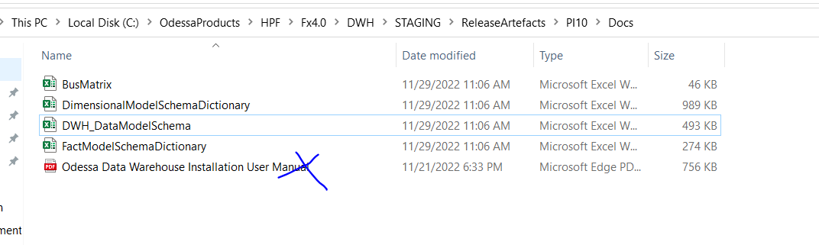

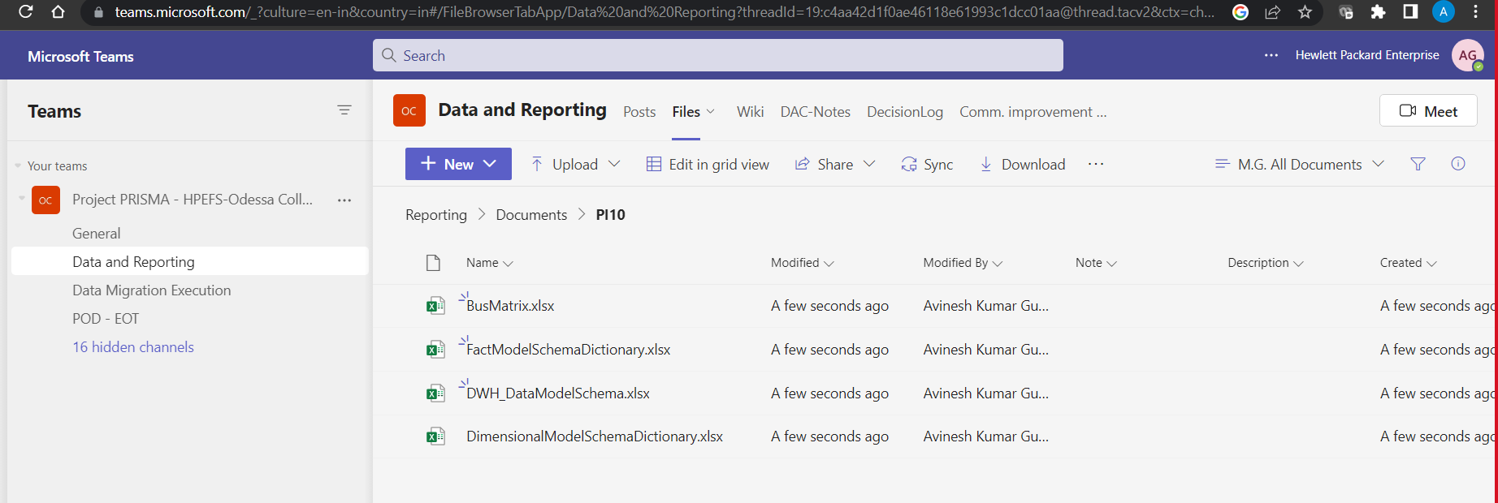

# 17. Partner Portal Deployment

Partner Portal deployment follows the hybrid model. There are some components which require manual steps for deployment. Please refer to the below list with sequence for deploying this application.

For deployment, users should be using Create Release options to trigger the deployment. Below is the list of tasks which explain automated and manual steps.

For creating release, refer to section 17.2.

## 17.1 Automated and Manual Release Tasks

|  |  |  |  |
| --- | --- | --- | --- |
| Sequence No. | **Component/Task** | **Deployment Mode**  **(Automated/Manual)** | **Instructions** |
| 1 | **Create Release**  Trigger Pipeline for reading release content from storage container and uploading within DevOps Artifacts | Automated | **Pipeline Name -**  Get & Deploy Artifacts  Refer section 17.2 |
| 2 | **Deploy Partner Portal Components**  Trigger Pipeline for Deploying contents (App, Api, Job, Doc Portal, Database & Reports) | Automated | **Pipeline Name -**  Odessa Partner Portal w Artifacts  Refer section 17.3 |
| 3 | **Update Config Changes**  Configuration Changes | Manual | Refer section 17.4 |
| 4 | **Restart Partner Portal Services**  Trigger Pipeline for Restart Core Services | Automated | **Pipeline Name -**  Restart Partner Portal App Services  Refer section 17.5 |
|  |  |  |  |

## 17.2 Steps for - Create Release

* Trigger Pipeline to download and Upload content in DevOps Artifacts.
  + **Steps: -**

Release Pipeline -> HPE-DEV -> PartnerPortal -> **Get & Deploy Artifacts** -> Create Release

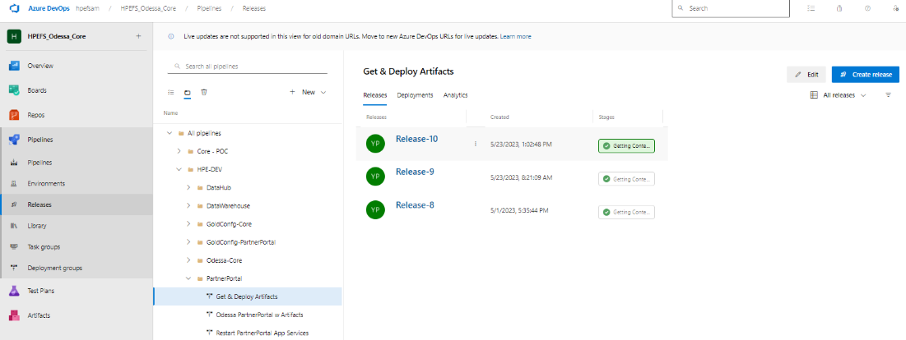

Provide Release version shared by Odessa team -> Create

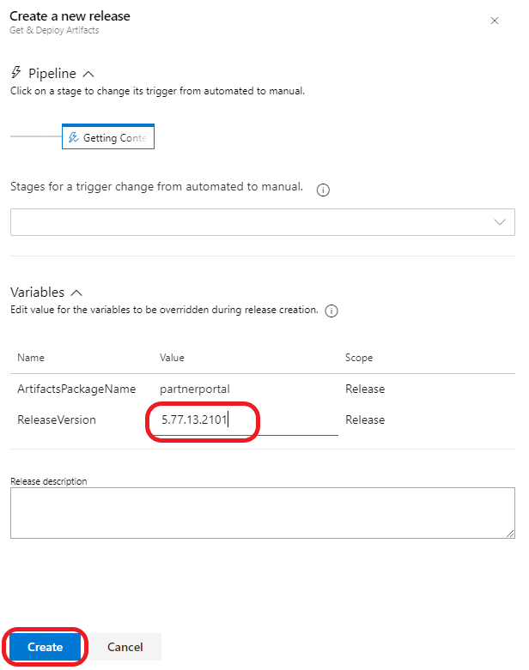

## 17.3 Steps for – Deploy Partner Portal Components

* Trigger release. Steps: -

Release Pipeline -> HPE-DEV -> PartnerPortal -> Odessa PartnerPortal w Artifacts -> Create Release

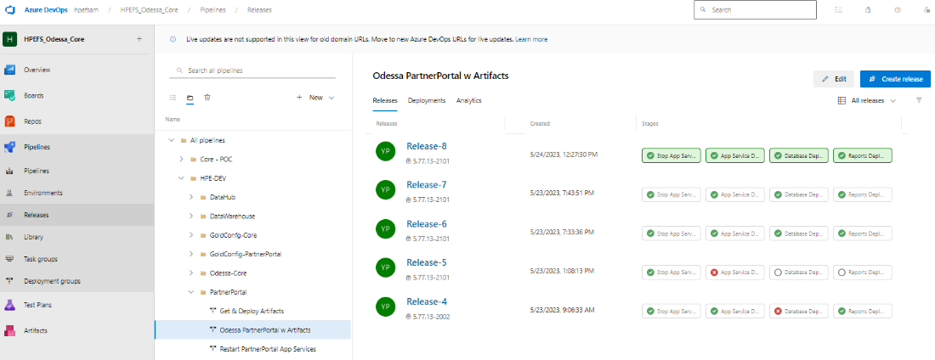

Select Artifacts version from dropdown-> Provide Release version -> Create

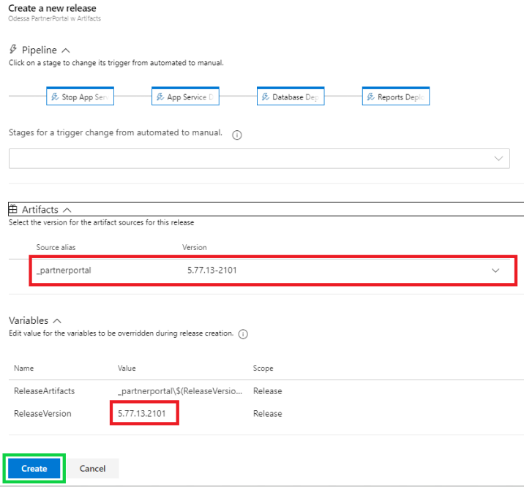

## 17.4 Steps for – Update Config Changes

* Update Configuration file.
  + **Steps: -**

Login to Jump box->Open WinSCP -> Login to specific Web App’s (APP, Web API, Job Service) FTP Credentials.

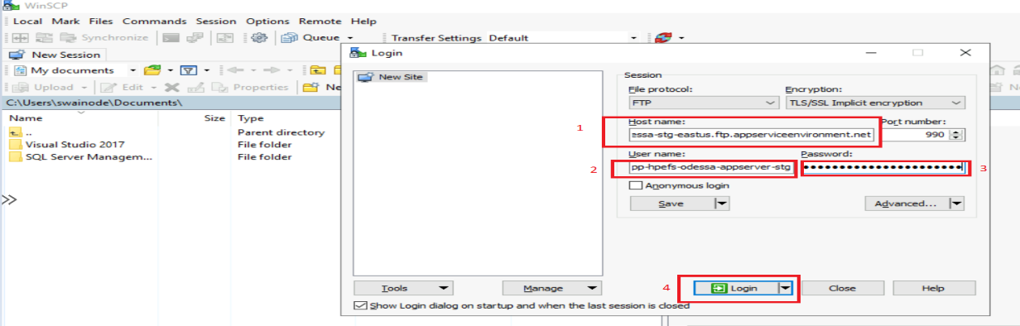

* For App and Web API update Following file according to readme.txt file.
* Appsettings.config
* Connectionstings.config
* Web.config
* For Jobs/Windows Service update following file according to readme.txt file
* Appsettings.config
* Connectionstings.config
* LW.WindowsService.exe.config

## 17.5 Steps for – Restart Partner Portal Services

* Restart Services. Steps: -

Release Pipeline -> HPE-DEV -> PartnerPortal -> Restart PartnerPortal App Services -> Create Release

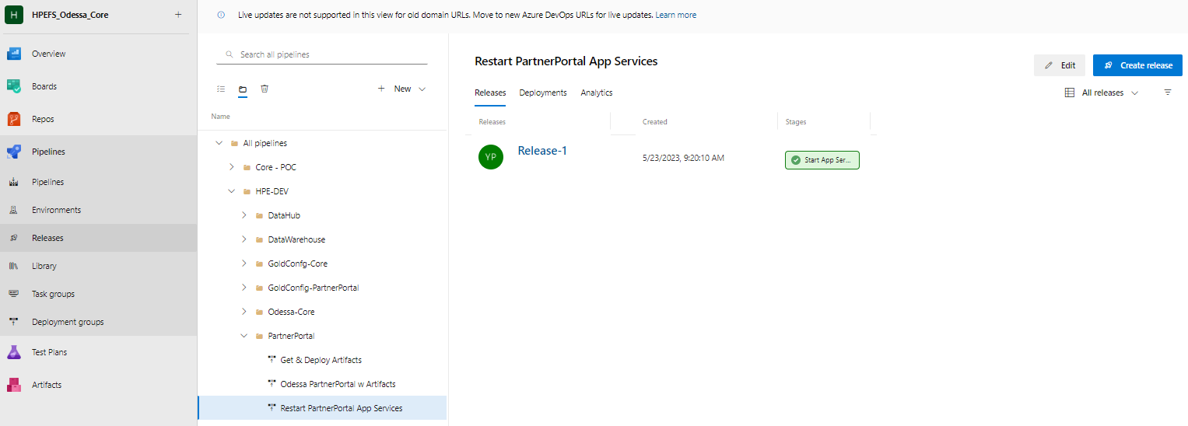

* Create the release.

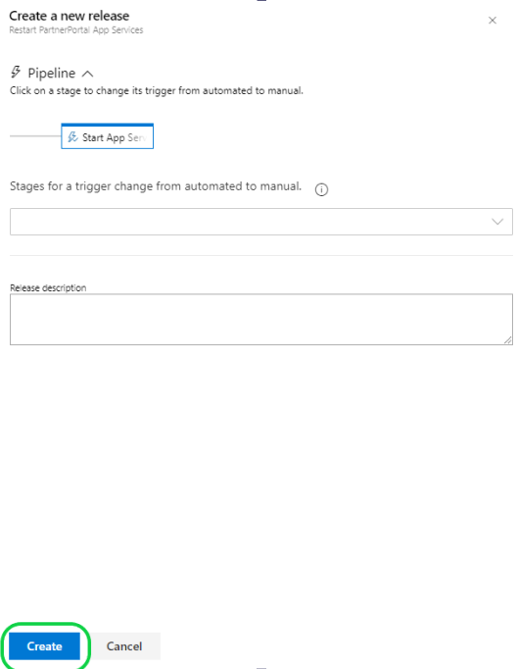

# 18. Gold Config – Partner Portal Pipeline Setup

## 18.1 Prerequisite Configuration/Permissions

Below table contains the permissions granted for gold config environment and are the pre-requisite configuration for DevOps Pipeline setup.

**Note: Similar permissions are required to be granted for higher environments to set up DevOps Pipeline.**

|  |  |  |  |
| --- | --- | --- | --- |
| **Type/**  **Category** | **Pre-configuration Permission Tasks** | **Object/**  **Resource Name** | **Notes** |
| Azure Service Principal | Create DevOps Service Principal (SP) | **Service Connection –**  odessa-hpefs-devops-sp-dev | This is the first step where SP to be created in Azure |
| DevOps  Service Connection | Create DevOps Service Connection (SC) by pointing to above SP | **Service Principal-**  odessa-hpefs-devops-sp-dev | Once we have above SC then create SP in DevOps by pointing to this SP |
| DevOps  Artifacts | Add Contributor Access to Project Collection Build Service | **Path -** Azure Devops->Artifacts->Settings->Permission->  Permission - Contributor | By default, permission is set to – Collaborative which needs to be updated with Contributor access.  This has already been given so no further access is needed for higher environments. |
| Azure VMSS | Granting access to VM Scale-set on Storage Account’s container | **VMSS Name –**vmssdevopsnonp  Storage Container Name – stodessacoreblobdev  **IAM Role -** Storage Blob Data Reader | This access has been given already so no further access is needed for higher environments. |
| Azure SQL Mi | Grant IAM role to SQL MI for SP | **SQL Mi** –sqlmi-odessa-dev  **SP** –odessa-hpefs-devops-sp-dev  **IAM Role** - Contributor | Permission to SP for accessing SQL Mi |
| Azure SQL Mi | Create new SQL user for DevOps within SQL Mi and grant sys_admin roles | **Local SQL User –** OdessaDevOpsUser  **SQL Mi –** sqlmi-odessa-dev  **Roles –** sys_admin | Permission needed for deploying DDL, DML and Job creation related scripts |

## 18.2 Automated Pipeline Deployment Workflow

**Note:** Partner Portal Gold Config has only database deployment. Currently, Gold Config deployment happens only within DEV environment. These Gold Config services are in the process of moving to Production. After movement, releases only happen in Production not in DEV or any other environments.

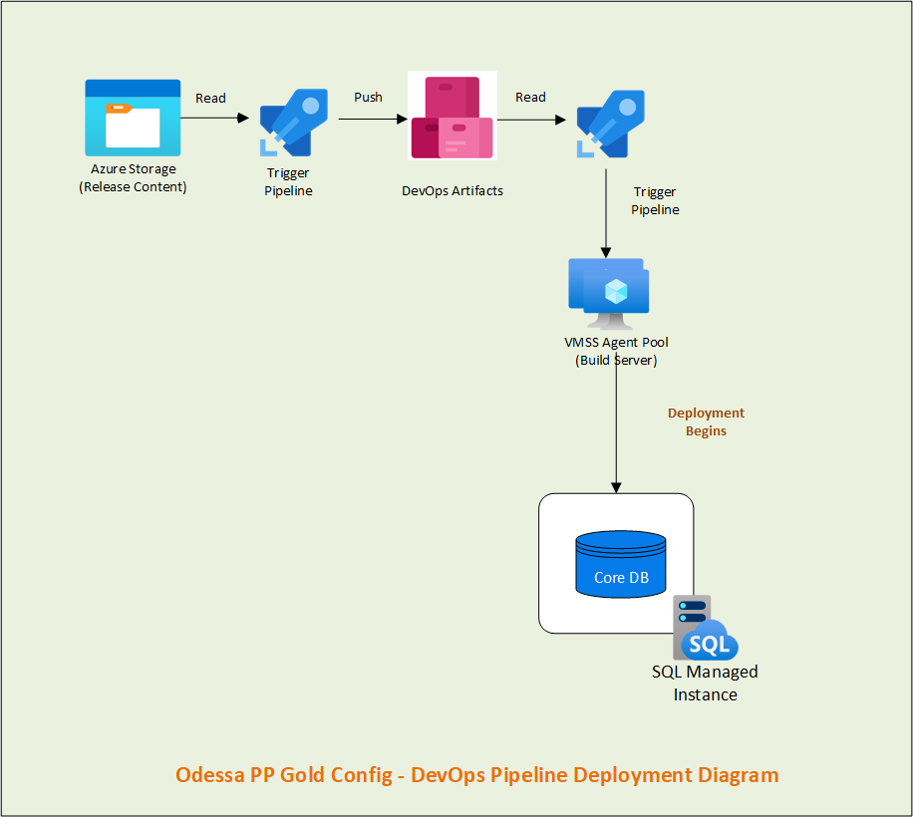

## 18.3 Pipeline Setup

### **18.3.1 Pipeline -** Odessa Partner Portal Config w Artifacts

* + - **Job – Read Artifacts & Deploy**
    - **Task List –**

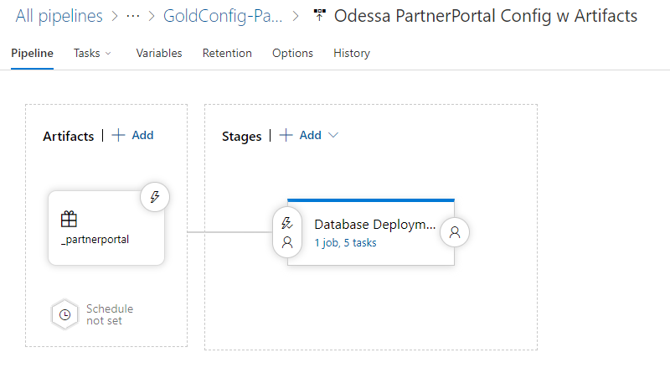

# 19. Golden Config – Partner Portal Deployment

## 19.1 Gold configuration deployment steps

Golden Config deployment follows the hybrid model. There are some components which require manual steps for deployment. Please refer to the below list with sequence for deploying this application.

|  |  |  |  |
| --- | --- | --- | --- |
| **Sr. No.** | **Component/Task** | **Deployment Mode**  **(Automated/Manual)** | Instraction |
| 1. | Deploy Gold Config – Partner Portal Component | Automated | Section 19.1.1 |
| 2. | Release version verification in database | Manual | Section 19.1.2 |
|  |  |  |  |

### 19.1.1 Deploy Gold Config – Partner Portal component.

* Trigger release. Steps: -

Release Pipeline -> HPE-DEV -> GoldConfig-Partner Portal -> Odessa Partner Portal Config w Artifacts -> Create Release

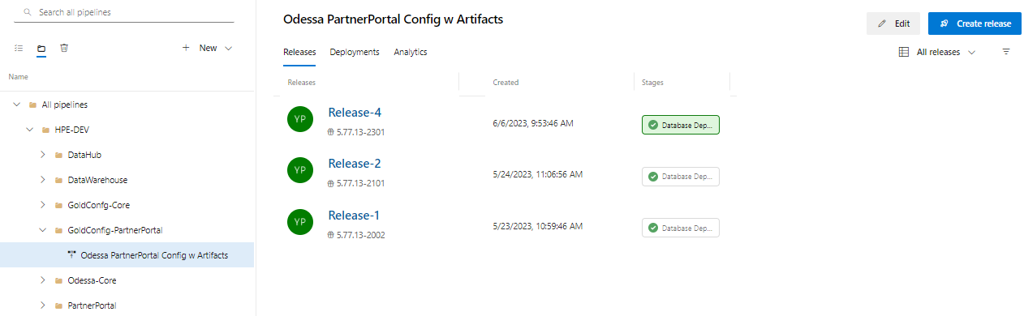

Provide Release version shared by Odessa team -> Create

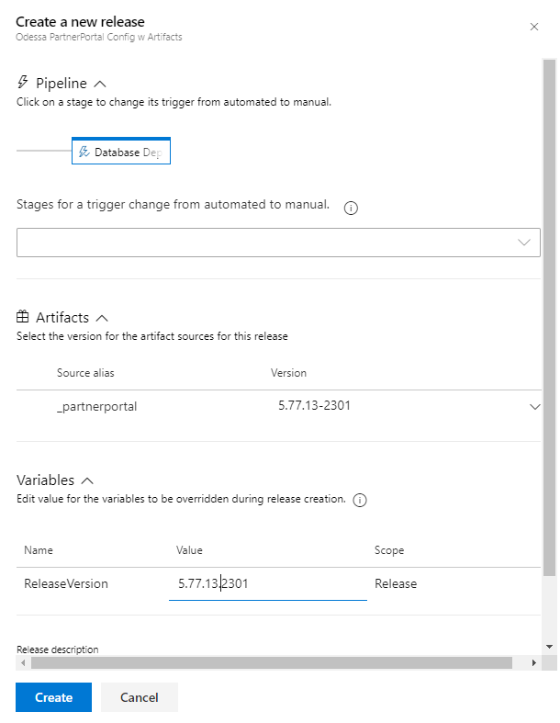

### 19.1.2 Release version verification

Need to query in HPEFS_PP_Config database

Select * from releaseversions order by 1 desc

# 20. Data Hub Deployment

## 20.1 Data hub deployment steps

Data Hub deployment follows the hybrid model. There are some components which require manual steps for deployment. Please refer to the below list with sequence for deploying this application.

**Note: Before triggering DH release, please make sure DH job(Partial) is not running.**

|  |  |  |  |
| --- | --- | --- | --- |
| Sequence No. | **Component/Task** | **Deployment Mode**  **(Automated/Manual)** | **Instructions** |
| 1 | **Create Release**  Trigger Pipeline for reading release content from storage container and uploading within DevOps Artifacts | Automated | **Pipeline Name -**  Get & Deploy Artifacts  Refer section 20.2 |
| 2 | **Deploy DH Components**  Trigger Pipeline for Deploying contents | Automated | **Pipeline Name -**  DH W Artifacts  Refer section 20.3 |
| 3. | **Update Config Changes**  Configuration Changes | Manual | Refer section 20.4 |
|  |  |  |  |
|  |  |  |  |
|  |  |  |  |

## 20.2 Steps for - Create Release

* Trigger Pipeline to download and Upload content in DevOps Artifacts.
  + **Steps: -**

Release Pipeline -> HPE-DEV -> DataHub -> **Get & Deploy Artifacts** -> Create Release

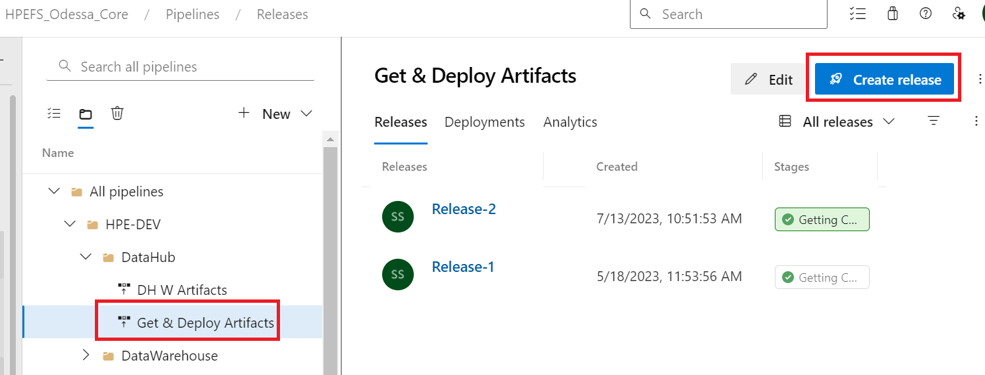

Provide Releaseversion shared by Odessa team is release template -> Create

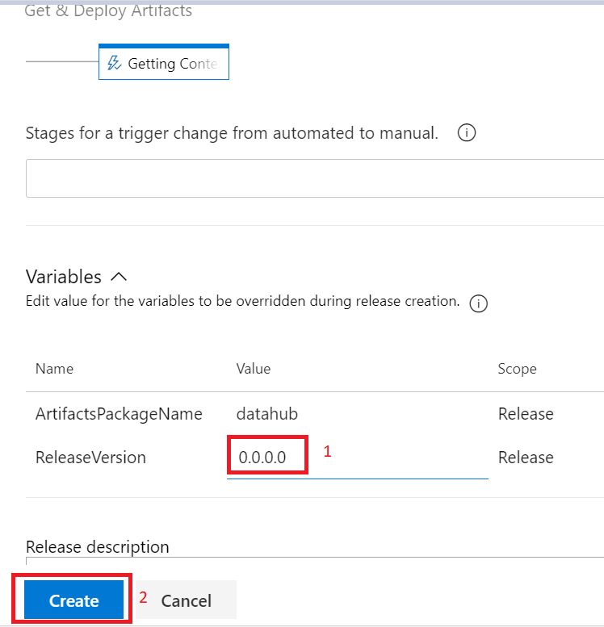

## 20.3 Steps for – Deploy DH Components

* Trigger release. Steps: -

Release Pipeline -> HPE-DEV -> DataHub -> DH W Artifacts -> Create Release

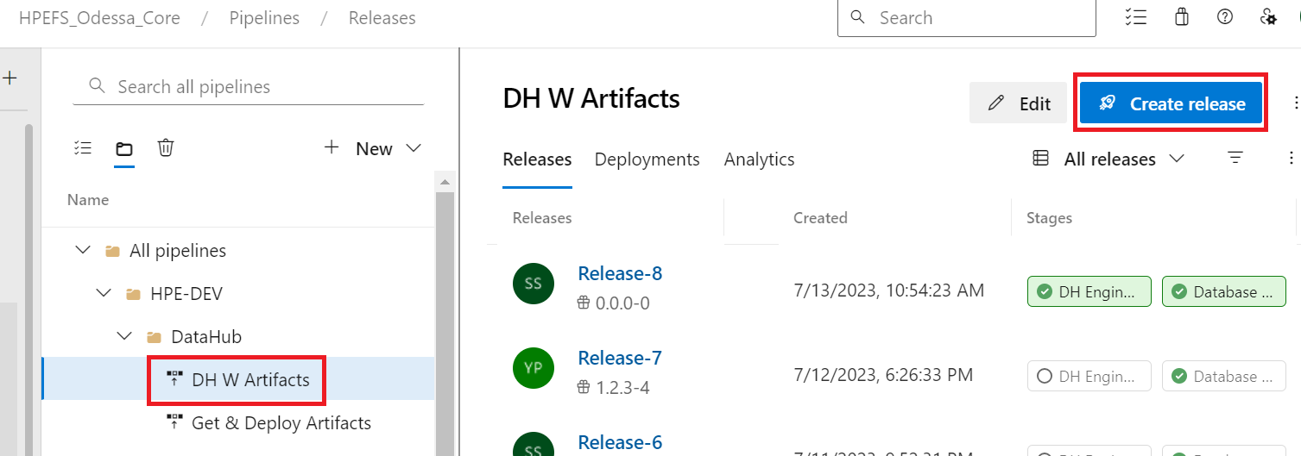

Choose artifacts version from dropdown-> Provide Release version -> Create

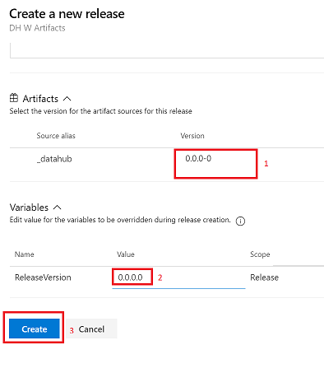

## 20.4 Steps for – Update Config Changes

Login To jumpbox -> From jumpbox login to DH Engine VM -> Go to Engine Path

Update DH.App.exe.config based on release template.

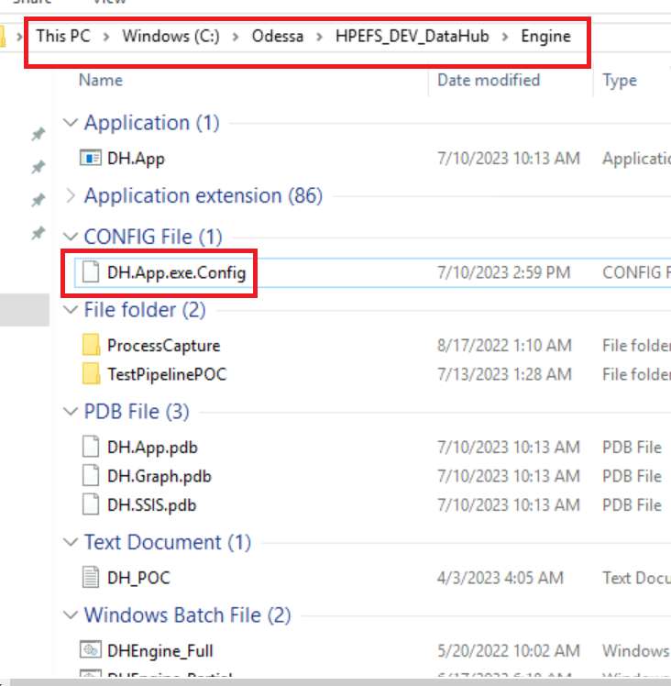

# 21. Annexure

## 21.1 Notations

|  |  |
| --- | --- |
| Abbr. | Description |
| SC | DevOps Service Connection |
| SP | Azure Service Principal |
| Insights | Data warehouse |
|  |  |
|  |  |

## 21.6 Datahub– Resource Mapping

|  |  |  |  |  |  |
| --- | --- | --- | --- | --- | --- |
| **Folder Content** | **Azure Resource Type** | **Azure Resource Name**  **(DEV)** | **Azure Resource Name**  **(ITG)** | **Azure Resource Name**  **(STG)** | **Azure Resource Name**  **(PROD)** |
| Engine | VM  Console Application | vmdatamartdev - 10.17.10.5 | Vmdatamartitg -    10.17.18.4 | Vmdatamartstg1- 10.17.26.5  Vmdatamartstg2- 10.17.26.6 |  |
| DB | SQL Server | SQL Server -  vmsqlrepldev2\hpfsids_OdessaDM  DB Name - DATAHUB_ODESSA\  UserName: Odessa_Deploy_User01 | SQL Server - VMSQLREPLITG\HPFSIDS_ODESSADM, 1433  DB Name - DATAHUB_ODESSA  UserName : Odessa_Deploy_User01 | SQL Server - vmsqlreplstg\HPFSIDS_ODESSADM, 1433  DB Name - DATAHUB_ODESSA  UserName: Odessa_Deploy_User01 |  |
| License | N/A |  | Reference |  |  |

# 22. References

* DevOps Odessa and HPE POC - <https://hpe.sharepoint.com/:x:/r/sites/msteams_a09baa/Shared%20Documents/Technology/Infra%20and%20Environments/Environment%20Transition%20Recordings/DevOps%20Odessa%20and%20HPE%20POC.xlsx?d=w8ae83229fa6b4153b8adff246be07225&csf=1&web=1&e=4xG0c4>
* Environment Transition Recording and Documents –

<https://hpe.sharepoint.com/:f:/r/sites/msteams_a09baa/Shared%20Documents/Technology/Infra%20and%20Environments/Environment%20Transition%20Recordings?csf=1&web=1&e=1UsjnH>